On the USB drive each session has a folder, i.e., 2021 Summer. Buddy Group folder is for misc. buddy files.
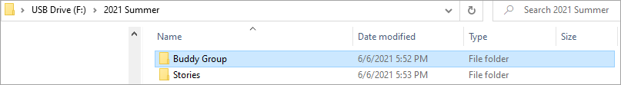
Stories has a folder for Buddy (feedback story related files), Draft (my story files), and Final (my finished story).
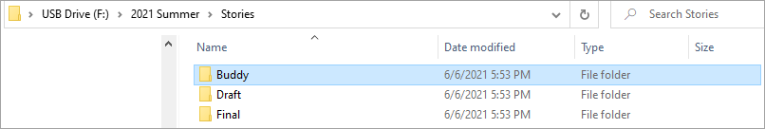
In the Buddy (feedback) folder I have a folder for each month.
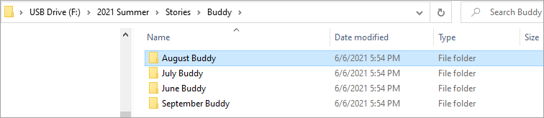
As I received stories for feedback, I save them in the month folder along with a copy of my feedback form.
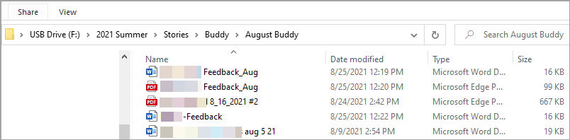
The Draft folder contains a folder for each month.
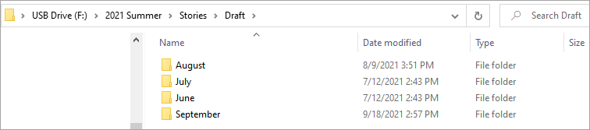
Inside the month folder I save my story and the Feedback folder is where I save feedback files I receive.
