Blue Overalls and Red Buttons
by Susan Owens / 747 words / May 12, 2022
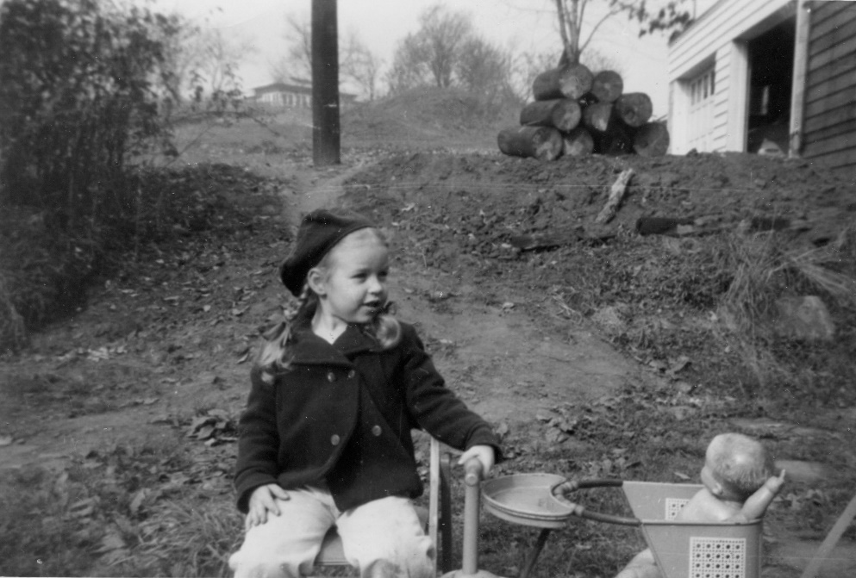
Summer 1950. I was five years old and I needed a friend. That spring we moved into the house my dad had been building at the top of the hill ever since I could remember. I had more room to play than when we lived in the farmhouse at the bottom of the hill, with us in one half and Aunt Velma and Uncle Jack in the other, but I had no one to play with. My brother and sister were too little, and Mom was too busy taking care of them to worry about me.
Sometimes I visited “Ma” Mechtly, who lived on the other side of the narrow country road that ran past the farm. “Ma” wore her thick white hair in a single braid down her back, and her kitchen always smelled delicious. That spring she showed me how to find violets and May apples in the woods behind her house. I liked going there, but it wasn’t the same as having a friend my age.
Before we moved, I’d spent most days with Aunt Velma. She and Uncle Jack owned the farm and sold part of it to Dad for our new house. They weren’t really related to us, Mom said, but I loved them anyway. I still visited them a lot, and that summer Velma taught me to play Canasta and made me mayonnaise sandwiches on Wonder Bread whenever I asked. But she was way too old to jump rope or hunt for wild blackberries or climb the cherry trees in our front yard.
One day when I was really lonely, I decided to visit the farmhouse on the corner of our road. Maybe they had kids my age. I’d never gone so far from home by myself, but I took a shortcut through the fields, so I figured Mom wouldn’t mind. As I got closer, I saw a girl in light blue overalls with big red buttons, bouncing a ball against the side of the barn. She wore brown oxfords, just like mine, and bright pink socks. She looked at me and smiled.
“Hi,” I said. “My name is Sue and I’m five years old.”
“Hi,” she said, walking toward me. “I’m Janet. I’m six. Do you live around here?”
“Up there,” I said, pointing to the outline of our house in the distance.
“Wow, that looks far away. Did you come all by yourself?”
“Uh huh.”
“Wanna play with me?”
Did I ever! I didn’t stay long, in case Mom went looking for me, but it was long enough to know I’d found a friend.
“Can you come back tomorrow?” Janet said as I turned to leave.
“Sure.” I went to Janet’s many days after that, and the summer sped by as we chased each other around the yard, jumped rope, explored nearby fields, and scooped up jacks from the hard-packed dirt by her kitchen door. I was never invited inside, but sometimes her mom would bring us lemonade and cookies. If it started to rain, we’d scoot into the open-air shed built against the barn and climb bales of hay to watch raindrops form waterfalls at the edge of the roof.
My folks had no problem with me visiting Janet, but for reasons I have long forgotten or perhaps never knew, Janet never visited me. In September, she was old enough to start school, which may be why our visits came to an end. I missed her a lot, but the loss of our friendship was not the only change in my world.
By the summer I was six, a new stretch of road, needed to serve the nearly finished Greater Pittsburgh Airport, was under construction near the farm, and Janet’s family was gone. The house they lived in, plus the two ancient maple trees at the end of our driveway, were sacrificed for the new road, and my time with Janet became a distant memory.
Over the years, whenever I heard the song “Playmate, Come Out and Play With Me,” I remembered my summer with Janet, but it wasn’t until the release of the 1950 census that I was able to find her once more. Sadly, she doesn’t remember me or much of anything about her early childhood, but we chatted amicably nonetheless, catching each other up on the highlights of our lives and promising to stay in touch. Who knows, we could become friends all over again.

