Jennifer Paster
5/9/2022
Good Friends
My son Bobby was born in 1983. I quit working at our family print shop to be an at home mom. After two years of being at home, I was crazy without adult interactions. I found a solution to my loneliness and craziness. Valencia Community College offered a Mommy and Me program for mothers and their children.
Excited on our first day, I walked in with my son Bobby. Sitting on the floor was my soon to be friend playing with her little girl, Lauren. Kathy had thick shoulder length red hair, freckles head to toe, and gentle green eyes. Looks were deceiving, there was a lot of personality packed in her 5”2 petite body. After introductions we quickly discovered that we had a lot in common. I was thrilled to find out that Kathy lived within a couple of blocks from us. From that point on the four of us were inseparable. Kathy was confident and easy to get along with. My son Bobby and her daughter Lauren started off rough though. Lauren reminded me of a cute sumo child cartoon character and later I found out that she acted like a sumo child also. She took advantage of Bobby’s shyness by frequently pulling his hair and rough housing. Thank goodness this stage of behavior changed when they got closer the three years old.
After a year of going to parks, road trips to the beach, playdates at each other’s homes, trips to the Science Center, we felt the kids were old enough to go on a trip. Kathy’s family had a cottage in a pine forest in Laurinburg, North Carolina perfect for family vacations. Generations of their family spent summers there. This was the start of many dual mother and child summer vacations.
Something magical happened to all of us in that pine forest. I know we were always excited to get away from the routine days at home. The summer days were long and we knew we needed to do something to keep the kiddos busy. We did not have T.V in the cottage in our first couple of trips. So each summer, Kathy and I planned a vacation theme based on new movie theater releases. That summer was Disney’s 101 Dalmatians.

Afterwards we asked, “Do you two want to take a ride down to the river?” The road that led to the river was long, hard clay, and framed on both sides by pine forest.

We were rewarded by their replies, “Yip-ee, yea!

It was almost dark when we all loaded up in the minivan and started out on the clay road. Suddenly Kathy started driving like Cruella De Vil, the most memorable character in the movie. She was pulling the minivan steering wheel a hard right and then left. Both of us snickered at how much fun we all were having.

In the back seat, the two swayed back and forth yelling, “Whoa, aaaaaaaah, oh no, hold on.”
In the movie, Cruella abducted the cute little dalmatian puppies so she could use them to
make her designer coat.

Kathy and I hackled, “My cute puppies, we got you now!”

Kathy and I connected on the same emotional level when we met. That connection grew into a long meaningful friendship. Sadly, we lost touch when the family moved away. More stories to come about our other themed vacations.
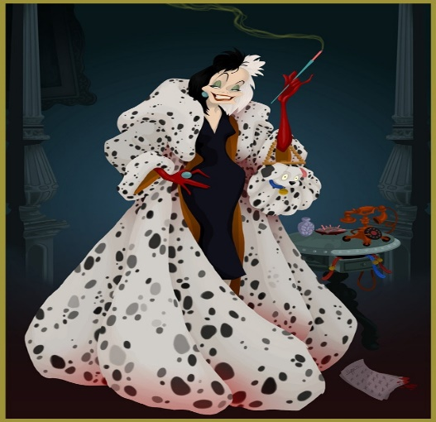
This is Cruella Di Vil, I am not sure how Disney pulls of scary stories and turns them
into kid’s movies. At least in the end the pups got rescued!

Kathy’s little girl Lauren reminded me of a sumo cartoon child

