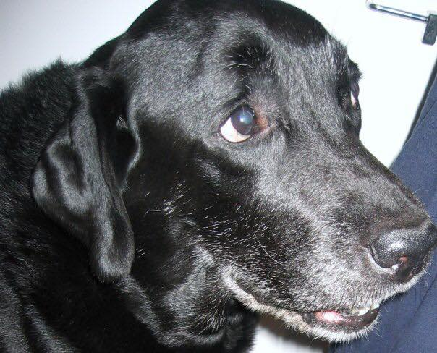

Unforgettable Ace
My unforgettable Ace, a Black Labrador Retriever, came into my life when I was going through an empty nest syndrome for the second time in my life.
Our son, Jeff, the family's baby, left for New York to live with his older sister to complete his high school education. Shortly after our son moved out, our Golden Retriever Max died. Both my husband and I were devastated.
The large house was too quiet without anyone greeting us upon returning from work. Max was not there to jump and wag his fluffy tail, and Jeff was absent inside his room to give me hugs when I opened the door. My life felt empty.
It has been a week since he died when I sat in front of the computer and googled Labrador Retrievers. My husband and I discussed the possibility of finding another dog. It felt awkward because I thought I was betraying Max soon after his passing.
Ever since I stood in front of the window of a shoe store in Sheepshead Bay, in Brooklyn, New York, I wanted to have a Lab. I was window shopping when a salesgirl ran out of the store, looked at me, and said, "May I pet your dog?" "What dog?" confused, I did not know what to say.
She ignored my answer and rushed by me. I turned around to see where she was going, and there behind me sat the most beautiful Black Labrador Retriever puppy. His demeanor smote me, and in my mind, I made a mental note—if I ever buy a dog, I want a Lab. That scene took place ten years before Max's passing.
Our family did not get a Lab when we went to look for dogs at a pet store in Brooklyn. They did not have any. Disappointed, we almost left empty-handed when I saw this beautiful fluff of golden fur in one of the kennels out of the corner of my eyes. I asked to look at the puppy, which was the end of the story. Max never left my arms and came with us that day.
When we decided to purchase another dog soon after his passing, I set my mind on a Lab. However, I wanted a Chocolate one, but when I googled my request, only two places in Florida had Labrador Retrievers available for sale.
First, I called the place that bred Chocolate Retrievers. I asked the owner if there were any puppies available at her residence. She said I was too late and that she had recently sold the last puppy from the litter her bitch had. She then proceeded to tell me that the next puppy litter would be months and months away. I could not wait that long. I need a companion right now.
I went back to my search and found a place in Lakeland. I called it a few times, but no one answered. Max died on the long weekend, and I still hoped that someone would answer me the next time I called. I called on Saturday-no answer. I called on Sunday-the line was quiet.
Keeping my fingers crossed, I dialed the number on Monday. The Gods of Animal Kingdom must have heard my request. A lady answered the phone, and I asked her if she still had a puppy available for sale. She answered yes and asked me if I had a color preference. I told her that, at this point, I did not care. I just wanted a Labrador Retriever. Then, in this case, I only have a Black Retriever. I said we wanted to see him.
I hang up the receiver. My husband and I piled up into his truck and drove to meet the puppy for four hours.
When we got to Lakeland, the owner invited us inside, and we walked through the house into a screened porch. The lady opened the door to one of the kennels, and out flew a fluff of black. I opened my arms to catch it. The adorable puppy jumped right in. it was love at first sight. I could not let go of him. He kept licking my face, making exciting sounds.
Together, we walked back into the kitchen and talked to the owner about taking him home. The lady said that she immediately knew that the AKA registered puppy, named Ace was the right fit for us.
I did not get to name my new puppy because he already had been registered as Ace Heatherwood Flashback when we met him. The lady could not decide whether she wanted to keep him or let him go until we showed up. Ace is from a family of show dogs. One of his relatives, named Floyd, is one the best of shows in Canadian competition. His bloodline was Finish, and unlike American Labrador Retrievers, he looked solid. Broad in a chest, low to the ground, and with enormous paws for a puppy. His pedigree belonged to hunting dogs. The Sire, his father, was a distinguished senior hunter with ribbons to prove, and so was the Bitch, his mother. But neither my husband nor I cared about all this stuff. We just wanted someone to love. We paid the asking price and picked up Ace's papers. With the puppy cradled in my arms, we went back into the truck and drove away.
I kept admiring Ace's beautiful face and his intelligent dark brown eyes on the way home. He was so loveable. We cuddled all the way home. My house will be filled with noise and laughter once again. I was super excited.
Before going home, we stopped at PetSmart to buy Ace his food, a new leash, a kennel, and a bed. We also picked some toys and dishes for him to use. When I walked into the house, I realized that I wore the wrong color shirt in my excitement to see the puppy. My pure white T-shirt turned black. I laugh each time I go back to this memory.
Inside the house, I put Ace down and gave him plenty of time to investigate the new place, then I opened the door to the porch, and he ran out straight to the pool. His owner told me that he was not afraid of water because she let him use the kid's pool. I was not concerned when he jumped inside the pool until he tried to get out of it.
Ace dove in at the deepest end of our pool and wanted to come out the same way. It proved to be a problem. Luckily my husband was right behind me when he noticed that Ace had started to choke on water and was about to go down. He leaned over the pool's edge, grabbed the puppy by his neck, and pulled him out to safety.
Our Black Labrador Retriever was traumatized for a while. He refused to go near the pool no matter how much we tried to entice him. One day I got annoyed and told my husband that we would be a laughingstock of our friends when they saw a water dog who did not know how to swim. "We have to teach him how to swim, and it needs to happen now!"
It was February, and it was too cold to go into the water, even in Florida. We heated the pool for this adventure. We did not do it for ourselves, but we were more than happy to do it for our four-legged child.
Armed with hot dogs, Ace's favorite snack, I stood at the lowest end of the pool and my husband at the deepest. To entice him to come into the water, I waved the sliced hot dog in front of Ace's nose. In his desire to get his treat, he forgot about his fear and took the first step down. At this moment, I lifted the hot dog into the air and threw it in the direction of my husband. Ace jumped and swam quickly to catch it. When he did, my husband showed him another piece of hot dog, and Ace continued to swim toward him. He was almost near it when my spouse threw it in my direction. That day, Ace worked for his keep. He went back and forth at least ten times until he forgot about his initial fright of the water.
Later on, my husband and I went inside the pool and enjoyed the afternoon swimming and soaking. We threw a toy to Ace to chase it. He became so adept at it that he did not mind getting in and out of the water by himself to either catch or bring it back.
By the end of the day, Ace became brazen, and it was then that we discovered that we had created a water monster. Without any warning, Ace started to jump into the pool. He enjoyed doing that, especially when he saw my husband move. He aimed to jump on top of his head. The first time it happened, Yefim did not know what hit him. I could not stop laughing. I have tears in my eyes as I write this recollection.
Later on, Ace developed a habit of grabbing my husband's arm when he tried to swim. He probably knew that Yefim was not a good swimmer. He acted as his protector.
Ace was a good dog. He was the best dog ever. Unlike other Labrador Retrievers, from the horror stories we heard from friends, he was obedient and did not give us any trouble. He hardly destroyed anything except for a pair of house slippers.
We had fun taking him to an obedience class. Our trainer suggested that we buy a video camera to record the lessons. We went to Best Buy and bought one. After recording Ace's first lesson, we came home, plugged the cassette in, and watched it on the TV screen. Ace did not leave our side.
At first, he lay on his pillow, but he jumped out, sat in front of the screen, and intently watched when he heard his name. Each time the trainer gave the command for him to perform, Ace repeated it. It was the funniest thing I have ever seen. He was so obedient and diligent in repeating the trainer's requests. I laughed so hard. I thought I'd wet myself by the time it was over.
That night we found out that Ace loved watching TV. He especially enjoyed any shows about animal training. One day, when the lady instructor gave her dog a command to perform. After the puppy did it, she said, "Good girl!" and gave her a cookie. Ace was in front of the TV. When he saw the cookie, he jumped, trying to catch it. It is how I figured out that he watched the show.
My extremely loving Black Labrador Retriever thought he was a lap dog, and, over the next nine years of his life, our large pup, who grew to be one hundred pounds of pure muscle, never missed a chance to cuddle with either Yefim or me on the couch. He brought us intense joy and happiness.
When I went to have my craniotomy Ace's picture came along with the images of my children to Tampa General. My constant companion was there by my side during my difficult recovery after the surgery. He never left me.
My unforgettable Ace was the best dog ever. There is a special place in my heart where I store the memories of my special Black Lab. These recollections of Ace will fade away the minute I am gone.

