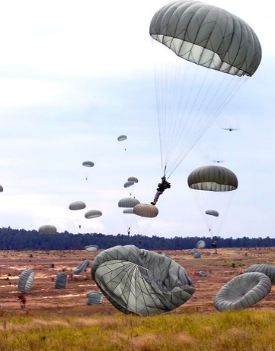
1973-GREECE– NOVEMBER - FROM PARACHUTES TO TANKS-Imagine driving on a country road in a foreign country. Suddenly the dozens of puffy white circular clouds floating in the sky were parachutes with bodies in military attire hanging at the end of long black cords cascading down to the open fields on either side of us.
Sunday evening, Atlanta, Georgia, November 4, 1973. My husband, Norman, and I with Liz and Dick Wilkins, were finally on the plane, flying to Athens, Greece, for an adventurous ten days, exploring the awesome, ancient remains of Greece. Dick, a lawyer, as well as a, Greek historian was the ideal person to be our guide. He had immediately pulled out his old Greek history books and became our guide.
Norman, a southeastern Georgia Phillips 66 distributor was offered yearly trips that included flight, hotel accommodations, car rental, and lots of other travel amenities. When he learned that Greece was that year’s destination, he called Dick who without hesitation said, “Let’s go!” The trip agenda allowed people to take their own side trips, but still be a part of
-2-
Phillips 66 Package group. We would fly together, stay in same hotels, attend certain Greek associated activities, but otherwise, we set up our own agenda and this Dick did.
We landed in Athens around 1:00 Monday afternoon and were bused to our hotel in the downtown area. There we rented our car to be picked up at seven the next morning, settled into our rooms long enough to unpack. We were exhausted from the long flight but we were within walking distance to the National Archeological Museum. We decided that would be a great place for us to start our adventure. There we were able to see the remains taken from the various sites we would be seeing. We retired early and up at 7:00a.m.
By 8:00a.m., coffee, pastries, Greek yogurt in hand we were in our car and headed to Olympia, three and a half hours away. There we will see where the Olympic Games began 3000 years ago in the 8th century B.C.
Once out of the city, the countryside was quite peaceful and scenic with patches of water interspersed with a flat grass ladened pasture terrain. It was at one of these flat land areas that we spotted dozens of parachutes floating down and khaki clad men landing on the grass areas.
-3-
Norman yelled, “Good God, Dick, there are paratroopers landing in the fields. What’s going on?”
“I can see them through my side and rear vision mirror. Holy cow! They’re stopping cars ahead; I hope we can find out what’s going on.”
We stopped. Dick rolled down the window, a military uniformed man asked to see his passport. He informed us that they were just conducting military exercises and not to be concerned.
Driving on Dick broke the tension, “I’m starved. Let’s stop at that store/diner ahead.”
In the store, mostly older men dressed in casual work clothes were sitting around at small tables reading newspapers. They glanced up at us and immediately dropped their eyes back to resume reading. Something was not right. Copies of the local newspapers were laying on a table near us. We decided to grab food and eat in the car while driving. Intuition was telling us the people there were not happy with us.
As the men got Liz and I our drink, chips, and a sandwich I decided to play detective. The newspaper’s front page had pictures of battle ships in
-3-
the Greek harbors. The captions were above in Greek. Remembering the Greek alphabet, I had to learn when I joined a sorority at FSU. The Greek letters indicated that Greece wanted our Sixth Fleet stationed there to protect Greece from foreign invasion to get out. The scouring looks we were getting, identified they suspected we were ugly Americans. We exited, got into the car, and drove on to Olympia. We had no further conflicts, but Greece did.
On November 14, university students began protesting the Greek military forces, causing military intervention. Rioting began. This was the evening we were to fly home. Our plane encountered an accident in route, causing it to be grounded until repaired. We were put on standby. Finally, on November 16, 8:00p.m. we departed unaware of the following.
Later that evening/morning, 2:15a.m., November 17, a government tank crashed through the steel gate of the Athens’ Polytechneio University killing many students.
t

