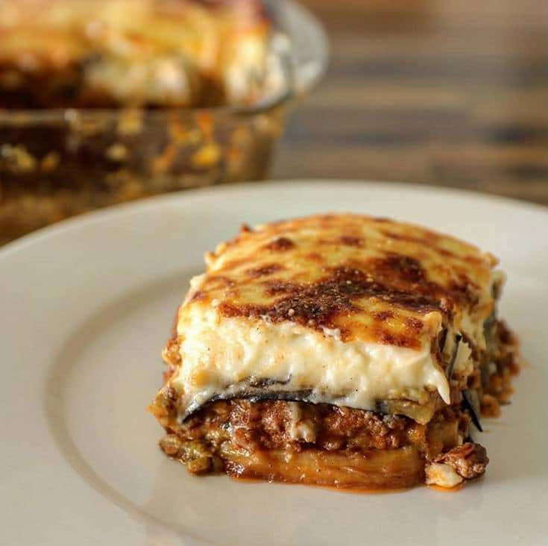
MOUSSAKA
Moo-sah-kuh

My most memorable trip occurred when I traveled to Greece, specifically Athens, then Crete. A favored meal was a Mediterranean dish called moussaka along with a fresh and scrumptious Grecian salad. Moussaka is a baked dish consisting of layers of sauteed slices of eggplant and ground lamb or beef (I prefer lamb. It tasted richer), flavored with tomatoes, onion, olive oil, garlic, and cinnamon. The dish is smothered in a creamy white bechamel sauce. I suspect Americans would use sprinkled grated cheese. Served with a favorite wine. Go for it but watch the high calorie intake.

