Stink Horn Fungi

The shortest trip I ever took occurred in my back yard trying to find the source of a foul-smelling odor detected days ago but couldn’t find out where it was coming from.

Then, one day I walked upon a bizarre looking reddish-orange tongue like shape oozing a black slime that smelled like dead meat. What the hell is that? I had never seen such a plant in my whole life. If I had been a buzzard, I would have flown down to my garden and checked it out. It made me gag.

Turns out it is called stink horn fungi or devils fingers. Branched fingers join at the top of the plant. It attracts insects that lay their eggs in feces. Visitors then spread the spores from the ooze for future germination. The plant arises from egg-like sacs and is related to the puff ball family.

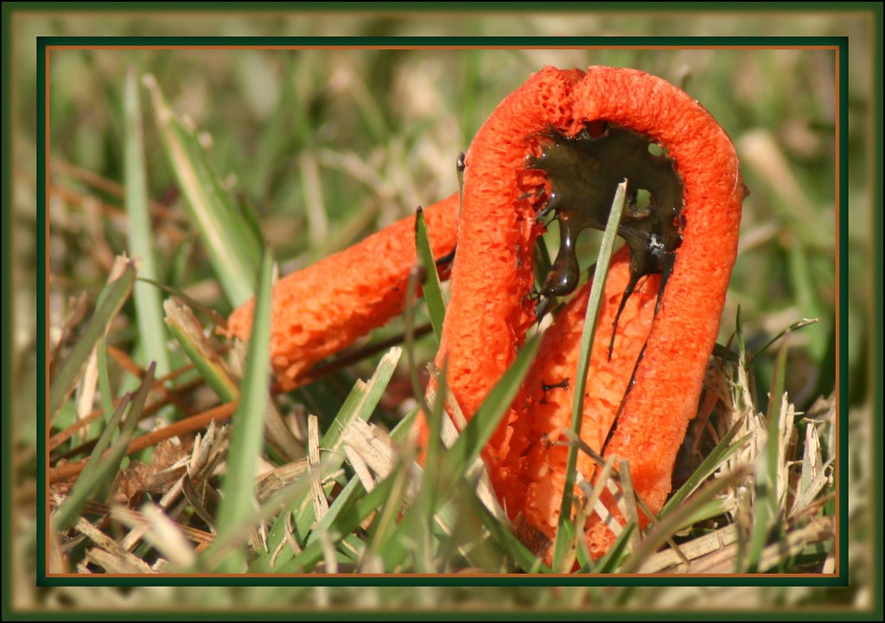
Stink Horn Fungi

