My First Spiritual Pilgrimage – The Grotto at West Bend Iowa 9 12 2022 by Vern Schmitz
As we pull up to the Grotto, I'm amazed and say, "Wow. This is really something."
My first cousin, Ken, fifteen, and I, fourteen, are looking at this impressive work. Ken responds, "Worth the three-hour trip, huh?"
"That's for sure. Can you imagine how much work this would be? We both have picked a lot of rocks from our fields, but this—this is unbelievable."
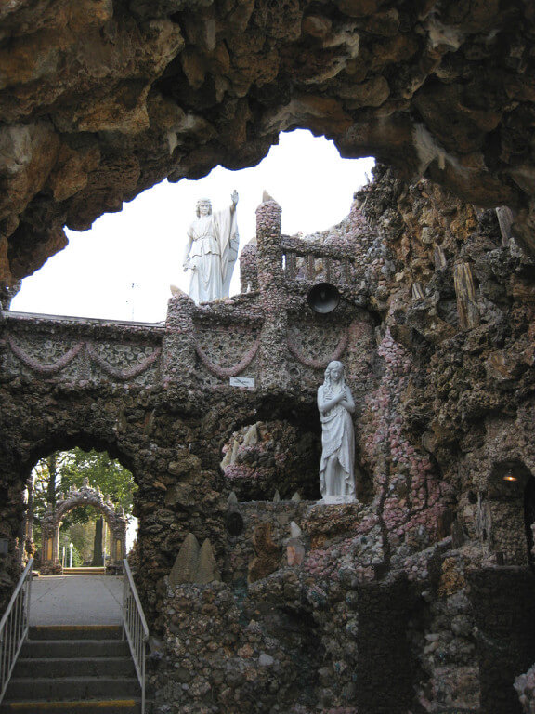
Ken had invited me to come along this Sunday afternoon. It was just four of us teenagers—my first trip out of Minnesota. We only did the necessary work of milking and chores and Mass on Sundays; I had the afternoon free. And because it was a Catholic Pilgrimage site, I was excused from the evening chores. We left soon after the 8:00 a.m. Mass.
I can't remember whose car we were in or who drove. Still, I readily remember the feelings of freedom, no chores until tomorrow morning, and the thrill of leaving central Minnesota and heading straight south to West Bend, Iowa. I had heard of the Grotto but had not expected to get an opportunity to see it. This trip was an exceptional opportunity.
As we continue to take in the immensity of this place, Ken says, "Look at some of these polished stones. Sure is nothing I've ever found in one of our fields."
I continue, "Rocks are nothing but a nuisance—we pick them up by the trailer load and dump them on the fence line—seldom attractive. Maybe an occasional big granite rock, too big to handle, that Dad blasted out of the ground with a few sticks of dynamite, and the pieces had some of the impressive formation patterns we see here. But—these rocks are just beautiful."
We continue to walk through the different grotto areas and the fourteen Stations of the Cross, depicting the final hours of Jesus' life and death, impressed by the beauty of the place. As we step into the cave-like domed grotto of the empty tomb of Christ, I am also struck by the engineering needed to make the entire arched room—ceiling and everything of rocks – no beams. A sense of the sacred came over me.
Most of the stones are of a size that one person could lift into place, but lots of larger ones are not. I'm impressed with the holy dedication of this effort. This grotto reflects decades of persistent hard work dedicated to the love of God and neighbor. This is a holy place.
One of the plaques tells us that Fr. Dobberstein is the origin and inspiration of the Grotto. He came from Germany as a young man and was ordained a priest in Milwaukee in 1897. And within a year was assigned to Saints Peter & Paul Catholic Church of West Bend, Iowa. He was still their pastor in the summer of 1959.
The plaque and some brochures explain how this impressive work came about. When Paul Dobberstein was a seminarian, he almost died of pneumonia and, in prayer, promised the Blessed Mary that he would build a grotto if God spared his life. He recovered. Shortly after his ordination, Fr. Dobberstein accepted an assignment to the West Bend parish, and with the permanence of his ministry, he began collecting stones. Some were precious, others semi-precious stones, from worldwide to keep his promise to Mary.
Fr. Dobberstein's artistic vision and endless building of the Grotto attracted the funds needed to continue the ambitious work. He never kept track of the dollars and hours he and his "good right arm, Matt Szerensce, put into the Grotto, for this was God's work.
On our long trip home, I felt buoyed by my first spiritual pilgrimage, by my encounter with signs of extraordinary dedication to the work of building something that inspires others. And I think I began to develop a rudimentary understanding that my persistent and dedicated efforts on the farm also created something bigger than myself. It, too, was holy work.

