1937 - SOUNDS OF THE OCEAN
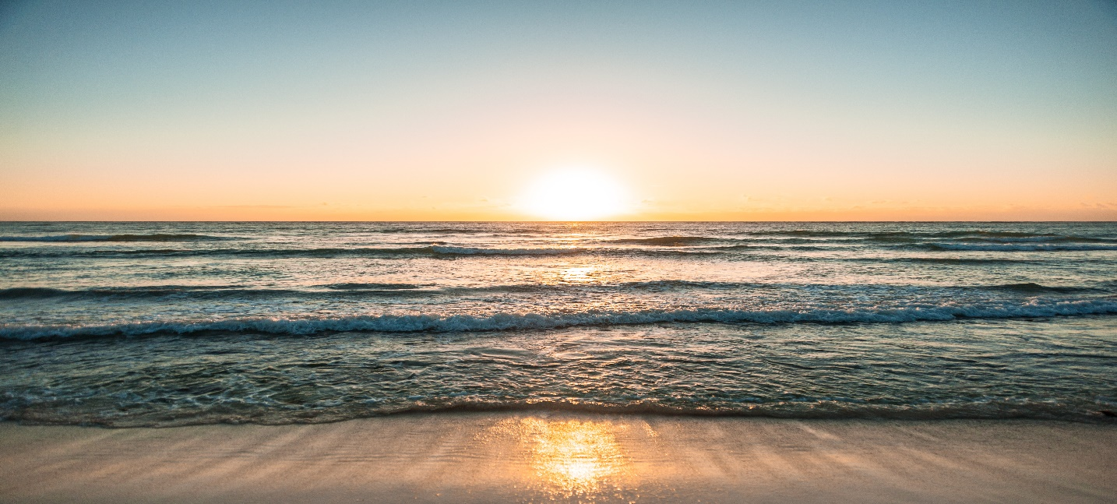
I was five years old and living in Cincinnati, Ohio, when I was first introduced to this magical sound. One day, my father came home from work and announced, “I have a two-week vacation coming up. What say we drive to Miami, Florida? I have old childhood friends living there that have given me an open invitation to stay with them.”
Mother smiled and nodded with that wrinkled frown saying, “Can we afford it.”
I squealed, jumped up and down yelling, “Yes, yes let’s go?” Daddy went on to say, “We can pick oranges and grapefruits right off the trees. But most fun, we will be our seeing and swimming in the ocean. And yes Melba, I have been squirreling away cash, enough for our trip.”
-2-
It was sometime in June, around my June 22 birthday that we pilled in our four-door shiny black car and drove to Florida. I certainly was not looking forward to having to sit in the back seat with my stuffy, critical Aunt Marie who was coming with us. She only liked my boy cousins and was always ignoring or criticizing me. However, I saw a different side of her on this trip. I was surprised when entering the car, she announced as she climbed into the car she pulled me close to her and declared, “We are really going to have fun, Jackie, you and I are going to wade and maybe even swim in the ocean. Aren’t you excited?”
And thus began my first ocean adventure, where I was to learn different ocean sounds and their effects upon me. We spent our first night in Florida in a motel in Sarasota, Florida, a city located on the western part of Florida, where the Gulf of Mexico splashes it gentle waters upon its soft, white powder sugar like sandy beaches. I emphasize white and soft, because the sand off beaches of Miami, were quite the opposite, as was the ocean. The Gulf of Mexico’s waves were gentle and seemed to invite one to lay in the surf and be soothingly caressed and massaged by this healing salt water. The Atlantic Ocean, perhaps due to its vast expanse of
-3-
its size, stretching eastward to its European continents. It was somewhat intimidating, very forceful in its demeanor.
Miami is located quite a distance south of Sarasota and on the eastern side where the immense Atlantic Ocean seemed to ‘crash’ its rougher waters on very coarsely ground light brown sandy shores. The waves there seemed determined to knock us down letting us know they were the boss. Even the salt fumes vaporizing up and outward from the waves, had a different smell, more intoxicating and more cleansing.
My father’s feelings, I’m sure set me on the ocean air cleansing path for life. I remember the first time that trip that we approach the ocean in Sarasota, my father exclaiming, “Wow, how relaxing this ocean and it’s air is. I feel like a new person and really ready to face life’s challenges.”
My gentle spirited father was even more exhilarated on the beaches of Miami, where the waves seemed to be bigger and fiercer. This was where we would move three years later for three years and later, fifteen years to be exact, for his life.
My life eventually took me to the beaches, farther north, to St. Simons Island. There, I learned to walk barefoot and loose haired on the sands of
-4-
the beach twelve months of the year, rain, snow, sun and all kinds of weather. There I learned to inhale the smells of that salt air. There I learned to clear good and bad cobweb out of my head and body that try to stifle one’s life. There
The sound of the ocean, whether it is calm, slow-rolling and self-contained, or rough, thrashing, and angry, is a sound that can soothe my frazzled mind and body. As it rolls softly or roughly onto the sandy beaches brings a beautiful finality to whatever is weld up in me. As the salty mist-like fragments that it throws into the air and engulfs our senses seems to wash away all the cobwebs that clutter up brain.

