1937 - SOUNDS OF THE OCEAN
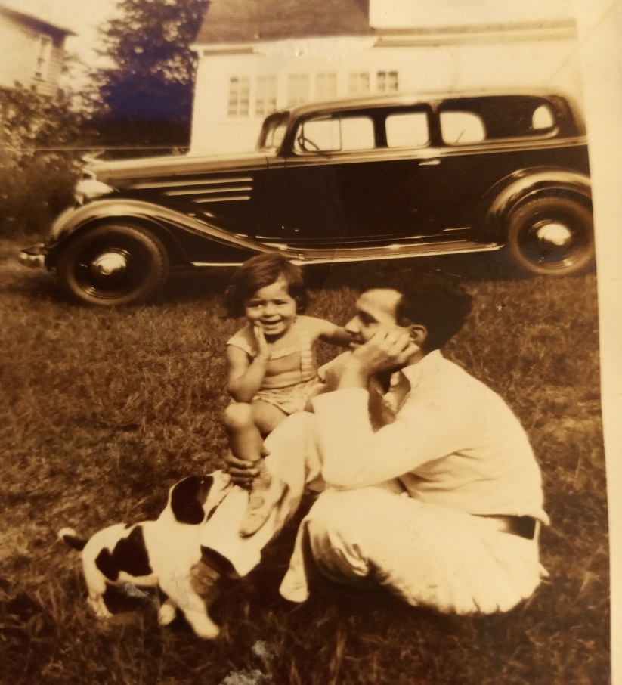
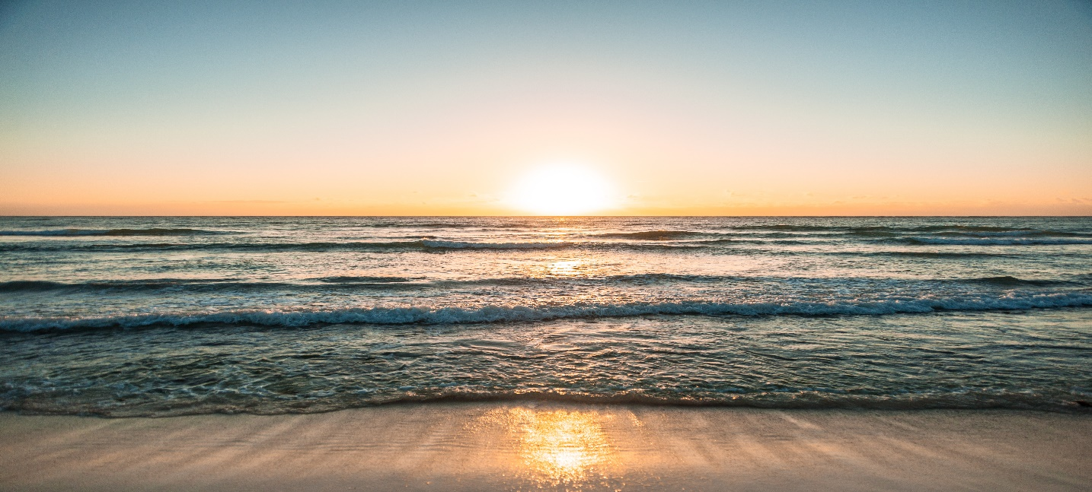 I was five years old and living in Cincinnati, Ohio, when I was first introduced to this magical sound. One day, my father came home from work and announced, “I have a two-week vacation coming up. What say we drive to Miami, Florida? I have old childhood friends living there that have given me an open invitation to stay with them.” Mother smiled. With a wrinkled frown she responded, “Can we afford it?” I squealed, jumped up and down yelling, “Yes, yes let’s go?” Daddy went on to say, “We can pick oranges and grapefruits right off the trees. But most fun, we will be our seeing and swimming in the ocean. And yes Melba, I have been squirreling away cash, enough for our trip.
-2- It was sometime in June, around my June 22 birthday, that we climbed in our long shiny black 1932 Chevrolet, comfortably accommodated the four of us, and drove to Florida.
I certainly was not looking forward to sitting next to my stuffy, critical Aunt Marie, who was coming with us. She only liked my boy cousins and was nasty to me. However, as we climbed into the car, a different side of her a different side of her appeared.
To my utter amazement, Aunt Marie pulled me close to her and joyfully declared, “You and I are really going to have fun, Jackie. We’re going to wade and maybe even swim in the ocean. Aren’t you excited?”
And thus began my first ocean adventure, where I was to learn different ocean sounds and their effects upon me. We spent our first night on the beach in Sarasota, Florida, a city located on the western part of Florida, There the Gulf of
-3-
Mexico splashes it gentle waters upon its soft, white powder sugar like sandy beaches. I emphasize white and soft, because the sand off beaches of Miami, where our destination was Miami, were quite the opposite, as was the ocean. The Gulf of Mexico’s waves were gentle and seemed to invite one to lay in the surf and be soothingly caressed and massaged by this healing salt water. The Atlantic Ocean, with its vast expanse of the entire eastern spans of the United States, stretching eastward to the European continents. It was somewhat intimidating, very forceful in its demeanor.
Miami is located quite a distance south of Sarasota and on the eastern side where the immense Atlantic Ocean seemed to ‘crash’ its rougher waters on very coarsely ground light brown sandy shores. The waves there seemed determined to knock us down letting us know they were the boss. Even the salt fumes vaporizing up and outward from the waves, had a different smell, more intoxicating and more cleansing.
My father’s feelings, I’m sure set me on the ocean air cleansing path for life. I remember the first time that trip that we approach the ocean in Sarasota, my father exclaimed, “Wow, this ocean and its air is so relaxing. I feel like a new person and ready to face life’s challenges.”
4-
My gentle spirited father was even more exhilarated on the beaches of Miami, where the waves seemed to be bigger and fiercer. Miami was where we would move three years later, for three years, move back to Cincinnati for six years, when we would move back to Miami until his death.
My life eventually took me to the beaches, farther north, to St. Simons Island. There, I learned to walk barefoot and lose hair on the sands of the beach twelve months of the year, rain, snow, sun, all kinds of weather. The sound of the ocean, whether it is calm, slow-rolling, and self-contained, or rough, thrashing, and angry, is a sound that can soothe and cleanse my frazzled mind, and cleanse the garbage locked up in my body. Walking barefoot on those sandy beaches, I seem to physically exit a lot of stored up garbage. Also, from the footprints, I could tell whether there are one set of prints where the Lord is carrying me, or two sets where we are walking side by side. This footprints in the sand philophy came from the poem, Footprints in the Sand.

