Kindred Spirits
Steven Weisberg
5-18-2023
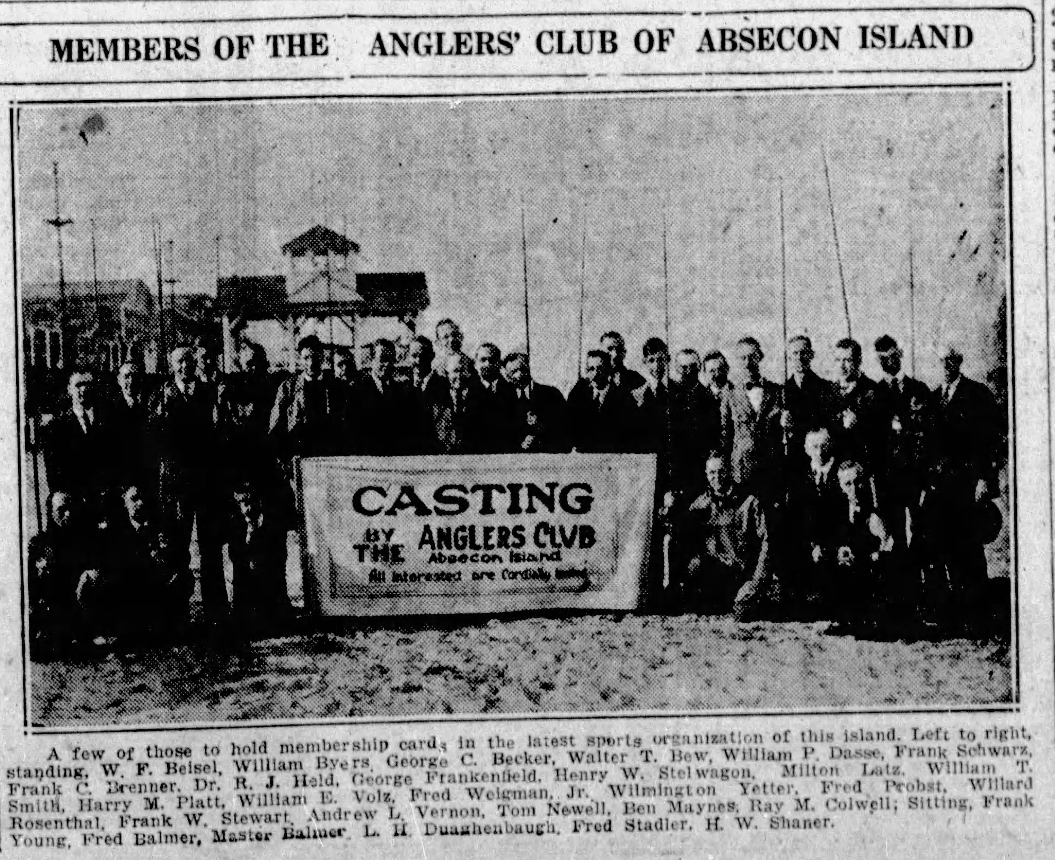
Photo courtesy of the Atlantic City Press – April 9, 1923

A child of the atomic age, I was a devout Mouseketter. Every afternoon after school, I commandeered our black and white tube TV to “come along, sing the song and join the jamberee” in the Official Mouse Clubhouse. I connected most with Cubby and Tommy but secretly liked Darlene and Annette even more. At the end of the show, I hated to say goodbye, but, I’d make sure I’d see them real soon. Why? Because as Jimmy said, “We like you”. And, if Darlene and Annette REALLY liked me, well maybe showing up again real soon would mean Darlene and Annette might like me even more. It left a lasting impression. The Mickey Mouse Club kids showed me that a clubhouse is a place where… ”you’re as welcome as can be”.
Tube TV’s gave way to transistors then chips; atomic went nuclear and all of it digital. In September 2020, when I visited my brother Max at the Anglers Club of Absecon Island, I experienced comradery of kindred spirits inside an actual, real-life, clubhouse.
From the outside, tall slats of a secured wood gate protected a well maintained shack on the beach. Once through its doors, its nautical wood essence embraced me with its welcoming warmth. Windows opened; shore breezes whisked away telltale traces of stale musky air. I shuffled in my sandals along the seams of the white oak hardwood floor, the panels aligned and buffed to highlight the light brown coloring of its smooth grain. The walls were paneled with dark rustic timber with smoothed knotholes retaining old wood charm and character. It felt like a classic beach house with the welcoming warmth of a family-run guesthouse.
I plopped my laptop bag on an empty rounded mahogany card table, sliding the straight slatted-back mahogany chair out of the way. It was a big chair for a large person, first class seating for long nights of social gambling. Telltale scars, gouges or ash burns from cigars on the armrests were muted by wood stain. The damage though from age and use, like windswept facial wrinkles, gave it character. Unburdened of my stuff, whatever tension I carried was released to the wind to be replaced by unstructured seashore decompression.
I set up my laptop and arranged the hodgepodge of notebooks, random scraps of paper with ideas, sayings, and expressions collected over time hoping to summons the muse of inspiration and reflection. The clubhouse provided a sanctuary of quiet seclusion for the deep introspection I wanted. Occasionally though, a creak from the weather-worn wooden bones of the building produced an arthritic groan, serving as a subtle reminder for me to get up from the chair stretch my body.
It was Indian summer with sumptuously delicious warm days of early fall. It portended the approach of harvest season. In recalling the stories of old Atlantic City and its places and cockeyed characters, newly or long gone, I felt I was harvesting my memories, hoping to gather as many as I could while they remained ripened for recall. I’d always regarded myself as an eternal teenager in spirit, youthful and invincible, but as my body creaked like the clubhouse, my mental jukebox hit the Age 70 button which cued up and played Frank Sinatra’s September of My Years.
In the days and weeks that followed, as uncertainties of covid mushroomed into a virulent boogeyman, I found solace in the past. In the clubhouse on the beach, my mind dove inward and backward in time. My head was buried in retrospective sand.
I walked around the clubhouse, studying adornments on the wall; pictures of men holding fish the size of an infant; a nameplate of remembrance for past club presidents; poems about fishing, photography of the Pier, a tapestry of Margate City landmarks, and a large plaque dedicated to H. Willard Shaner, founder of the club in 1923; For the Glory of the Sport prominent under his name in bold capital letters.
On a late afternoon as the air was cooling quickly, the sun set brightly from a southern and westerly angle. It illuminated the pier with a golden hue, bathing it in orange and yellowish gilded light. In the chair in front of my laptop, my eyes were drawn through the front window to a rich luster of color which appears only at this time of year. Like a hypnotist mesmerizing a subject, I followed the light along the stretch of the pier; where sand meets the shore to where sea meets sky and sky dissipates into the expanse of infinity. I marveled at the view; its timelessness and still-life tranquility.
I stood up completely stilled, silenced and absorbed. I couldn’t tell if I was breathing or not; I may have become invisible. I melted into the moment; of feeling connected to something pure and eternal. In pinball speak, “all the specials were lit”.
In a Nano-second that lasted no more than the time a firefly glows at dusk, I realized, men before me and those that will follow both knew and will discover this spot, at this time, and experience the same vision of universal connection. With crystal clarity, I understood H. Willard Shaner’s For the Glory of the Sport transcended conquest of catching big fish; it ran deeper, more intimately to the awareness of oneness with sand, sea, sky, air, and fire from the sun.
My body warmed then shivered. I peered over to those names on the wall, the elders who stood before me on this spot and passed along these wooden floors over nine decades.
Through stilled silence, they spoke, Welcome to The Anglers Club of Absecon Island.
In a small sliver of heaven on earth and through the sport of fishing, I experienced an image, its sensation and the meaning of glory.
