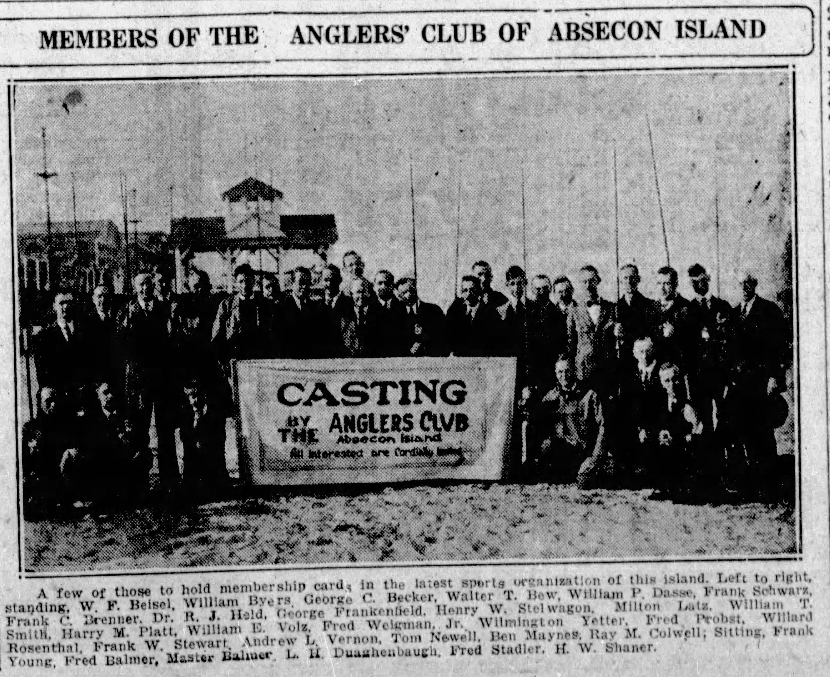
Photo courtesy of the Atlantic City Press – April 9, 1923

A child of the atomic age, I was a devout Mouseketter. Every afternoon after school, I commandeered our black and white tube TV to “come along, sing the song and join the jamboree.” My favorite kid’s show taught me a lifelong lesson. For Mouseketeers everywhere, a clubhouse is a place where… ”you’re as welcome as can be”.
Atomic went nuclear and all of it digital. Tube TV’s gave way to transistors then chips. My mouse ears now sport airpods.
In September 2020, I visited my brother Max at the Anglers Club of Absecon Island, its ninety-seven year old wooden clubhouse a sanctuary of quiet seclusion and deep introspection. It was Indian summer; sumptuously warm days of early fall portended the arrival of harvest.
I’d always regarded myself as an eternal teenager in spirit, youthful and invincible. Now, as my seventy-something body creaked like the clubhouse, I felt the urgency to harvest my memory, and gather stories of the old Atlantic City I once knew; its famous landmarks along the Boardwalk and the array of summer-season cockeyed characters as numerous as broken shells on the beach.
From the outside, it was a well-protected shack on the beach. Windows opened; shore breezes whisked away telltale traces of stale musky air. Through its doors, its nautical wood essence and aroma seduced me. It looked like a non-descript beach house with the welcoming warmth of a family-run guesthouse. Seams of white-oak hardwood flooring were tightly aligned and buffed. The light brown coloring of its smooth grain complemented paneled walls of dark rustic timber with smoothed knotholes retaining old wood charm and character.
I plopped my laptop bag on a rounded mahogany card table, sliding a heavy, slatted-back mahogany chair out of the way. A big chair for a large person, it offered first-class seating comfort for long nights of social gambling. Its telltale scars, gouges and ash burns were muted by dark wood stain. But, the damage gave it character.
Sea air had always provided that secret elixir to summons my inner muse of inspiration, one that atrophied in covid lockdown and had grown as flaccid as my arms had gone weak. Sifting through my composition notebooks of randomly scrawled hieroglyphics of ideas, sayings, and expressions collected over time, I’d hear an occasional creak from the weather-worn wooden bones of the building. In the quiet, it produced an arthritic groan, serving as a non-too-subtle reminder for me to get up from the chair and stretch my own creaky bones.
I walked about the clubhouse, studying adornments on the wall; pictures of men holding fish the size of an infant; nameplates of remembrance for past club presidents; poems about fishing, photography of the Pier, a tapestry of Margate City landmarks, and a large plaque dedicated to an H. Willard Shaner, founder of the club in 1923; For the Glory of the Sport prominent under his name in bold capital letters.
On a late afternoon as the air was cooling quickly, the sun set brightly from a southern and westerly angle. It illuminated the pier with a golden hue, bathing it in an orange and yellowish gilded light. Hypnotically, my eyes were drawn through the front window to a rich luster of golden color which only appears in Indian summer. I followed the light along the stretch of the pier; from where sand meets the shore to where sea meets sky and sky dissipates into the expanse of infinity and beyond.
I couldn’t tell if I was breathing and may have become invisible. I melted into the moment, of feeling connected to this still-life imagery; radiant and pure, eternal and timeless.
In a Nano-second lasting no more than the glow of a firefly at dusk, I realized, men before me stood on this spot, at this time of year, and were similarly transfixed. With crystal clarity, H. Willard Shaner’s, For the Glory of the Sport, assumed significance beyond conquest of big fish. It spoke to a quiet oneness with the elements of sand, sea, sky, air, and fire from the sun.
I glowed then shivered and peered over to those names on the wall. These were the elders who over nine decades, stood before me on this spot and passed along these same wooden floors.
In stilled silence, I heard Welcome to The Anglers Club of Absecon Island.
How ironic, while looking deeply inward for meaning, I looked away for a moment and experienced glory.
