OCTOBER 2001 – OH, MY GOD NO, IT CAN’T BE
By Jackie Raymond
As I opened the door to get in the car, my husband, Norm was sobbing and uttering loud guttural sounds, then, “Oh my God! No, no, it can’t be, he can’t be dead.
Jumping back from the open door, I screamed!
“Ron, Shirley,” I screamed, “come quick, hurry, something horrible has happened.” Norm’s brother and sisters-in-law were in their car waiting for Norm and I to get into our car and follow them to a restaurant. They turned off their car, hopped out and ran towards us. Some of the others in their group did likewise.
Ron ran to Norm’s side of the car and opened his car door. Norm was being told about the horrible car accident that had occurred around noon in south Texas. Our daughter Dawn, son-in-law Ron, two grandsons, seven-year-old Ryan, and two-year-old Tyler were returning from Ryan’s first swimming meet, thirty miles from their home when the accident occurred.
-2-
Norm again crying out, “No! that can’t be, my little Ryan dead, burned to death. Oh, my God.”
Ryan had a swimming meet that morning in Harlingen, Texas, fifty miles east of McAllen and as the four of them were returning home to McAllen to celebrate Ryan’s seventh birthday, the accident occurred.
Their 1996 Land Rover had the rubber on one of its tires detach, go flat, causing the car to go out of control. Ron who was strong, a weight-lifter and Marathon runner, was able to pull the car to the right averting a head-on collision with oncoming cars from the left lane. However, that sharp pull to the right, caused the car to flip, roll sideways and eventually roll sideways over a three-foot metal barrier wall finally settling passenger side down. To add to the tragedy, sparks spuing forth from the rolling car ignited the gas in the gas tank, located under the passenger side, resulting in flames and smoke.
-3-
The smoke caused Dawn, sitting in passenger seat and who was asthmatic, to have a breathing attack. Panicking she screamed: “I can’t breathe, my legs are burning! I must get out.” That caused her to urgently seek air. Unhooking her seat belt, she scrambled upward over her husband who had been driving, to get air. As she reached the open window, she realized she had not turned backward to make sure Ryan had released himself which he could do, but had not. Small flickers of flames started to appear under Ryan’s seat. She and Ron saw what was happening at the same time. Ron pushed Dawn out of his window, and she fell seven feet to the ground below.
Ron quickly turned, managed to break the back door window, (details have never been told) crawl in over Tyler, the two-year-old strapped into his car seat and grab Ryan’s hand. Ryan seemed to be in shock.
“Unhook your seat belt, Ryan,” Ron yelled -- NOTHING
-4-
Tyler was in the way, so he released Ryan’s hand, unhooked Tyler, grabbed him out of his car seat and dropped him below to Dawn. He then turned back to get Ryan’s hand. Too late!! Ryan, engulfed in flames, burned before daddy’s eyes. A sight, to this day, twenty-two years later, Ron cannot erase from his eyes or mind. Dawn, likewise, cannot forgive herself for thinking of
herself and not helping her beloved Ryan.
Ron, Dawn, and two-year old Tyler had to be airlifted to Dallas, Texas, which was the closest Burn hospital were both children and adults were treated. Ryan’s remains were placed in a morgue somewhere between McAllen and Harlingen, Texas. A month later, when Ron, Dawn and Tyler were released from the burn hospital in Dallas and back in McAllen, my oldest, sweet grandson was cremated. I from Orlando, arranged his funeral

-5-
service in McAllen, Texas, at their Catholic Church where I had sung in the choir when we lived there for ten years.
Norm and I were frozen in time and unable to move. Some how we ended up in the back seat of our car with Ron driving us to Miami to their house where we could assimilate the happening and make plans. It’s still a blur. We had come to West Palm Beach, Florida, from Orlando to celebrate Ron’s and Shirley’s Wedding Anniversary. Thank goodness we had planned to spend the night at their home in Miami. We were unable to drive.
Below is our beloved Ryan who we know is one of God’s angels. He now has a Burn Foundation out of Alabama called Ryan Shines which he did and still does.

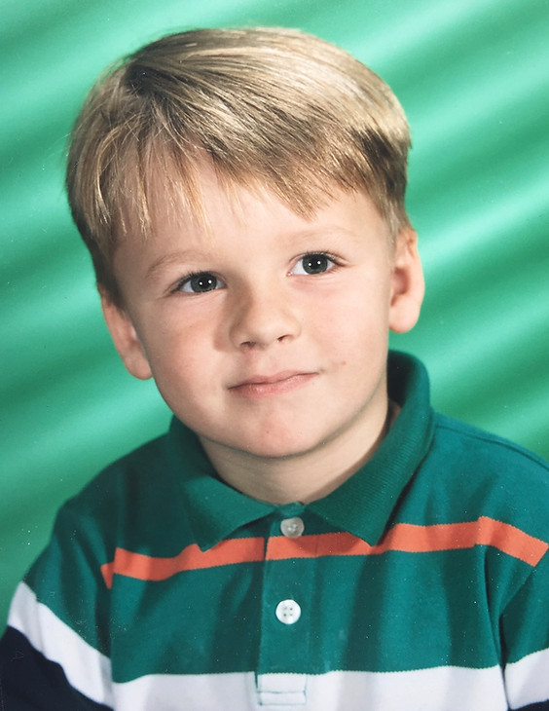
-6- The foundation helps other burned children Nationwide. I love you, sweetheart.

