The Flood
The spring of 2022, especially April, was snowy and wet here in the Beartooth Mountains of Wyoming and Montana. Tim and I left for a much-needed vacation on April 8th. The entire time we were gone it snowed almost every day at the ranch. May was extra soggy as well. Memorial Day weekend the Beartooth Mountains received record snowfall. Dead Indian Pass got 3 feet. Some areas over the Beartooth’s got over 6 feet. The Park (YNP) got their share of wet, heavy snow too.
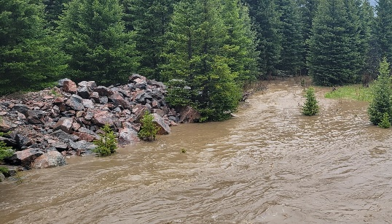
June 5th, the Clarks Fork River, which runs through the ranch was busting through its banks. My small evergreen tree that I use as my gauge to keep track of how high the river is, is just starting to go under water.

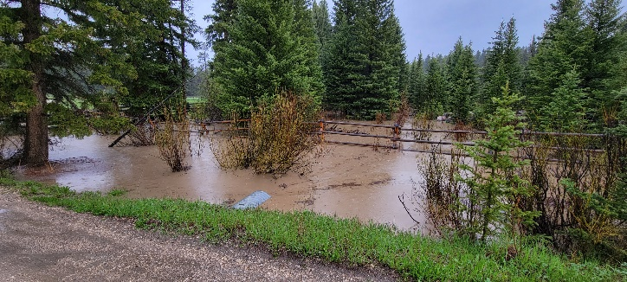
Saturday, June 11th it rained hard all day. Sunday, June 12th rained hard all day again. We went to the river multiple times just to see how much it was rising. The river is starting to flood the area where the culvert runs under the driveway. The culvert is still working though, just a lot of water trying to go through it. We can start to see the river rising by the minute.

Crazy Creek, a tributary to the Clarks Fork, is roaring and almost coming up over the bridge it’s just a foot under the bridge. Linda, one of the ranch owners is here from North Carolina and driving a rental BMW. Jimmy, our ranch hand, is here with his small truck, Emma, our wrangler, is here with her small car, Chris, our fencer, is here with his brand-new truck. About 9:00 pm I had a crazy thought and insisted that everyone drive their vehicles over the bridge to the other ranch across the river from us. I figured if it started to flood here, we could get people over to the other ranch with a 4-wheel drive truck so they could drive out at least. I never imagined that night what was about to happen…would happen.

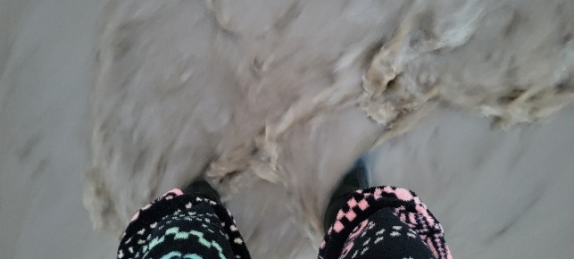
It was 4:30am, Monday, June 13th, something woke me up. Probably the sound of the rushing river from our open bedroom window. It was still fairly dark out, so I shone my flood light out onto the horse pasture. All I could see was the shimmery glow of water from my light. I walked to the top of our hill and looked down on a lake of water flowing through the pasture, the river had exploded. Our horses were down there. At first, I couldn’t see them. I looked as far right as I could and got a glimpse of them standing on the only non-flooded area.
I got Tim and said we need to get the horses to higher ground. So, we trudged through the water wearing our green boots and me in my fleecy sweatpants.

We got to the horses who were a bit spooked by us approaching them on one side and rushing water on their other side. We walked them to the upper pasture. We drove out and checked on the other herd of horses and they were safe and not in harm’s way. At 5:20am we drove to where the water was flowing through the pasture. We got out of the car and walked down the driveway towards the river. The water splashed against my green boots just inches from going in. Tim was ahead of me and got to the bridge first, I was just trying to stay upright while walking through the running water. The roar of the river was too loud for me to hear what Tim said as he turned around towards me. He mouthed…it’s gone. What? What’s gone? What do you mean? He yelled louder “Geri, the bridge is gone.” I had to see for myself, so I walked up the slight slope to the edge of the bridge. Never in my life have I ever felt quite like I did in that moment. I felt completely stranded, unable to get “out” …this is our only way off the ranch. Surreal. The bridge was still there but the other end was twisted and completely in the river that was gushing brown, violent water over it. Large trees were starting to jam up against it. I turned around and headed back to the car. The water we trudged through just a few minutes earlier was already running harder. I felt dizzy and tried hard to keep from falling in.
