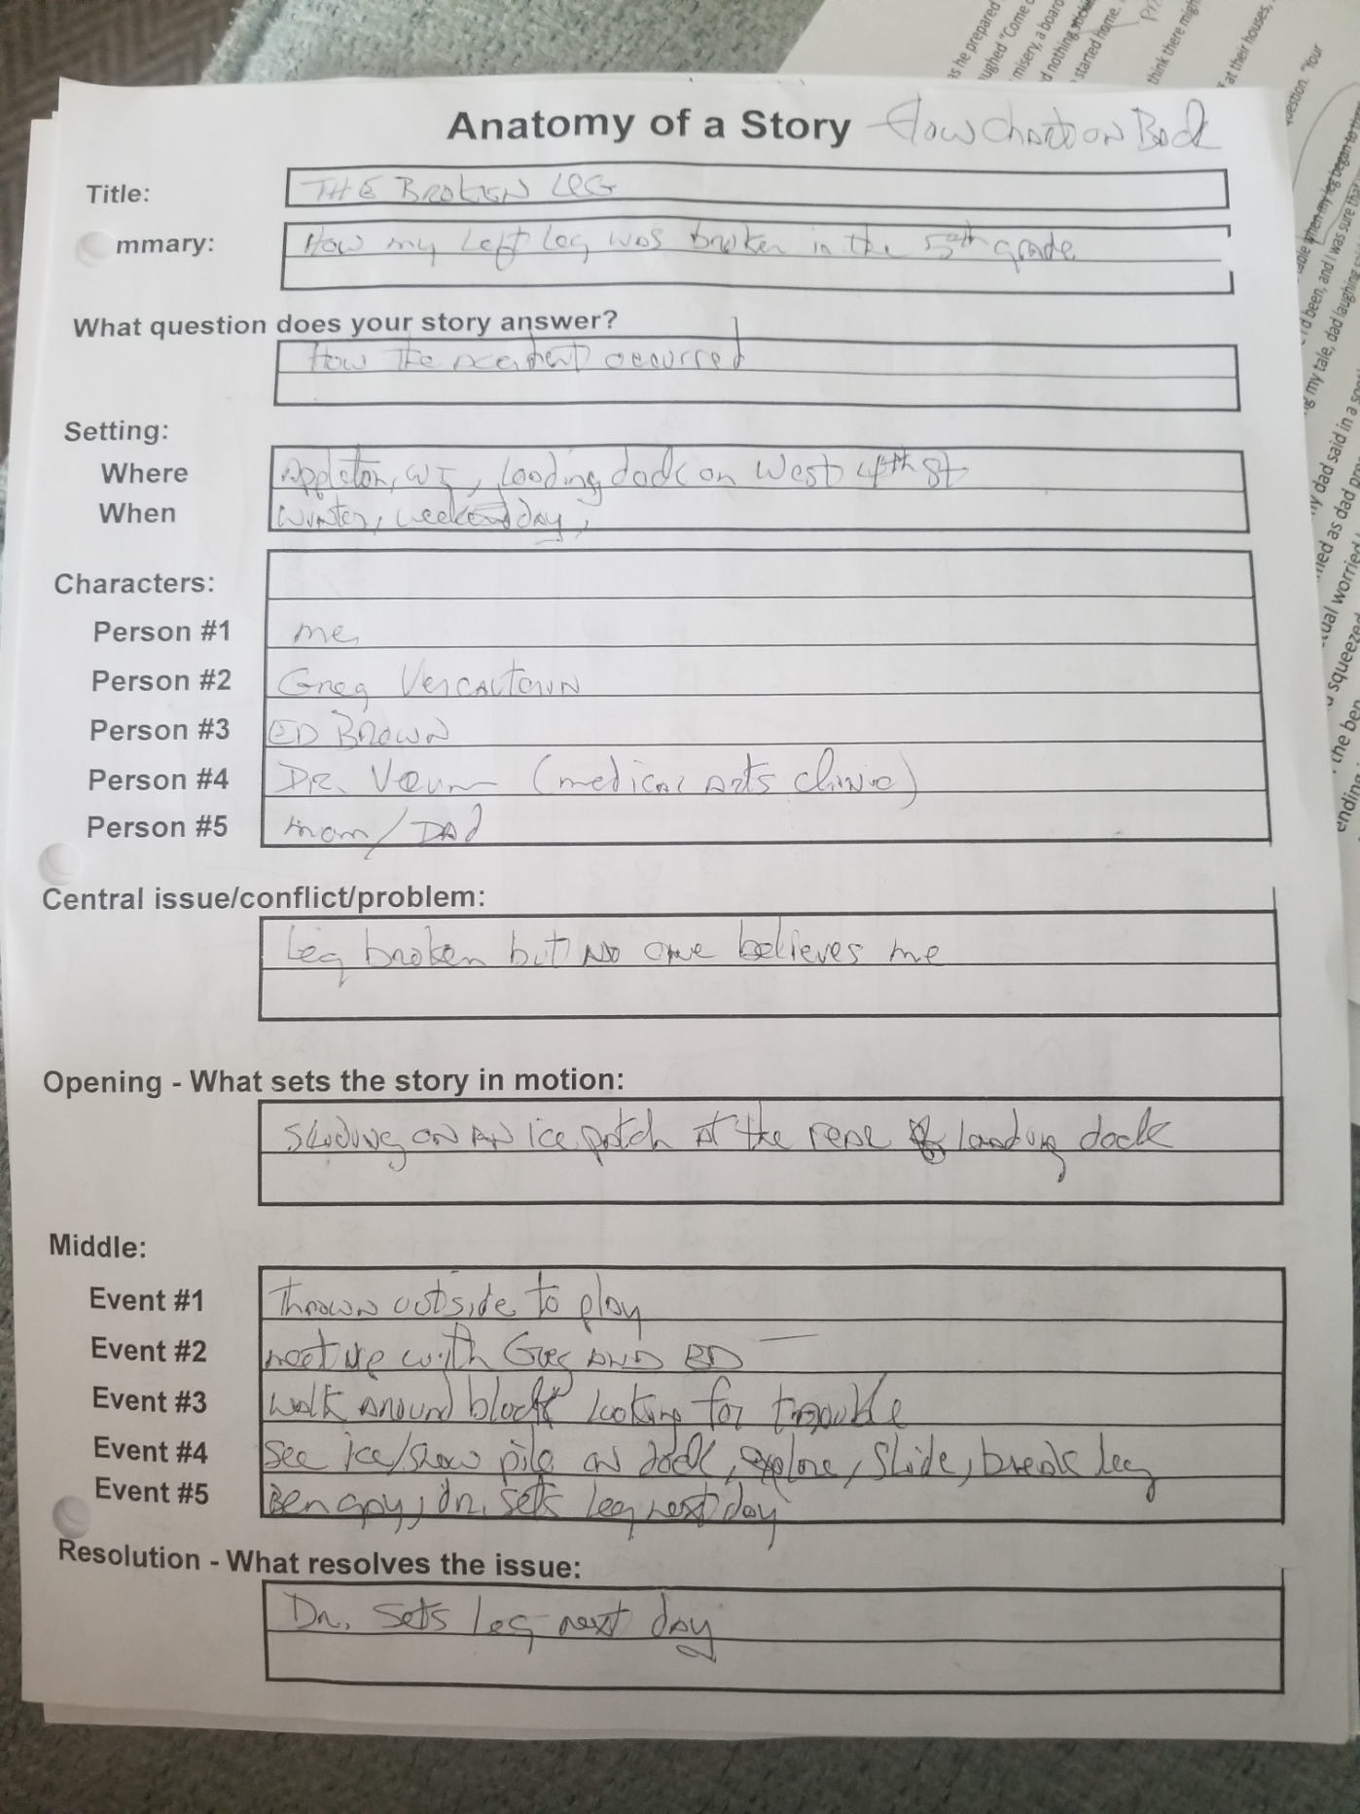
Figure 1: Anatomy
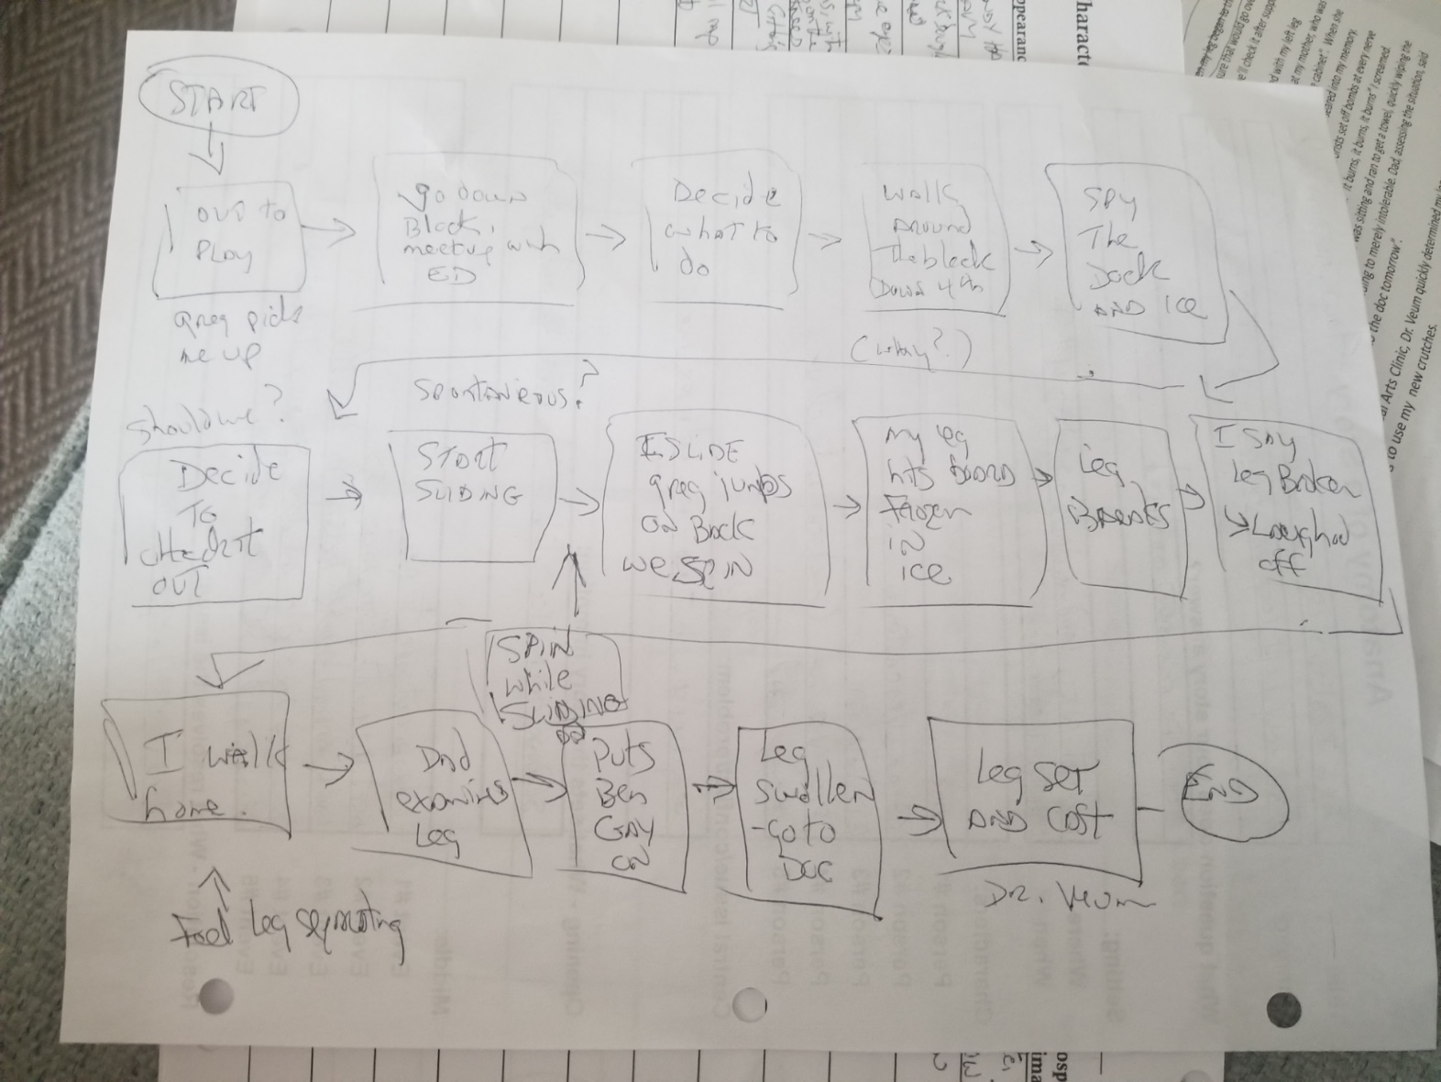
Figure 2: Flow Chart (on back of anatomy)
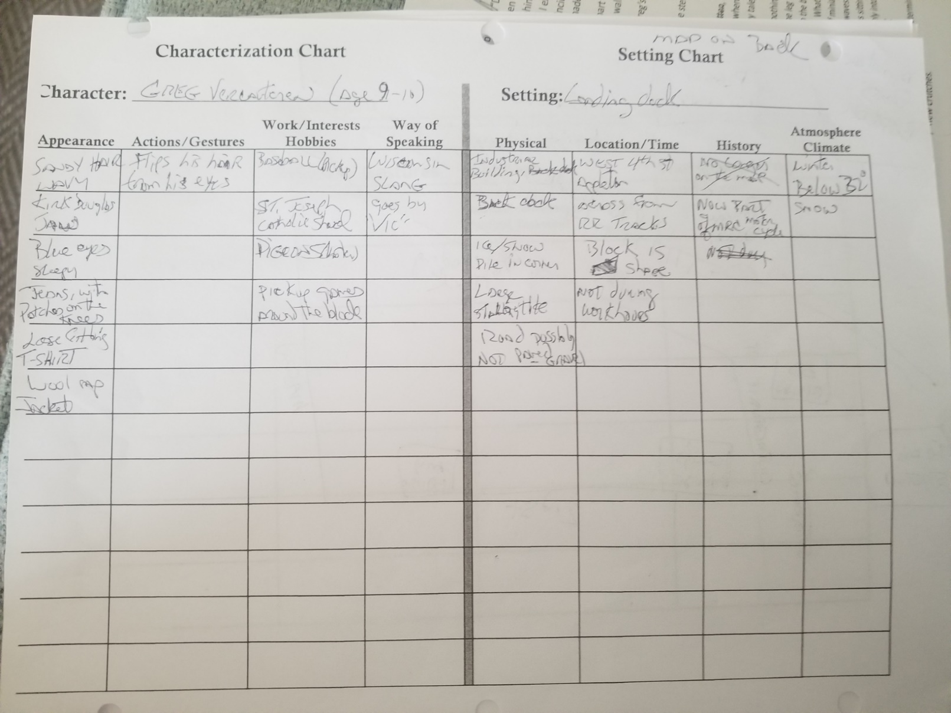
Figure 3: Setting and Characterization (Greg)
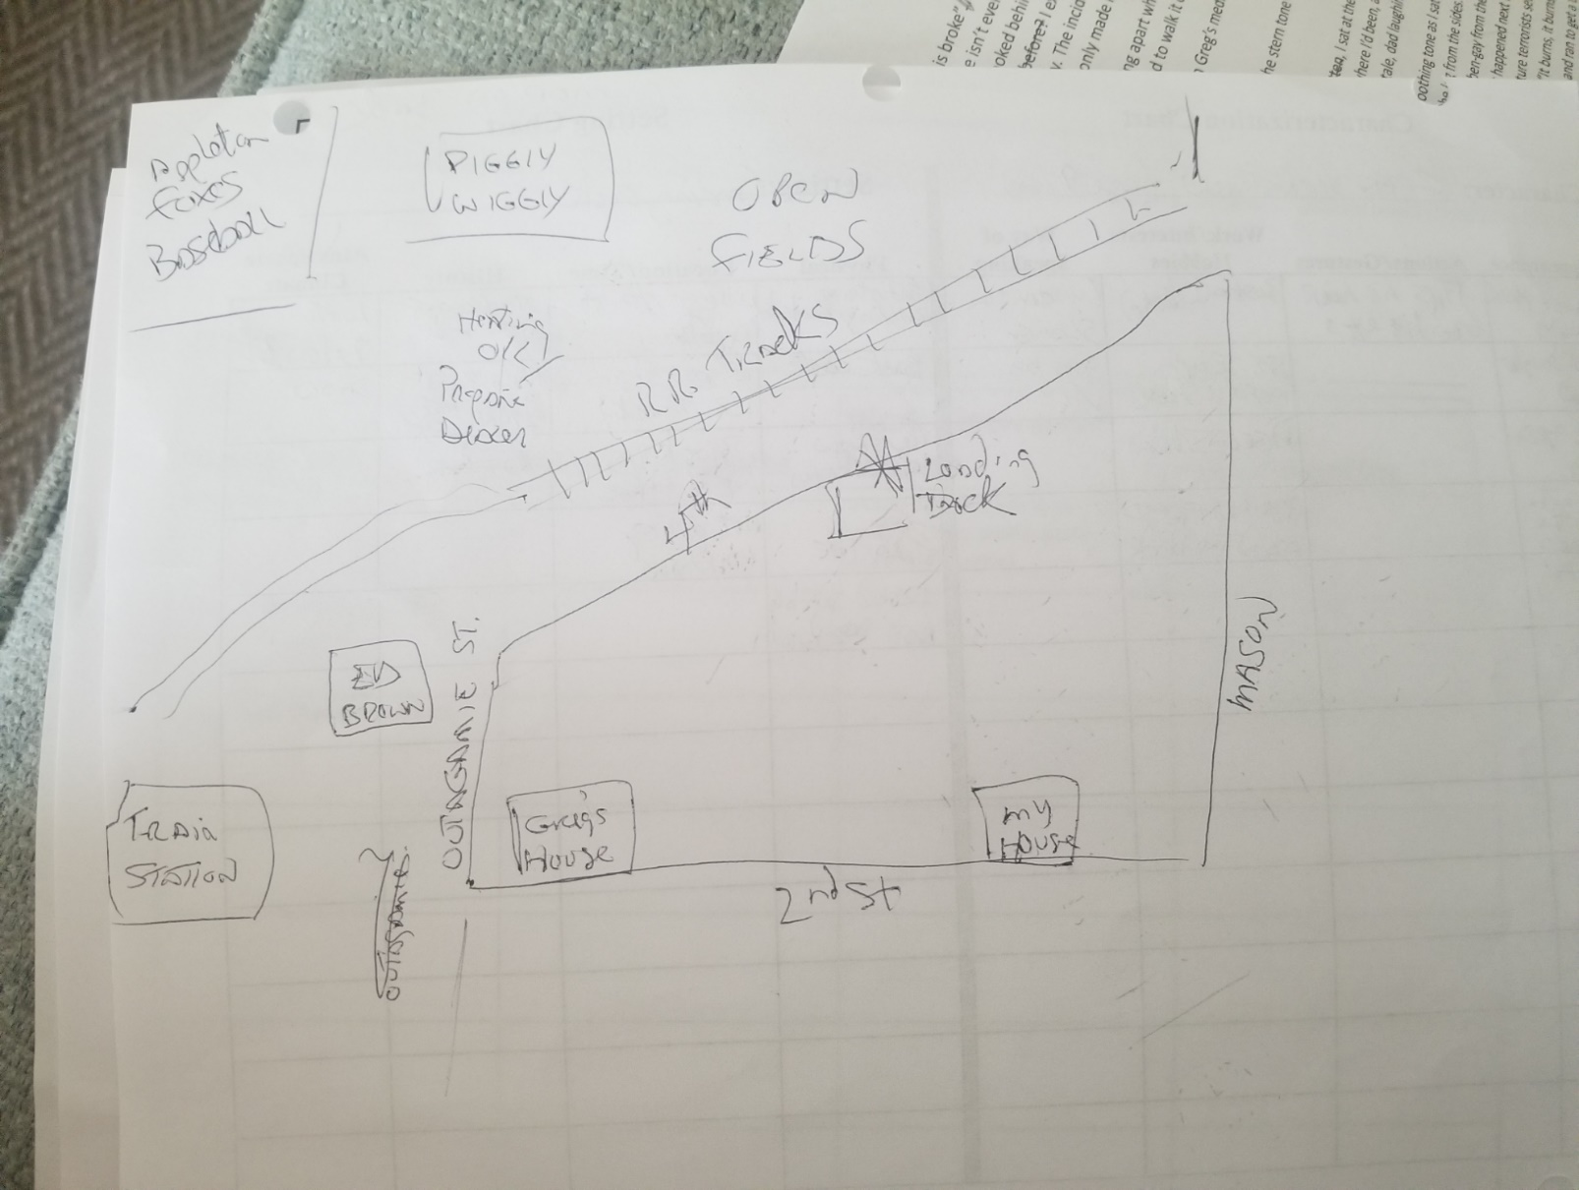
Figure 4: Map (back of setting chart)
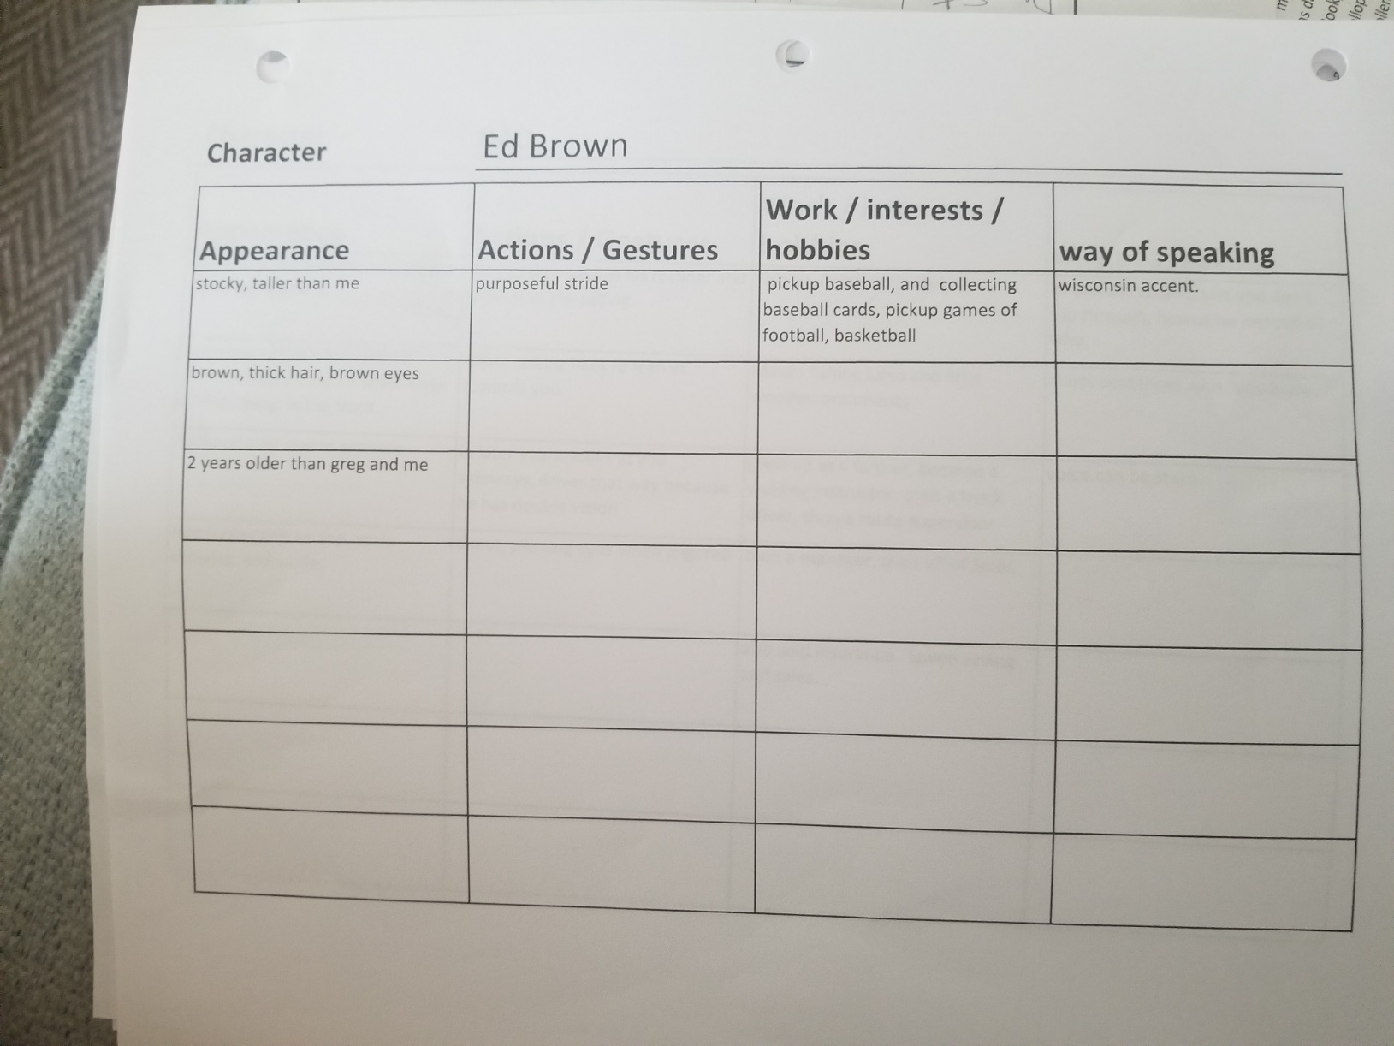
Figure 5: Characterization, Ed Brown
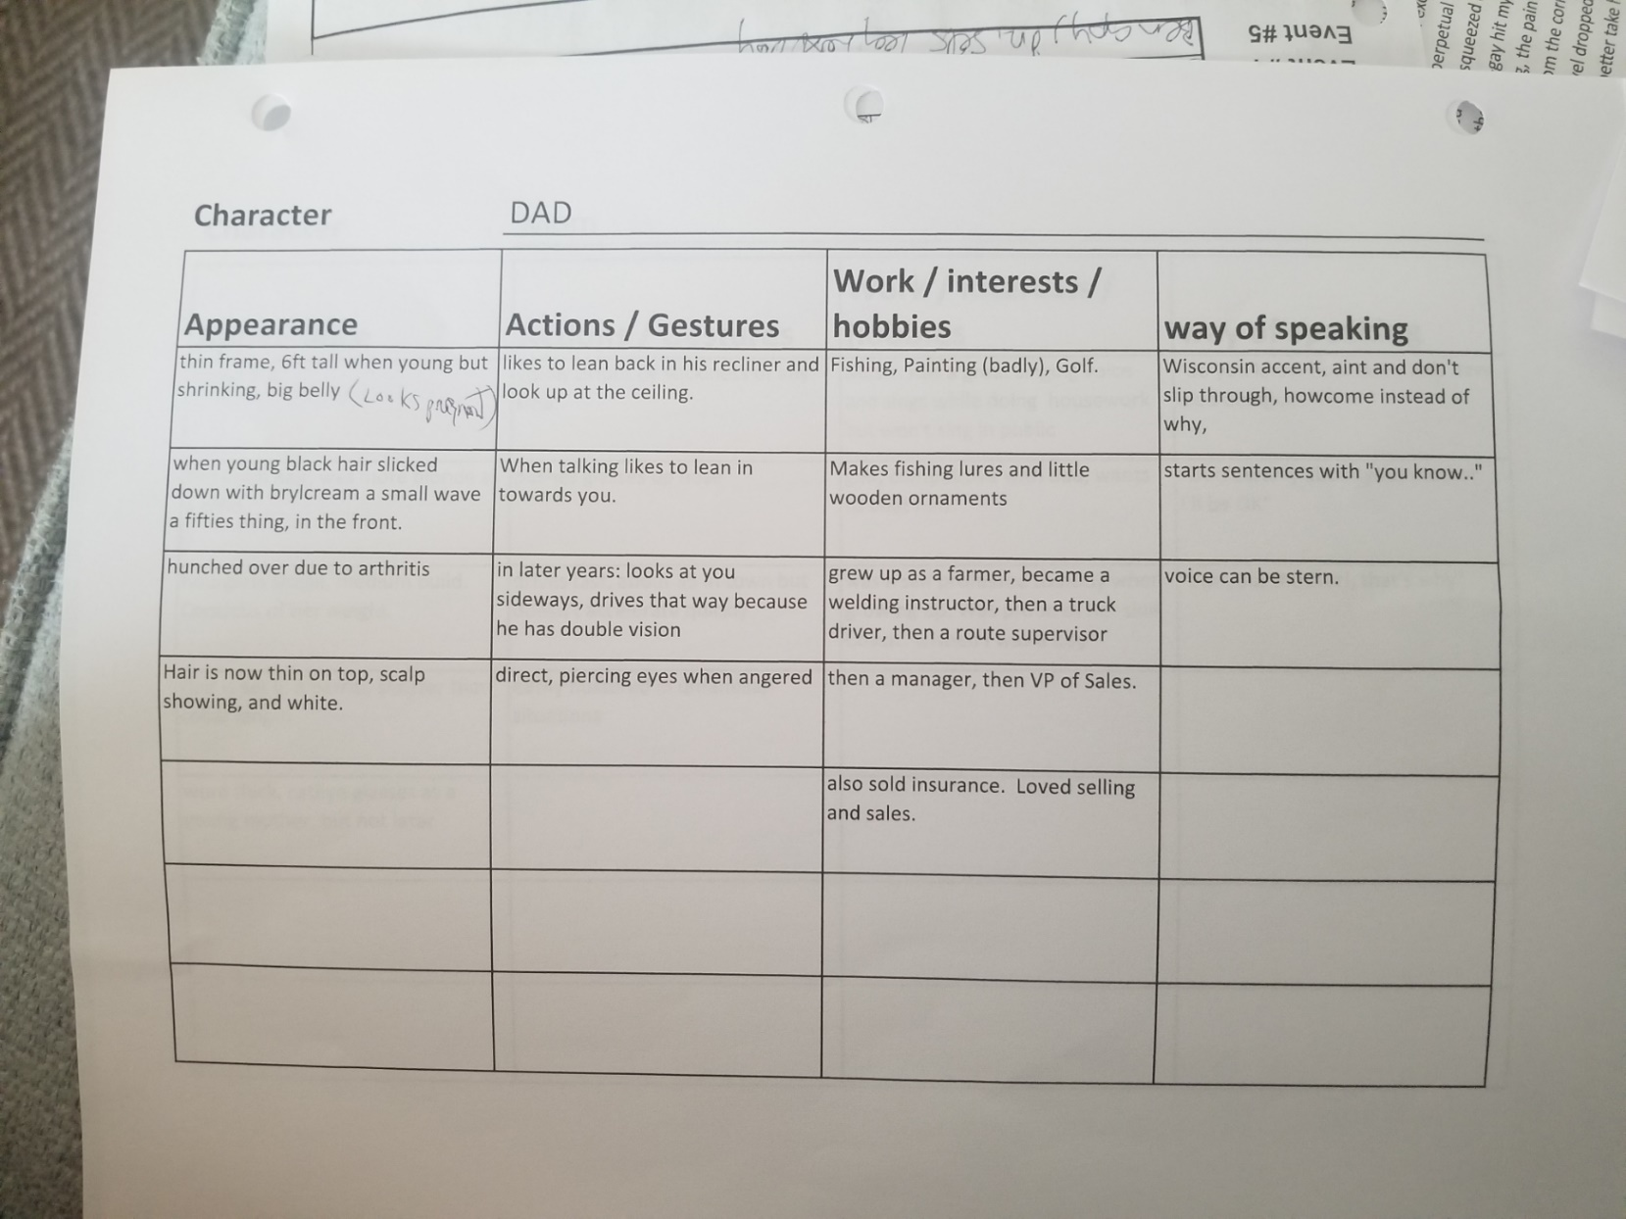
Figure 6: Characterization, Dad
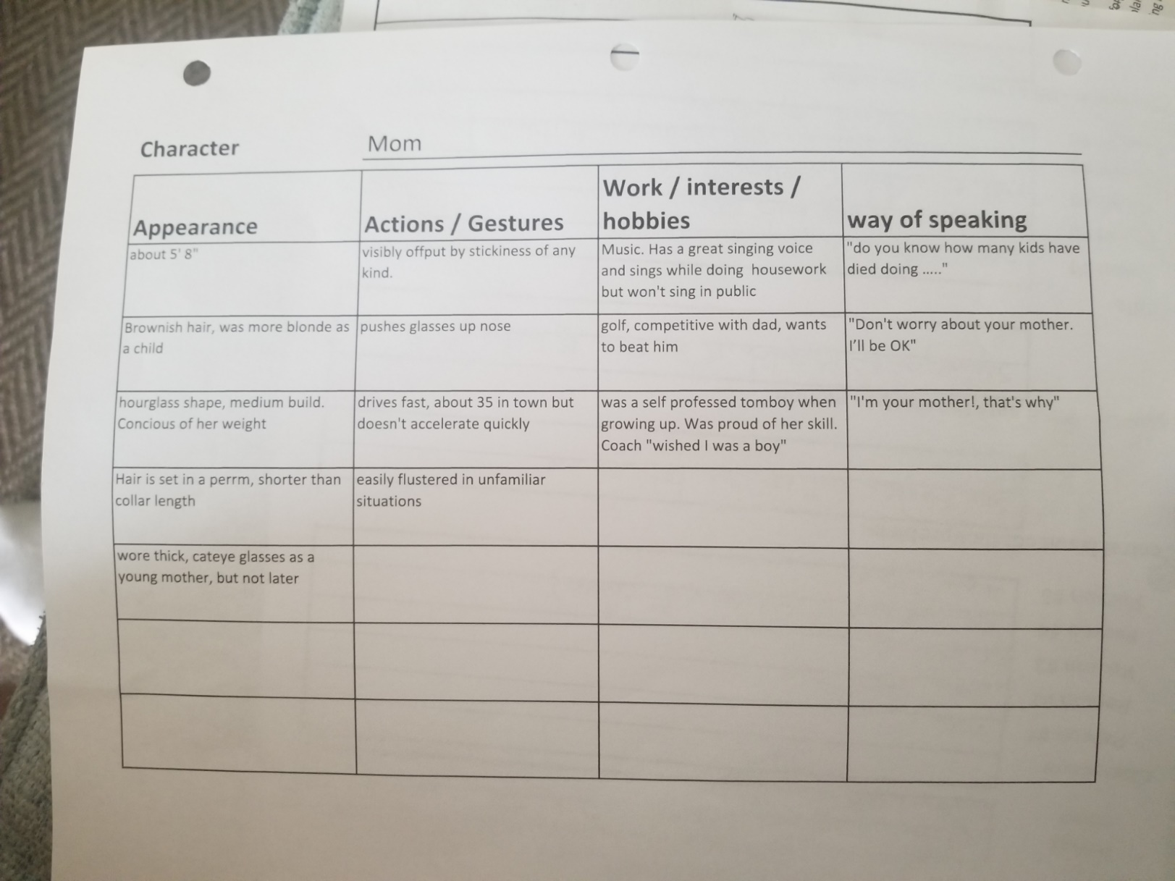
Figure 7: Characterization, Mom

