The intersection of infinite and awesome.
Steven Weisberg
5-17-2023

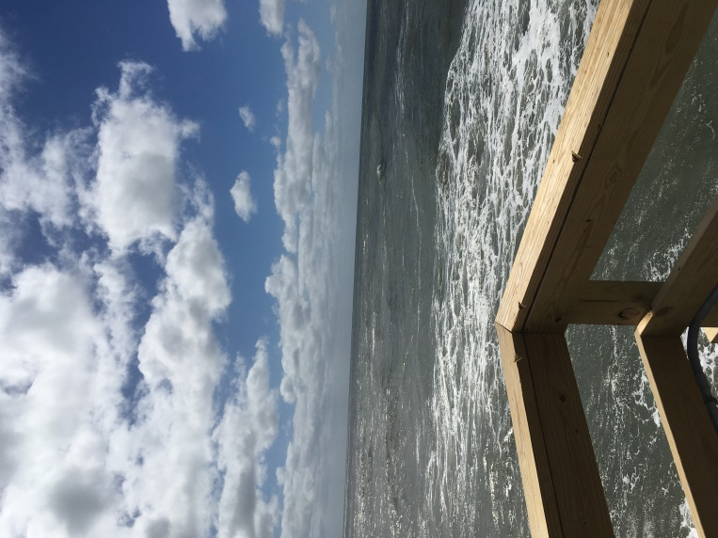

I stood at the intersection of infinite and awesome, a ninety-degree elbow of water-resistant natural hardwood railing, 500 feet out from shore at the furthest end of the fishing pier. Gazing out to the celestial blur where surf meets sky, my mind melted into the moment as my brother yelled “going out” before whipping his fishing rod in a full-force overhead cast to launch a hook full of fish entrails out to sea.
The ocean lapped against the pillars of the pier in lazy rhythmic sloshing. Each wave cast forth its bounty of freshly churned, moist aerated salt. I breathed in slowly through my nose, savoring the cool mist of the early fall ocean breeze. It was a familiar smell, a marine aphrodisiac, both comforting and invigorating to my body and soul. With each deep and deliberate inhalation, I expanded my lungs fully to the threshold of pain in my ribcage. And with each slow exhalation through my mouth, my thoughts drifted further into the deeper chasms of memory. Salt air is medicinal in that way.
2020 was a year of adjustments. Having lost Mom in August of 2019, the days, weeks and months that followed morphed nonchalantly into the next year. Time was consumed by dispersing clothes, collectibles, books, papers, photos and the miscellaneous accumulations of things one holds dearly over a lifetime. In the prism of hindsight, taking care of mom during her decline was relatively easy compared to the solitary task of liquidating the personal stuff that surrounded and identified her.
Like Jimmy Stewart’s character, Elwood P. Dowd, in the 1950 film classic Harvey, where he converses with an imaginary six-foot rabbit, I’d enjoin my mom in a verbal discussion of what to do with each of her belongings. Bizarre as it may have appeared; it filled the quiet void of the condo and helped me through the process, even though, even then, we had our arguments.
”Mom, what do you want to do your thirteen-piece canister set, the one you got as a wedding gift?”
“I want you to have it”.
“What... how am I going to carry it on a plane back to Florida?”
“You’re good at packing; you were the one who packed the Chevy for our summers down the shore. You know how to pack”.
“Mom, you’re killing me here”
Still, it was good to have her company albeit by channeling her spirt.
“When I’m gone” she once told me, well before the pancreatic cancer was discovered, “know that I’ll always be there for you. You just need to tap into me.”
After everything was gone, estate matters settled, and the canister set on display in my home, I tapped into mom with the update.
I spared the petty spats with my siblings, hidden complications, miscommunications, unanticipated legal fees and specifics of the stuff for which I couldn’t find new homes and had to cast to their fate in anonymous bags and boxes left orphaned at a Goodwill drop-off site.
“You took care of me as you promised you would” she replied ethereally. “Now… I want you to take care of yourself”, she emphasized.
“Seriously, Mom” I sighed. The persistent crick on the right side of my neck loosened its grip on the lipoma over my right scapula and I felt I could turn my head without pain.
Her logic was clear and keen; it cut deep to my gut where a still-lingering sense of loss melded with long held feelings of abandonment. It tasted like inhaled air from a deflated inner tube. Intellectually, I knew the busywork was a masquerade of buried grief. It lurked within me, bitter and stale, a radioactive genie in a bottle with a crumbling cork that could pop anytime or anywhere.
“You need a break” she stated. “And, you know” she continued “there’s no better place for you to be than down the shore. And… there’s no better person for you to be with than with your brother on the pier”.
I couldn’t argue with her.
She knew me too well.

