The Margate Fishing Pier
Steven Weisberg
5-18-2023
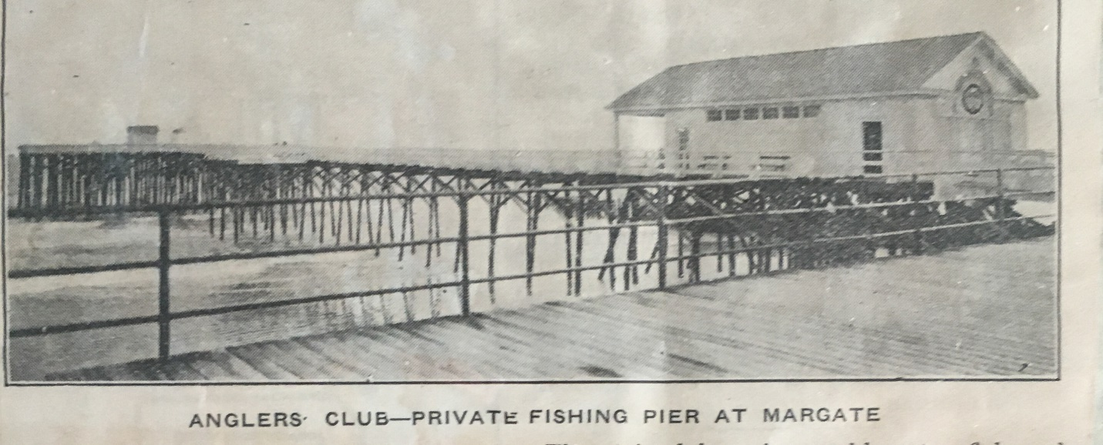

The Margate Fishing Pier in the quaint, tony town of Margate, New Jersey is a local institution. The ten feet of beach under its wooden walkway is sacred space. Innumerable first kisses happened there between young lovers seeking refuge from their parents; marriage proposals were made, wedding pictures taken and ashes have been cast to the wind on days of brisk offshore breezes. Surfers hang-out till the sun sets and beach goers without beach chairs hang their towels on the system of stout crosshatched structural pillars, each one, approximately the width of a mini-redwood tree. Horseflies and mosquitos propagate in the damp recesses of the rafters while sand crabs burrow in the wet sand by shore’s edge for surf fishermen to dig up and use as cheap bait.
The fishing pier has been built and rebuilt, restored, reconstructed and renovated several times. It’s been resilient in its century of existence; surviving the Great Atlantic Hurricane on September 14, 1944; the Ash Wednesday Nor’easter of 1962; a mysterious fire, alleged to be arson but never proven, on October 21, 1988, and Super Storm Sandy on October 29, 2012. While the Fishing Pier is a public landmark, access to it is granted through private membership only in the Anglers Club of Absecon Island.
Founded by H. Willard Shaner, an Atlantic City journalist, entrepreneur, promoter and hustler of the roaring twenties, For the Glory of the Sport became its signature motto. In 1923, H. Willlard raised twenty-five thousand dollars from fishing aficionados and private investors to acquire beach front property and ocean access rights for construction of the original 300 foot fishing pier and the modest club house for its members. His slogan implied the glory of catching the Big One. Considering H. Willard’s finesse with a casting rod was equal to his ability to wend influence, For the Glory of the Sport during those Boardwalk Empire Days of Prohibition may have been code for private investors who wanted the glory of a big catch in the form of a fishing vessel containing smuggled Canadian whiskey. $25,000 dollars in 1923 money is equivalent to $450,000 today. In retrospect, the founding private members of the Anglers Club of Absecon Island needed pockets as deep as the depth where deep-sea game fish swim. H. Willard proved to be a master of reeling-in varied species of Big Ones.
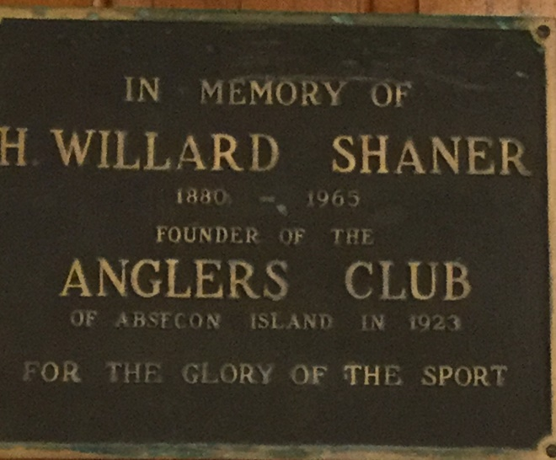

My brother’s passion for fishing is equal to my love of creative writing. His ability to write, however, is equivalent to my skill at identifying fish. While Max can identify every freshwater or saltwater species, my knowledge of fish extends to the deli counter where fish come vacuumed sealed in a package or in a glass jar. Still, through his fisherman’s instincts, he discovered the Margate Pier decades ago, became an Absecon Angler and now, one of its former Board Presidents. Though we spent our summers down the shore when we were kids, we didn’t grow up with the Margate Fishing Pier.
In the off-season after Labor Day, when thongs of summer vacationers return to the city, the South Jersey shore assumes the serene charm of Indian summer; the days are still warm but not hot, the nights cool but not yet chilly. The frenzy of the crowds dissipates like melting snow on a winter’s day with late-spring-like warmth. And the Fishing Pier with its charming wooden clubhouse is visited sparingly by the remaining locals, most of whom, might show up on weekends, if at all. Essentially, the privacy of the private fishing club is guaranteed. My brother prefers to fish alone; and for a writer who’s looking for a quiet spot to write family stories of youthful indiscretions during summers down the shore, the Anglers Club of Absecon Island is an unassuming spot where a bit of heaven exists on earth.

