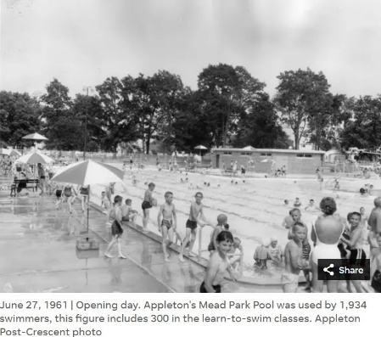
Not everyone was allowed on the high dive at Mead Park Pool. The teenage life guards sitting in the elevated chairs, protected from the sun by large umbrellas, enthusiastically policed “the deep end”, the dive area where the water was twelve feet deep and separated from the rest of the pool by a floating rope. The high dive stood at least fifteen feet high.
We loitered at the rope, watching kids jump off the high dive and disappear under water as we unconsciously held our breath waiting for them to resurface.
“That one looks scared” said Greg pointing.
“I bet he belly flops” Eddie added
And he did, landing with a loud slap on the water.
At that moment everyone stopped talking. Every kid in the pool knew that sound and turned to look. The lifeguard quickly glanced over to make sure there wasn’t any blood, and then resumed his slow scan.
We let out a collective “Ohhhhhh”.
” He got creamed” a nameless kid said. And we all agreed.
“He didn’t jump. He just tried to fall, and that’s why he bellyflopped” remarked Eddie confidently. Eddie had no expertise in diving, but we believed him anyway.
We waited for the next kid to jump, caught up in a struggle between the desire to jump and fear; fear of the height, fear of drowning, and fear of bellyflopping.
“I wonder how far you go underwater” I said.
“I heard a guy actually hit the bottom” replied Greg.
“Could I hold my breath long enough to make it to the surface” I wondered.
“If you can hold your breath thirty seconds, you can make it,” said Eddie.
I turned to face the big clock on the bathhouse wall, waited until the second hand hit twelve, then held my breath until it passed the six. I could make it!
“I’m gonna try it” I said foolishly
“You’re too chicken” said Greg, tormenting me.
“Well, if you’re so brave then go first” I retorted
“You’re the one who wanted to do it” responded Greg immediately
“They’d never let me” I said, desperate now for a way out.
“Look, there’s a kid about your size waiting to go up” said Eddie pointing, a gleam in his eye.
Eddie’s remark was as good as a dare. Why did I open my big, fat, mouth?
I bobbed over to the ladder, stealing sideways glances at the diving board, which seemed taller now. Getting out of the water, I walked past the lifeguard, hoping to hear him whistle and kick me out of the area. But he just glanced in my general direction and looked away. My heart raced as I approached the ladder behind the high dive.
Climbing, I concentrated on the ladder, white knuckle hands on the railing, as I willed my legs to push me up one tread and then the next. Suddenly I was on the diving board, much narrower and longer than it had seemed from the ground, my feet glued in place, heart pounding like an angry troll punching his way out of my chest.
“Look, he’s chicken” I heard some kid say from far below.
My knees shook like mom’s washing machine just before it broke.
“Yeah, he’s yellow” another kid added. Suddenly I hated them all.
I marshalled my courage and managed to let go of the rails; my feet slid more than stepped down the board, now bowing with my weight, and I stood at the end; toes curled around the edge.
Remembering the bellyflop and Eddie’s advice, I bent my knees and made a small, tentative jump and was in the air. As I fell, I remember having time to look across the pool. I saw the clock. It was 2pm.
Closing my eyes and holding my breath, my feet slammed into the water. I felt the splash and heard bubbles rushing past me as I plunged into the depths. I could have been a mile under water. I heard muffled voices on the surface and far away splashing. Coming to my senses, I frantically kicked my legs, fighting for the surface, and after an eternity broke through in an eruption of water, my lungs bursting. I quickly gulped some air and dog paddled to the ladder.
I ran-walked back to Greg and Eddie.
“What was it like?” asked Greg
“Piece of cake” I replied, with more than a little swagger. “You just climb to the top and jump off”

