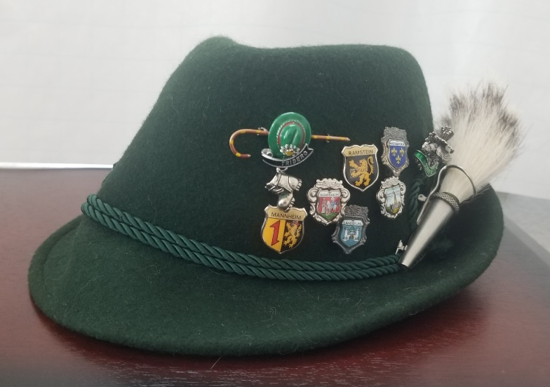
I was embarrassed when my father bought it at one of the many tourist traps in Heidelberg. A cheap, tourist-quality hunter’s cap, marked on the inside lid Echt Bayerisher Sport-Hut (authentic Bavarian Sporting hat). To complement it, he bought a brush, an accessory worn on the side of the cap and angled toward the back. A sporting hat is part of a traditional hunting uniform. The full ensemble includes Lederhosen, high socks, a white shirt, a bolo tie, and a green jacket. It was fortunate Dad bought just the hat and brush.
The clerk fastened the brush on the hat, which was a blessing. God only knows how Dad may have attached it. After the exchange of some Deutschmarks, Dad put the hat on, checked himself in the mirror, and sauntered out of the store as if he were Kaiser Wilhelm in full regalia. Mom and I trailed, but not too close.
I was twenty-six years old and stationed at Ramstein Air Base in southwest Germany. Mom and Dad were in Germany to attend my college graduation. I had attended night school since arriving at my first base and had now, almost three years later, amassed enough credits for a Bachelor of Science degree from the European Division of the University of Maryland.
We were in Heidelberg for the graduation ceremony and to see the sights. My dad, a natural tourist, had to buy the garish hat. And he wore it everywhere; on the street, in the hotel, to the castle, in the restaurant, and to the museum. At the time, Dad seemed oblivious to the effect it had on everyone he passed by, but as I see it now, I think he may have enjoyed the attention. Mom and I, however, were not oblivious, and we did not enjoy the attention.
It wasn’t too bad following my dad the tourist around Heidelberg, and then Triberg-im-Schwartzwald, both well-known tourist destinations. In tourist areas, he didn’t stand out too much, although the hat announced to anyone that he was an American. Corny T-shirts, cheap hats, dolls in traditional dress, and the like were very American. European tourists didn’t spend much money on novelty items. But they did buy small pins, or little metal shields which were attached to a cane with two tiny nails, or maybe a small ceramic item. Asian tourists, like the Japanese, weren’t souvenir buyers either. But they took multitudes of pictures with their 35mm cameras, even common items like street signs. I cannot even imagine the agony of a post-trip slide show in a Japanese home.
But the hat did garner more attention in Landstuhl, the small town where I lived just outside the base. Landstuhl is not a touristy area, although it does boast the ruin of Nanstein Castle on the hill. I had a great view of the illuminated Castle at night from the small second-floor balcony of my apartment. My landlord, Herr Hans Hempling, a WWII Wehrmacht veteran, lived downstairs. When he saw Dad’s hat, he almost laughed out loud but caught himself, and just signaled nice hat.
Later, I needed to go to the grocery for a few items, and Dad insisted he accompany me, hat on head. Dad was amazed at how sociable the Germans were. We were greeted with wide grins as we walked into the store. Germans, he remarked, were not at all like the sober and stoic people he had heard about. I knew of course the source of all those smiles. It was the hat, which they’d talk about at dinner that night, and I was sure they’d mention they’d seen the hat in the company of the American who lived in Herr Hempling’s house at 16 Austrasse. Neither fear was true. I’m sure they had a little laugh and moved on; the incident forgotten in the flow of life. I’m also sure now, they didn’t recognize me. I was just another American, one of many who lived in town or worked at Landstuhl U.S. Army Hospital. But my young, self-conscious brain didn’t understand any of that and was mortified.
Dad is gone over ten years now, but I’ll have his hat, and his memory, forever. I remembered the hat after he died and searched for it everywhere, without success, when I visited Mom. She found it several months later and sent it to me. It was a bit crumpled. Dad had stored it in a place logical to him alone, a box in the garage. Then the hat sat in a display case, balanced on top of the two-liter beer mass (mug) my mother-in-law secreted in her purse at the München Octoberfest when they visited us in Germany just a few years after my graduation. I have just in the past few weeks pulled it out and started to wear it, although it is a half-size small. It helps me write, a little piece of my father and his sense of humor, perched on my head at an angle, rakishly, like I am Sam Spade or something.

