Wintertime Fun

I grew up in the 40s and 50s in Maine, when we had REAL winters! I’m talking about walking to school between snowbanks two or three times taller than we were!
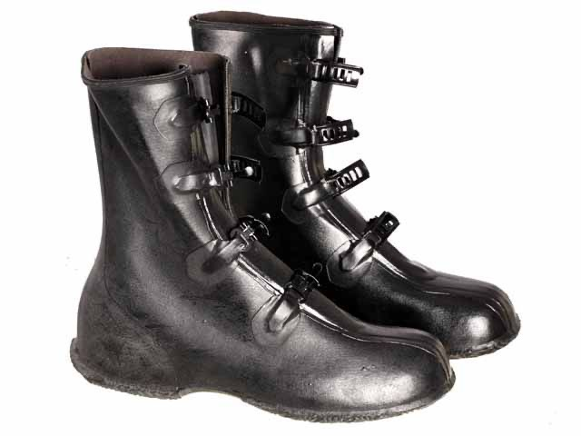
My little brother and I woke up to Jack Frost on our bedroom windows and ran downstairs from unheated bedrooms, carrying our clothes, to jostle each other over who’d get to dress standing over the register in the living room floor. If it was a Saturday, after breakfast we’d bundle up to play outside: snow pants over my dungarees, buckled “overshoes” on our feet, mittens knitted by Mama, connected through jacket sleeves with yarn so we wouldn’t lose one or both, topped with winter jackets, scarves and hats. I’m sure we looked like little Michelin men, building a snowman or making snow angels.

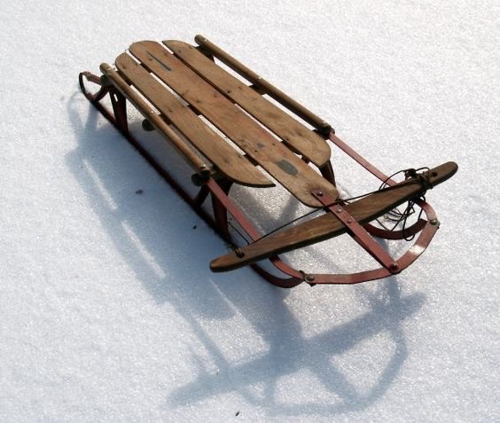
Friends from up and down the street would join us. Some days we’d build two forts on opposite sides of the front lawn, stockpile snowballs, and have a snowball fight, girls against boys. Other times we’d pull our sleds up the hill behind our houses and slide down, at a thrilling speed if it was cold enough for the snow to form a tough, shiny crust, then trudge back up to do it all over again.

When Mr. Goodwin, three doors down, flooded their side yard to make an ice rink, I’d go there to ice skate. (My brother never joined us, maybe because all three of the younger Goodwin kids were girls.) Some bigger kids skated on the river uptown, but we were never allowed. A nine- or 10-year-old boy - exactly my brother’s age; they even shared the same birthday - had drowned there, falling through the ice.
By afternoon, we’d be tired enough to come in, stripping off our soggy, ice-clogged mittens to hang on a kitchen rack to dry, getting out of our boots and other gear, and warming up with hot cocoa Mama had made. We always begged for a marshmallow to melt on top. Yum! Probably she’d have made cookies by that time, too - crisp thin molasses, frosted sugar, or chocolate chip.
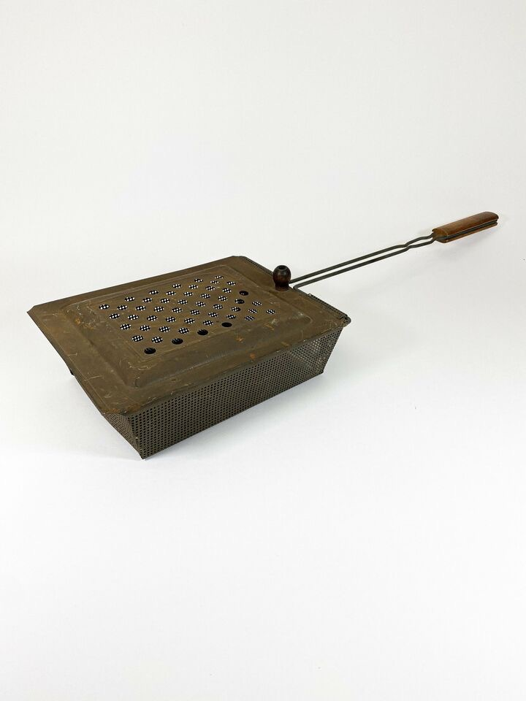
Early every December the whole family piled into Daddy’s Chevy and went out to some woods where he chopped down a tree. We’d make chains of paper and popcorn to decorate it after he put on the lights. Remember those big, multi-colored bulbs? Only Mama hung her glass ornaments with tinsel inside. We could add tinsel, but only if we hung it strand by strand, no tossing on clumps allowed. In the evenings we’d help make double-decker (peanut butter and chocolate) fudge or stretch taffy. Sometimes Daddy would pop corn, shaking the kernels in a metal pan on top of the stove (just found one offered for 60 bucks on eBay - and you wouldn’t believe what those vintage Flexible Flyer sleds go for!).

On Christmas morning we’d wake up before our parents and go down to see what Santa had left in our stockings. Always a tangerine, the only time that tropical treat was ever available, some small trinkets or toys, a marshmallow Santa or other candy, and a silver dollar in the toe. For the presents under the tree, we had to wait until after breakfast, which always featured Mama’s fresh-baked cinnamon rolls. After our tree, it was time for the best part of the day: dinner at Grammie and Grampa’s, with all our Taylor cousins and aunts and uncles, followed by presents, handed out by Grampa playing Santa. How he and Grammie must have enjoyed having their clan gathered all around them! It was, truly, “the most wonderful time of the year.”

Copyright Liz Brown 12.17.23

