Africana Connoisseur, A Character Sketch
Norma Beasley

Columbus landed on the tiny Caribbean Island of Grenada, West Indies in 1498. Known as the spice island-nutmeg, mace, ginger, clove, and cinnamon. No doubt its lush forests, glistening waterscapes and waterfalls, powdery soft sands, and warm sunshine invited further exploration.

After slogging through clogged I-75 travelling north to Atlanta and navigating Google reroutes, my designated driver, Jeanette, and I, arrived on Mary Drive in the subdivision of Remington Glen to spend the Christmas holidays with one of my best friends, Joy Church-Boyce. Joy hails from Grenada. Doctor Church earned her degree from Saint George's University School of Medicine Grenada, West Indies. She later became a board-certified family physician in Atlanta. Met and married Andre Boyce, a musician, and became a mom to Ashia, her daughter, who graduated from Georgetown University, D.C. Ashia has now married and is enjoying her honeymoon with Aaron Frye in the Bahamas. Unfortunately, Ashia only had a short time to enjoy her dad before he passed away from cancer when she was a youngster. Joy continued in her career and became a Physician Director with the Kaiser Southeast Permanente Med Group.
Joy, 5’3½”, possesses a deep throated voice, and exhibits a profound passion for plants as I do. There is a plant in every room of her contemporary split-level home. Her love of plants flows outside to a backyard waterfall, lit at night, and surrounded by outdoor seating and a background of tall pine trees. But my favorite sacred space in her home, is a room of plants with designer pots that remind me of a compact Eden. The different plant textures, forms, and scale, provide a sense of privacy and produce a calm relaxed atmosphere. I visualized myself enjoying that space quietly reading, writing, or meditating to my heart's desire.

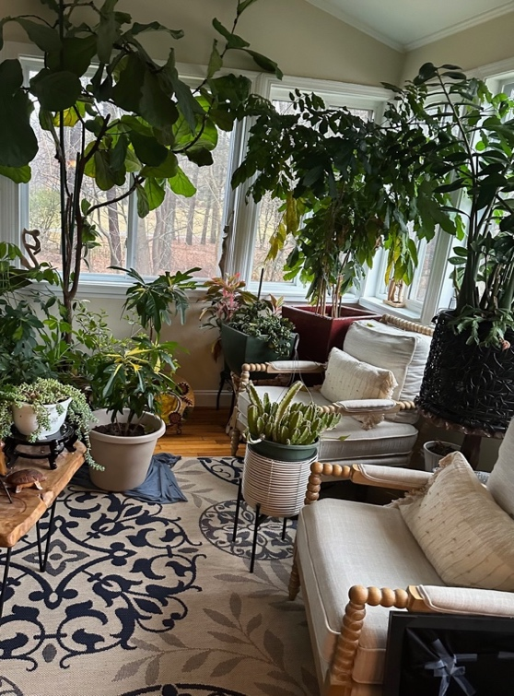

Another favorite room was the downstairs den area of cushy lounging, a large flat screened TV, and large comfy throw blankets and pillows I could nestle in. In one corner stood Another favorite room was the downstairs den area of cushy Another favorite room was the downstairs den area of cushy lounging, a large flat screened TV, and large comfy throw blankets and pillows I nestled in. In one corner stood the Christmas tree I helped decorate with all the gifts for family and friends.

Joy quietly tends to the needs of her 90+ year old mom and sister Athene who suffers with MS. Jason, her brother, lives with her. He was the kindest and sweetest guy to me during my holiday stay. Tending to my every need. He made me feel quite at home and like a queen.

She has acquired a collection of rich African sculpture pieces and colorful paintings placed strategically throughout her sunken living room, raised dining area, and the bedrooms.
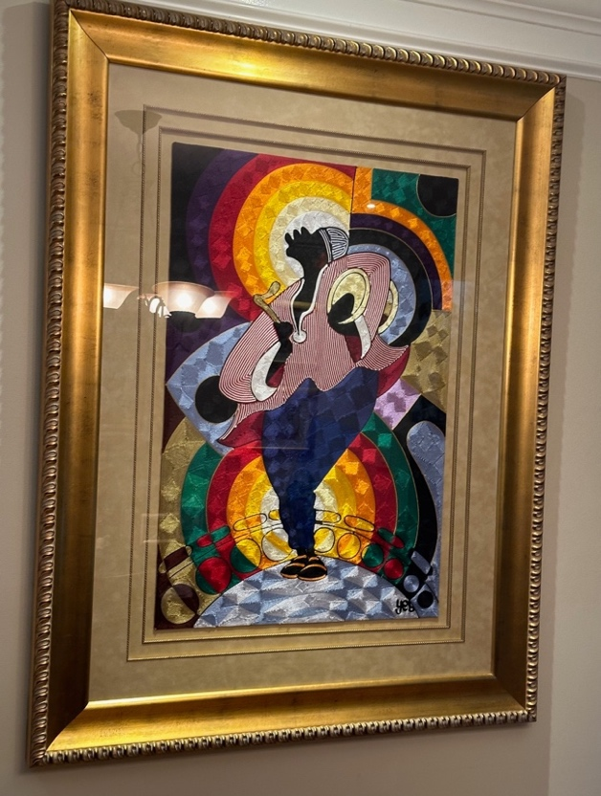
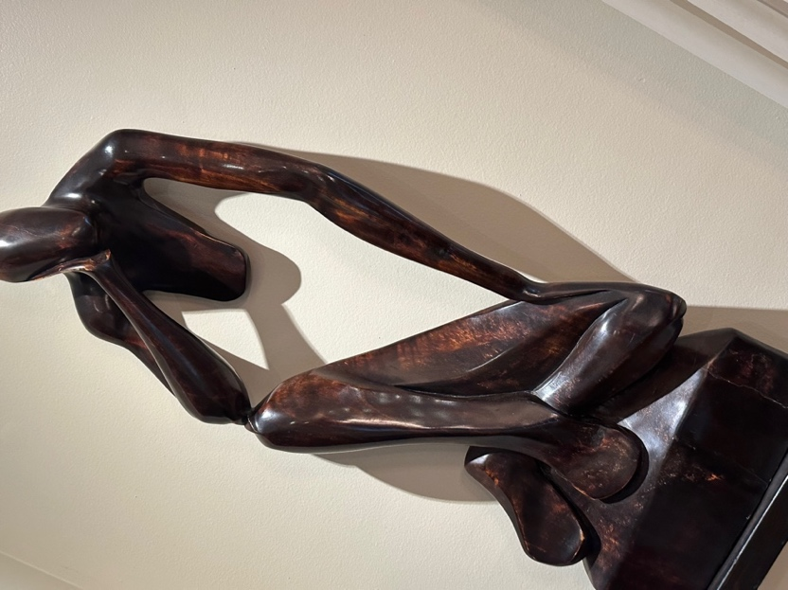

I was invited to peruse her walk-in master bedroom clothes closet. It was well organized, displaying a plethora of shoes and modest clothing selections. I like shoes too. It reminded me of standing in the women’s department of Macy’s in New York. Imelda Marco would have been proud of the shoe display. The bath and shower areas were nearly as large as my great room.

For Christmas dinner I enjoyed familiar foods such as greens, mac and cheese, duck, grilled salmon, brisket, fresh baked bread, cakes, apple pies and many other delicious favorites. Some of the island selections were tomato and cod fish for breakfast, tamarind balls, and sorrel, a deep red island Christmas drink. I liked mine spiked with rum. Yummy. However, I did miss black cake, a kind of island fruit cake. It is boozy, sweet and chewy. Missed my plantains also.

When I think of Joy as a person, she personifies strength, caring, patience, thoughtfulness, trustworthiness, sincerity, calmness, and sensibility.

I enjoyed meeting all my old friends from long ago and new ones met. Some I had not seen for 10 years. Youngsters were now all grown up. It was a pleasant experience leaving me with memories I will treasure forever.

