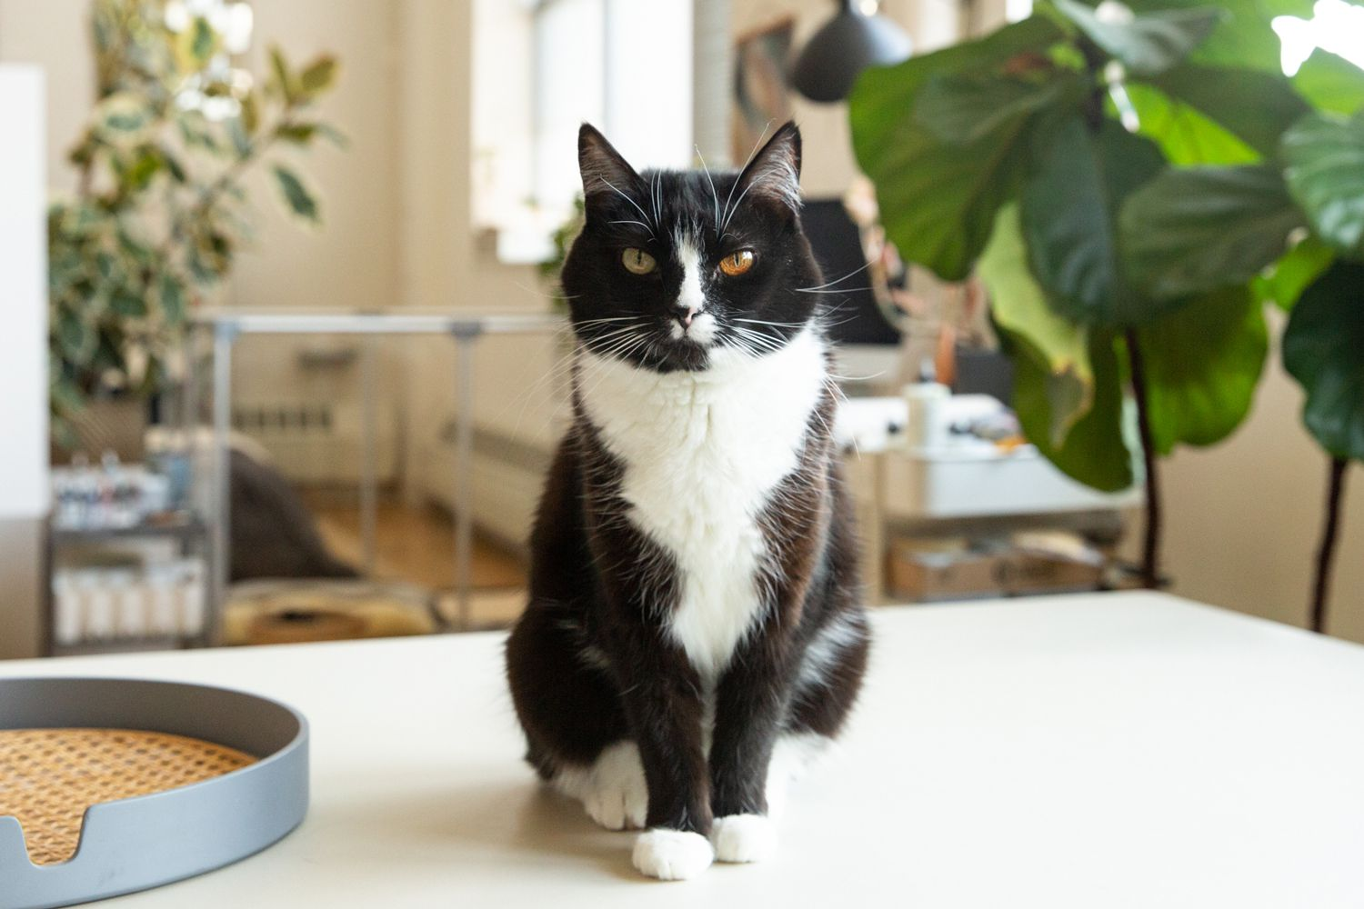
Our cat Percy scratched my face.
He pooped in my sister’s crib.
Mom and Dad said he went to live on a farm.
Grandma and Grandpa took him.

