Three Takes on
Love/Relationships

Different Doors
55 Words

Everything had already been said and decided. We had nothing left but to appear before a judge and sign the uncontested divorce, which took all of ten minutes.
We walked out of the courtroom into the hall and hugged. He turned right and went out one door. I turned left and went out the other.

A New Bar of Soap
60 Words

I thought love was sweet words spoken from deep within the heart, cards of handwritten professions steeped in sentiment, but my husband is not a man of words.
He knows I dislike using soap that has dwindled to a quarter of its original size, so every time I see a new bar of soap in the shower, I feel loved.

White Feet
73 Words

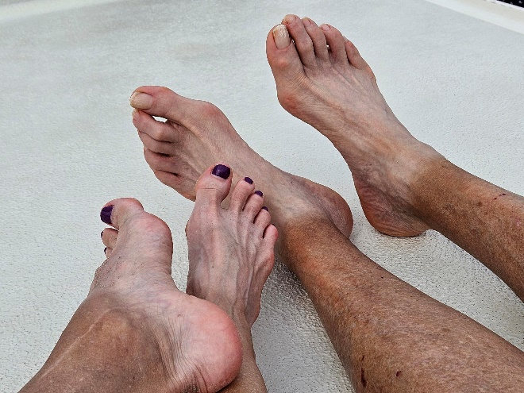
I made fun of my husband every time he took off his shoes and socks. His white feet next to his well-tanned legs just about glowed in the dark.
"Golfer's tan" was all he said in response to my chuckles.
I splashed into water aerobics a year or so ago and wear water shoes to protect the soles of my feet. It's been my exercise ever since.
Now, we are a white-footed family.

