A Letter to My Thirteen-Year-Old Self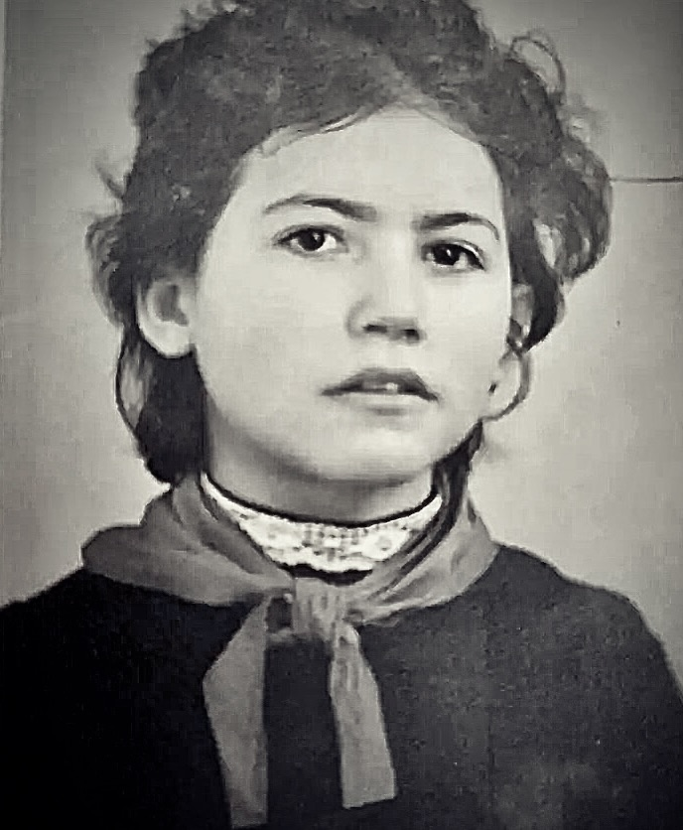
Dear Teenager,
Dear Teenager,
I’m writing to you from the future—57 years later, to be exact. It’s 2024, and I am now 70 years old. As I write this letter, I reflect on the many experiences and lessons that have shaped our lives. I want to share some thoughts and insights with you, the young version of myself, as you navigate the complex world around you.
Growing up as a Jew in the Soviet Union, you've already faced your share of challenges. I remember the feelings of being different, of sensing that our identity was both a source of pride and a target for prejudice. I remember how my teacher labeled me an outcast on the first day of school by mocking my name in front of my classmates. Understanding why people treated us differently because of our heritage was difficult. However, I want you to know that this part of our identity will become a source of incredible strength and perseverance.
At 13, you are full of hopes and dreams, wondering what the future holds and what you must do to get there. I remember how much you wanted to become a doctor. You worked hard to receive as much education as possible, even joining extracurricular classes to better your knowledge.
Mama told you that education was the key to your success, and you believed her. Even though you felt overwhelmed by her assertion, you reassured yourself that you could achieve those dreams despite the discrimination you experienced daily. Hold onto them, even when the world tries to tell you otherwise. Your determination will help you navigate life’s insecurities.
The Soviet Union does not treat those who stand out kindly. You will face discrimination and times when you feel like an outsider. But through these experiences, you will learn the power of empathy and the importance of standing up for what is right. You will develop a sense of justice and a deep appreciation for the value of family love and the solidarity of friends.
Looking back, I wish I could tell you how much you will accomplish. You will find ways to thrive despite the obstacles, achieving things that now seem out of reach. You will graduate with the Red Diploma, one of the highest honors a graduate can receive. You will make Mama proud. You will not allow hate to destroy your confidence.
Moreover, on your graduation day, you will stand at the podium and give a speech, holding your head high and proving to your enemies that their dislike did not stop you from achieving your dream. The education you receive, the family support, and the determination to pursue a four-year degree at the university of your choice will be your most treasured sources of pride and joy. Remember, success isn’t just about what you achieve but also about the person you become.
As you grow, you will discover the richness of your Jewish heritage. It will be your guiding light, your beacon of hope, leading you to a place where you belong and have a connection to something greater than yourself. The traditions, stories, and values passed down through generations will become a source of inspiration. Embrace this heritage, for it will be your fountain of strength in difficult times.
There will be moments when you question yourself as doubt and fear creep in. I want you to remember this: you are more resilient and capable than you realize. Every challenge is an opportunity to learn and grow. I want you to know you have a lot to contribute. Trust in yourself and the journey, even when it feels uncertain.
If I could offer you any advice, it would be to nurture your curiosity and never stop learning. The world is vast and wonderful, and your passion for discovery will lead you to unexpected and rewarding places. Be open to change, embrace new experiences, and never be afraid to ask questions.
As I write this letter, I realize the future still holds promise. The world is constantly changing, and each new day brings potential for growth and opportunity for success. Our journey isn’t over. There are still dreams to chase and stories to tell. There is still a chance to publish a memoir about our life in the Soviet Union. I sincerely believe it.
My younger, impressionable self, I leave you with these thoughts and all the love and wisdom accumulated from a lifetime of experiences. Remember that you are never alone; I am always here with you in spirit, watching over and cheering you on. Remember to choose love as your weapon and kill hate with kindness, but most of all, forgive from your heart all who hurt your tender thirteen-year-old self.
With all my love,
Kindly
Your seventy-year-old identical twin.
