Bazooka
Norma Beasley

Donnie D, a childhood schoolmate of mine, and I, were fierce competitors playing badminton. We both loved the drop shot. A shot hit relatively soft, to land just over and close to the net. Most of the time impossible to return. I relished seeing him gallop to the net to return the shot. He always entangled himself in the net, losing the point. The competitiveness carried over into a tabletop pinball game called Bazooka during the 1950s.
Bazooka was a game of chance rather than one of skill developed by Marx, a toy company. The game, a self-contained unit, consisted of five colored marbles, scored anchors that captured the marbles as they rolled down an inclined plane, and a spring trigger that released each marble toward a target. Highest score was the winner. We agreed not to influence gravity as each marble rolled down the incline toward a target. During the game we were joined by my cousin Anita who wanted to watch us play.
Donnie shot his balls first and accumulated a high score. Now it was my turn. Lady luck wasn't with me, and I became anxious and frustrated. Anita made it worse by teasing me. “Nah- Nah-Nah-Nah-Nah-Nah,” she chimed, while using the shame-shame finger gesture.
“Shut up,” I yelled. “Leave me alone. You're not playing this game.” The taunts continued. Suddenly I sprung to my feet, attacked her, and knocked her to the floor with me on top, breaking my glasses. Grandma heard the ruckus and came outside to see what was going on. She sent Anita home. Made me come inside. Donnie ran away. Grandma destroyed the game and threw it in the garbage.
Anita and I never fought again. Now in our 80s.

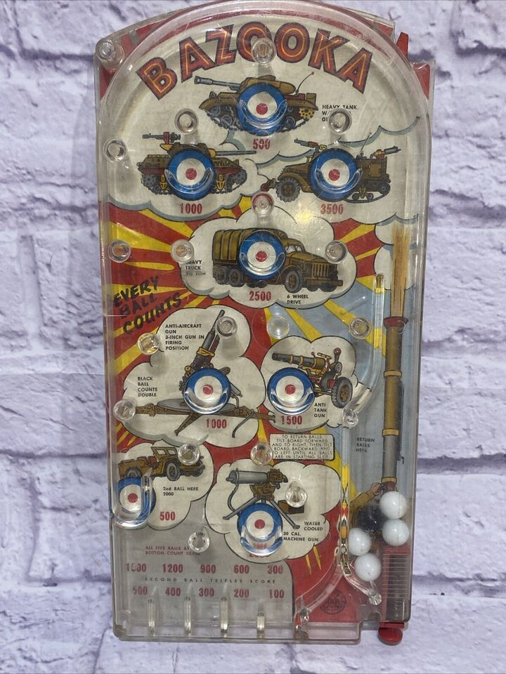
Curved transparent cradle receives marble. Score shows below.
Spring trigger with marbles

