CHAPTER 3 - SOLID KNOWLEDGE, CURIOUSITY, ADVENTUROUS LIFE
By Jacqueline Raymond
The transition from Elementary school to Hughes High School was an eye-opener. As I entered the school, a giant-sized Winged Venus statue greeted me. I was stunned.
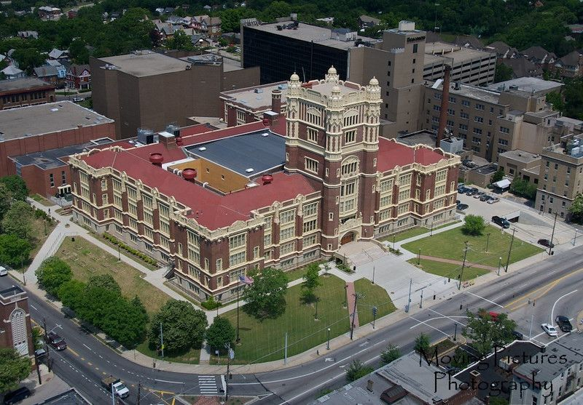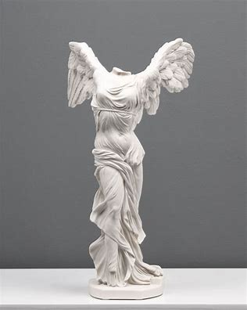
Hughes Highschool Winged Venus
It was six p.m., Sunday, Dad, teeth chattering, entered the house, shook off tons of soot-laden white snow, and in a calm determined voice announced, “This is the last winter I will shovel snow; we’re moving back to Miami, Florida this summer.”
“But I have two more years of high school.” I cried.
Calmly, but emphatically, Dad replied, “There are high schools in Miami.”
June 1948, we sold our house furnished, packed the trunk of our 2-door dark blue Chevrolet coup with clothes, pots, pans, and a ton of canned goods, and moved to Miami.
2. Drastically, my life changed in more ways than just weather. Cincinnati had it fabulous seasonal changes, Spring, Summer, Autumn, and Winter. Miami was somewhat one season, delightfully warm.
The first day of school arrived. Hughes High School was collegiately fashionable. My light grey heavy cotton straight skirt, slanted pockets at the waistline, and an inch and a half outward cuff at the hem line and simple puffed sleeved scooped neckline white blouse, looked somewhat out of place, different to say the least. 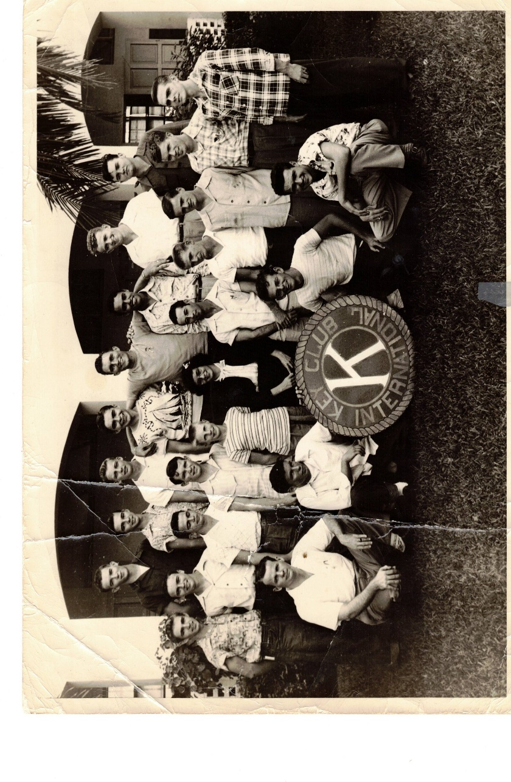
By the end of the first week all seemed to unconditionally accept me, and I was brought into the “IN” group. As the year progressed, my life got even better. Miami Jackson’s social activities were academically geared to enhance college bound students for those who chose. By the end of my Junior Year, I became a Cheerleader, acting in plays joined Thespians, grades elevated to As, Bs and National Honor Society. I was elected Vice-president of the Senior class and had my first boyfriend.

Miami Jackson Highschool, 1948.
