Judy Fink, third person structure
Micro-memoir
GIRAFFE ENCOUNTER

Around 2019 my family went to the “Giraffe Ranch” in Dade City, Florida to experience these majestic animals up close. We were told by our guide, “Do not try to touch or pet the giraffes. The reason being, in the wild they are prey animals and would bolt if they felt danger. Since the safari truck we will be riding in has a roof, if spooked they could suddenly raise their enormous head causing injury.”
The guide informed us each giraffe’s coat color variation is as unique as a fingerprint. As we drove near the enclosure, we saw them approaching the fence anticipating their treat. The sheer size was overwhelming at sixteen to eighteen feet tall. Unafraid they stretched their heads into the open sides of the truck, eagerly sticking out their twenty-inch tongues as we hand fed them cabbage, green onions, and branches with small fruits.
Following the lead of the older giraffes, an adorable baby, perhaps eight or nine feet tall, approached. Everyone in the truck “oohed and awed” as he chomped on his offered treats. One of the most striking things was their big brown eyes with lush long eyelashes…beautiful.
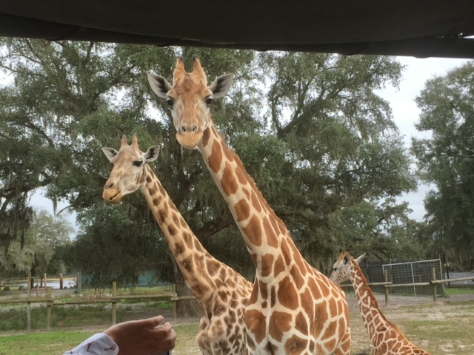
If only we were allowed to stroke their massive head or neck, what a thrill that would be, but respecting the animal and their safety was more important. Just being in their awesome presence was more than enough.

