Judy Fink
AUNT POLLY
My Aunt, Pauline Dennis, was one of my father’s two older sisters. Aunt Polly, as we called her, was the “fun” aunt. She had a great sense of humor and loved telling any joke she heard or made up. She stood about five foot, five inches and always had permed hair so little curls surrounded her face. I don’t recall in all my years of growing up, that her hairdo ever changed.
Aunt Polly and Uncle Howard at one time lived on an acre of land outside the town of Connellsville, Pennsylvania. The house stood on a small hill overlooking a set of once busy streetcar tracks. Those days of streetcar travel were long gone as more and more people purchased automobiles for daily life. Their backyard was full of trees and a large blackberry field. My brothers and I would each carry plastic buckets and go berry picking. Aunt Polly would make pies or cobblers out of our bounty. Our lips and fingers were usually stained dark from eating almost as many as we picked. One time I ate so many I got a bad tummy ache; I decided blackberries were no longer fun to eat.
Uncle Howard is a vaguer memory. He had been a coal miner in the forties and contracted emphysema from inhaling the dust of the mines. He therefore was always parked in a recliner in their living room with an oxygen tank next to him. The tubes ran up to a mask which covered his mouth making conversations difficult with adults and impossible with children. They were childless so Aunt Polly liked our family to visit to spend time with my brothers and I and occasionally our two cousins, Marty and Marvin.
If there was one thing you would remember about Aunt Polly was her love of “tchotchkes”. Her home was full of figurines of all kinds, teacups, vases and so on. Christmas was her favorite holiday, and she loved as much décor as possible on display. Porcelain Santas, reindeer, sleighs, snowmen, wise men and so on. Her coffee table had so many different figurines displayed, you had no room to place a drink.
Even though she had many things dispersed about the house, her great love was collecting salt and pepper shaker sets. I believe at one time she had over 300 sets. They were everywhere, the kitchen, living room, the dining room China closet was packed, even some were in the bathroom. Since everyone was aware of her collection, friends or family on vacation would pick her up a set related to the area they were visiting. Statues of Liberty from New York, flamingos from Florida, Eifel Towers from France, and on and on. It was overwhelming. She had some risqué sets she kept hidden in the back of her China closet which we kids weren’t allowed to see. Of course, we snuck in and looked when the adults were busy. All I remember was seeing a porcelain naked lady lying down with one breast as salt, the other, pepper.
Since there were so many sets, she had shelves specifically made to display them. Each unit was about four inches deep, seven shelves high and about four feet in length. They were connected at various heights on a backboard to accommodate different size sets. After all the sets were placed where Aunt Polly wanted them, she had a thick clear sheet of plastic made to cover the whole unit so none of the sets would get dusty. Then all five of them were securely anchored on the walls of her large kitchen.
You really couldn’t appreciate each set because there were so many to look at. I heard an Organization Expert on TV say that if all your collectibles are special, then none of them are special. He suggested only placing a handful on display at one time. You could then focus more on each piece and why it was special to you. Then weeks or months later, trade them out for a different group. Aunt Polly never heard about that rule.
I remember a sad situation happened when my grandfather, Aunt Polly and my dad’s father, passed away. Aunt Polly only wanted one thing from their family home and that was the bedroom set of her mother and father. Unfortunately, my dad was the executor of the estate and sold everything, including the bedroom set. Aunt Polly was broken hearted and so upset with my dad, they had a huge blowout fight…they never spoke again. The grudge continued to the point that my dad said he didn’t even want her to attend his funeral. When my dad passed away, Aunt Polly went to the Funeral Home early one morning before visiting hours to secretly view her brother’s body.
Prior to her death, she had worked temporarily answering phones for a local funeral home. She made a terrible mistake: she trusted the mortician and made him executer of her estate. In his crooked mind, that meant he could seize everything she owned. He had some women go into Aunt Polly’s home and remove bags and boxes of items. I thought she had a will but apparently it wouldn’t have made a difference. Everything she had was removed before we had anything to say about it. My family was to get some money she had saved but he took it all. I talked to a lawyer and told him the guy was a crook, a used car salesman in a cheap suit, (no offense to used car salesmen. Unfortunately, by then there was no recourse that would be worth it for us. Her life was gone as well as her belongings.
I wish I had one or two salt and pepper sets; something she loved, to remember how special she was.
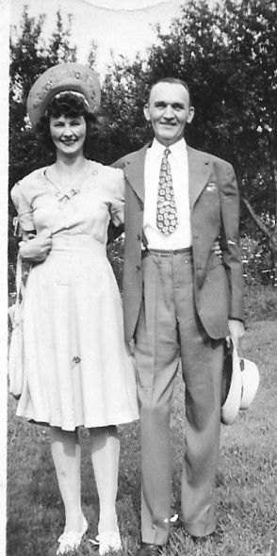
AUNT POLLY AND UNCLE HOWARD 1945

