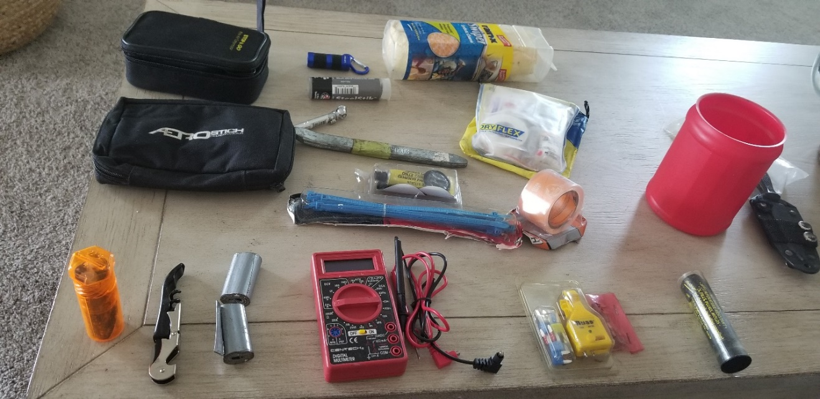
What to bring on a long-distance ride:
My personal long-distance kit, most of which fits into a one-pound coffee can

- Chamois. Prevents a wet crotch after a rain.
- Small LED Flashlight: Finds that small screw that fell somewhere into the dark recesses of the engine and then under the bike. Valuable even in sunlight.
- JB Weld: Make a replacement for the part broken because it was screwed in too tight.
- Duct or Gorilla Tape: Repair the fairing after the new bike falls over in the parking lot. Also temporarily reattaches broken turn signals, mirrors, and cracked windshields. I have two rolls from Aerostich.
- Tire repair kit: Remember the Why Pay More incident? Never again. Practice using the kit before traveling.
- Air compressor or CO2 cartridges: Tires never go flat at a gas station air pump. The air compressor may also be handy for filling beach balls or balloons. Ensure it plugs in and works before traveling.
- Fuses and fuse puller: Turns out a broken fuse is why the bike didn’t start, not the battery (see #8, Multimeter).
- Multimeter: Get a cheap one. You’ll probably drop it. It is a known fact electrical issues occur in hotel parking lots and under roadside bridges, always in hot sun or driving rain, but never in dry garages. Find it at Harbor Freight for about six bucks.
- Medical Kit: Get one with plenty of band-aids. You know why. Waterproof hiking/backpacking are the best. Supplement with ibuprofen and Neosporin for skinned knuckles.
- Zip ties: Fix broken/loose items in clothing and the bike.
- Rubber repair kit: Repairs leaks in rain gear, dry bags, and luggage.
- Corkscrew/Bottle opener: Without this essential item, you will push the cork in the bottle, drink all the wine, and wake up late.
- Boot knife: Looks cool. Never used.

