Culbertson, Montana – Almost to Canada

Dad’s next assignment seemed like an endless drive--799 miles from Denver. Culbertson, Montana, only sixty miles from the Canadian border and twenty-three miles west of the North Dakota border, had breathtaking scenery and the Missouri River winding nearby. The population was in the 700s.
To try to meet people, my sister and I drove my parents' large gray Imperial up and down the main street. We were usually met with interesting looks, mainly from guys who would motion for us to stop in a nearby parking lot. It seemed safe enough, and fortunately for us, it was.
On our first outing, we met two guys, Randy and Bob, in a shiny blue and white Mustang. Bob was friendly, but Randy caught my eye immediately. Brown hair, blue eyes, gorgeous white, straight teeth, about 5’11”, with a fun spirit. We chatted endlessly for about an hour and then invited them to our rental house to continue our conversation outside. I knew Dad would appreciate that.
The evening ended with a spring in my step and glassy eyes--I felt an immediate attraction to Randy. Each day after work, Randy came by and began to show me around Culbertson, introducing me to his friends. He invited me to his family’s farm/ranch west of town one evening to meet his younger brothers and parents. He was anxious to introduce me to his family. I feel he was as intrigued with me as I was with him. We were both twenty—the summer of 1978.
One day, when he was at work, washing the outside windows of a mustard seed mill, the forklift basket broke, plunging him thirty-five feet to the ground, where he landed on his face. He was life-flighted to Billings for traumatic care.

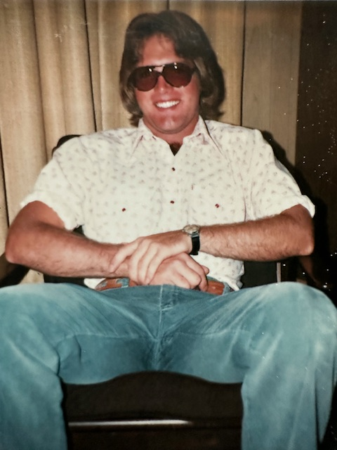

300 words

