STING RAY CITY
Judy Fink,
Grand Cayman Island, our next cruise ship stopover offered an adventure tour to “Sting Ray City,” a shallow area where stingrays were abundant. As our small boat slowed, many huge black round spots were seen moving under the crystal-clear water toward the vessel, it was a bit daunting. The guide said, “don’t worry, they’re just like dogs, they know when it’s dinner time and come running.”
Donning snorkel gear, we entered the water and were instructed how to feed these unique creatures, squid being their favorite. Their mouths are under their bodies, eyes on top. We were given small pieces of squid and were to place a piece between two fingers while keeping our palms up and flat. The rays in turn will glide over our hand and suck the squid into their mouths. Their smooth white underbelly felt like silk as they were gliding over our hands, accepting the offered treats. Moving from one person to the next, they often rubbed our legs with their satiny underside. The long “stinger” tail is their weapon when threatened so we were told to be careful not to step on one of the rays so “shuffle your feet through the sandy bottom to avoid this” our guide said.
Our instructor put his hands under one of the bigger rays and raised it to the surface so everyone could get a closer look. The top layer was completely opposite from the silky underbelly we felt, this was dark gray to black in color and felt like rough sandpaper. Everyone took turns gently stroking and marveling at their unique top skin.
Very few people ever get to see and touch creatures living under the ocean’s waves. I was more than thrilled to be one of them.
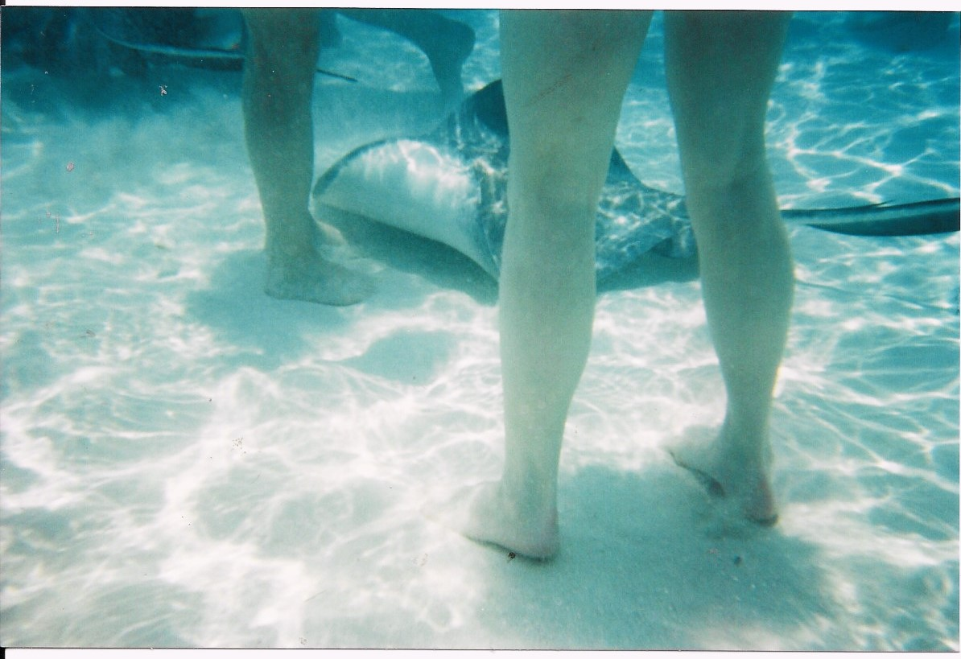

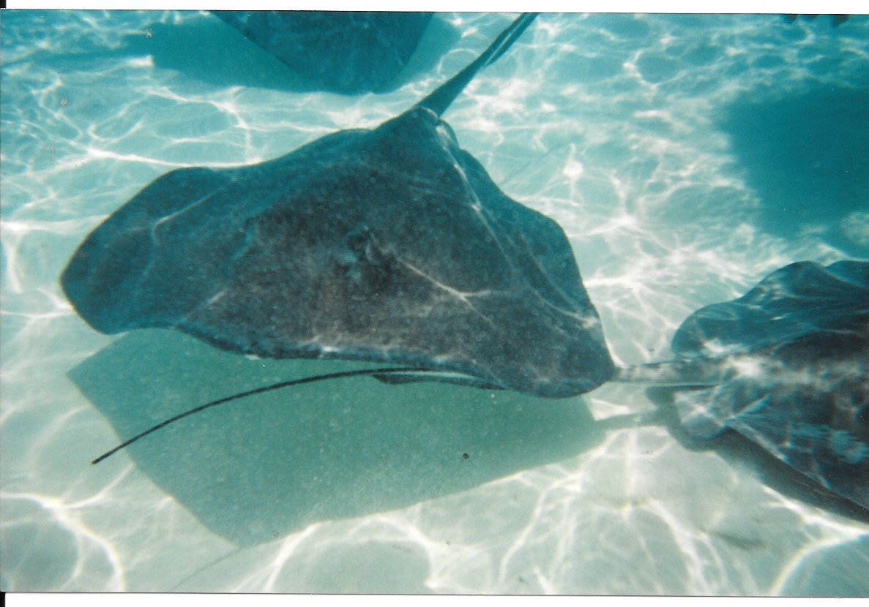

299 words

