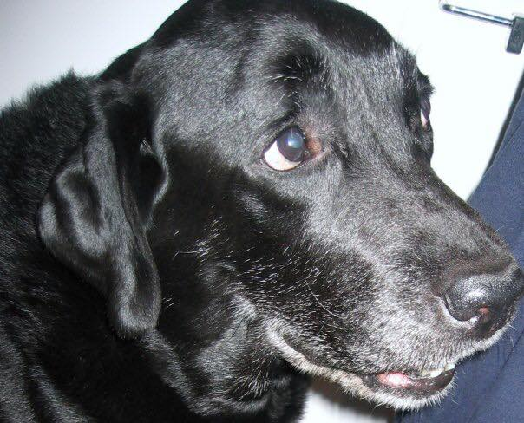

The Amazing Ace
Ace Heatherwood Flashback, a Black Labrador Retriever with a pedigree that could put King Charles to shame, entered my life during a profound loneliness. Our son, Jeff, had left for New York, and shortly after, our beloved Max passed away. The silence in our house was overwhelming, devoid of the familiar wagging tail and cheerful greetings; it felt like a mausoleum.
Ace’s arrival seemed destined. Years earlier, while window shopping in Brooklyn, a salesperson mistook someone else’s Black Lab for mine, igniting my desire for one. This memory resurfaced as I desperately searched for a new puppy to fill the void Max left.
Over a long weekend, hoping to find a chocolate lab for sale, I called several kennels in Florida. None of them had any. On the final day, I tried one last number in Lakeland. A woman’s friendly voice informed me she had one Black Lab left. At this point, I didn’t care about the color. Three hours later, we arrived, and a fluff of black fur leaped into my arms. It was love at first sight.
Ace brought immense joy and comfort to our lives. His obedience and loving presence made us laugh and cherish him deeply. I could never forget the day he almost drowned in our pool, trying to get out from the deep end, or the morning we warmed the pool for him so he could learn to swim. We laughed so hard watching Ace perform the recorded commands his trainer asked on TV. He was with me during a critical moment in my life, his spirit guiding me through a near-death experience. Ace was more than just a pet; he was my four-legged child, forever engraved in my heart. His absence is deeply felt, but his memory lives on, a source of warmth and love that endures.

