The Art of Sound
Norma Beasley


In September of 2018, Patricia Charpentier introduced our writing class to a new experience at the Orlando Museum of Art. We attended the exhibition of Nick Cave, best known for wearable mixed media constructions known as Soundsuits which act simultaneously as fashion, sculpture, and noise making performance art. Our assignment: tour the exhibit and document our physical, spiritual, visual, and mental impressions of the displays for a possible narrative.
Soundsuits originated as metaphorical suits of armor in response to the Rodney King beatings and have evolved into vehicles for empowerment. Fully concealing the body, the Soundsuits serve as an alien second skin that obscures race, gender, and class, allowing viewers to look without bias towards the wearer’s identity. His sculptures are crafted in collaboration with artisans from a dizzying array of materials that include beads, raffia, buttons, sequins, twigs, fur, ceramic figurines, toys and fabric. The Soundsuits are also displayed in exhibitions as static sculptures, arranged as groups of figures, information that are striking in their diversity and powerful stance. Cave structures also include nonfigurative assemblages, intricate accumulations of found objects that project out from the wall, and installations enveloping entire rooms.
Nick Cave
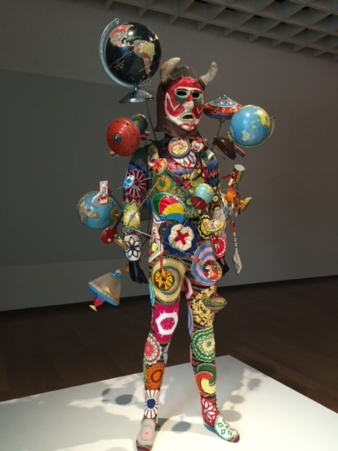
Cave draws design inspiration from a variety of sources. West African sacred dress, natural landscapes, antique shops, flea markets and handcrafts.
Throughout his career, Cave made use of found and ready-made materials to reference cultural, and autobiographical issues. The Soundsuits are named for the sounds made when worn by performers. Their meaning shifts and multiply with each exhibition and performance, set in places as varied as the theater stage, fashion runway, and city street. He also transforms painful experiences into hopeful images.
