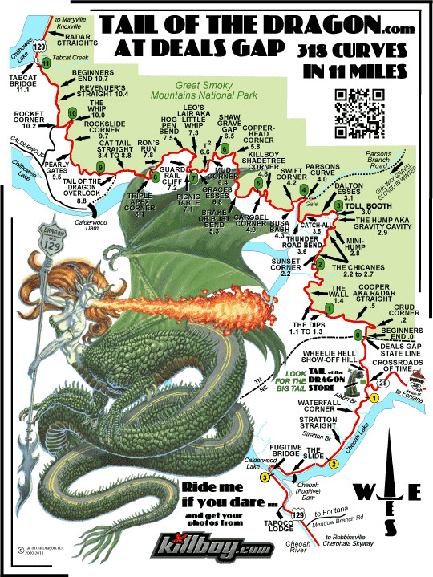
The Tail of the Dragon, a short stretch of US Highway 129, runs through the Smokey Mountains and is a bone breaker, bike breaker, and heartbreaker. The road draws motorcyclists like a wet T-shirt contest draws young men. In 2021 and 2022 alone there were 123 motorcycle crashes on the stretch, nine of which were fatalities.
So naturally Lisa wanted to tackle it on our trip from Pennsylvania to New Mexico, and, true to my masochistic nature, I agreed. I recall the demonic light in her eyes as she looked at the map. She had visions of exciting twists and turns. I had visions of shredded parts and fractured limbs. With 318 turns in eleven miles, the road presented a stark contrast to the sedate Blue Ridge Parkway we had just ridden.
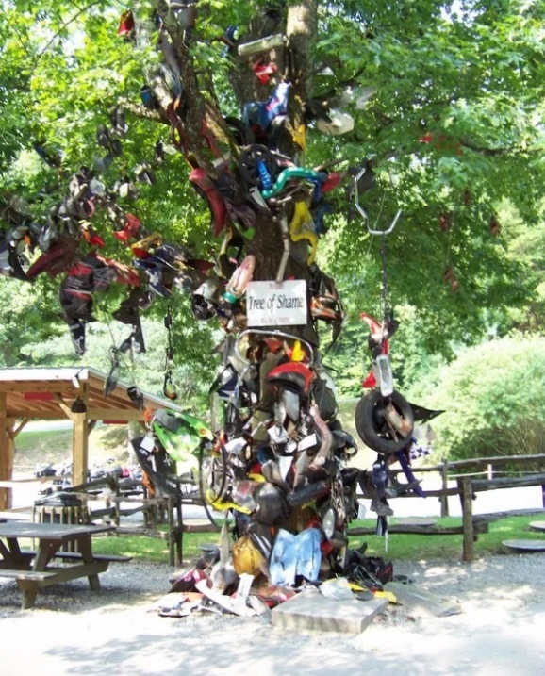
We picked up the infamous road on the North Carolina side and stopped at Deals Gap Motorcycle resort to pay homage at the Tree of Shame. There we joined other motorcyclists in macabre admiration at the collection of shattered parts. Cracked headlights, fairing shards, mutilated mufflers, and buckled handlebars hung from its branches. Even a tire and a set of crutches. Handwritten messages adorned the pieces; Turn #10- broken leg on the crutches, Turn #13-7/12/05 on the blue fairing., Turn #7-Too fast- on a set of mufflers. The busted chrome parts twisted and sparkled like tinsel in the early afternoon breeze, and I thought if the devil owned a Christmas tree, this would be it.
Our cruiser-style bikes were ill-suited for challenging hairpin turns and serpentine curves as the low-slung frames provided little clearance for leaning into sharp turns.
We watched a hapless motorcyclist dump his bike at the resort exit. Not a good omen. Bikers ran to help. We started our motorcycles. The road beckoned.
