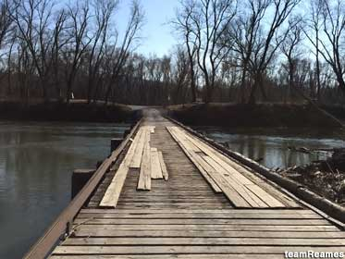
We were on the last leg of a 2,400-mile journey and hungry. Lisa loves mom-and-pop diners and had found one close to our route, but on a questionable two-lane road, as the roads Lisa selects often are.
The road led us to a bridge, but not a normal steel and concrete bridge. It was a wooden bridge, but not just any wooden bridge. This one was close to the water and, with its rough cross-members, resembled a railroad bridge. Instead of rails, cupped and warped two-by-tens formed tracks for tires.
The wooden bridge near Old Town, MD
We decided to chance it and carefully crossed single file. At the far end, 150 feet from the water’s edge, stood a small, white structure in the middle of the road, almost too small to be a phone booth. As we approached, we saw a pint-sized tin cup extend from the window at the end of a wooden dowel.
We stopped at the window.
“Twenty-five cents or fifty cents for the whole day,” said the clerk.
We realized it was a toll booth. Dumbfounded, we paid and, after taking a few photos, left. Once moving, my bike felt a bit squirrely. At the diner, I saw why. The rear tire was almost flat.
Fortunately, a classic car restorer had his shop next door. He took a look and found a slice in the tire. It wasn’t fixable.
But there was hope. His assistant, a motorcyclist, had a friend who had just bought a motorcycle that came with a spare tire. The spare might fit. After a quick call, the buddy arrived with the tire. I gave him $40 for it. The young assistant changed the tire, sparing me the work, but didn’t want any money. I gave him $60 anyway, a bargain considering he’d saved our trip.

