Where I’ve Laid My Head Barbara Rawls

Romulus, Michigan

My Dad built a two-story house, one room at a time, on a five-acre lot during the 1930 depression years. Dad worked at Ford Motor Company during the day. Salaries were meager in those days, but he still managed to buy a load of lumber each payday, just enough to build part of a wall over the weekend. By the time I arrived on the scene, the completed house contained a large kitchen, pantry, bathroom and three bedrooms. The two-lane country road could be viewed from the large front porch. The backyard contained a large garden tended by my mother, a fenced chicken yard and coop with a flock of chickens, a rabbit hutch with three rabbits, a storage shed, and a few rows of grape vines.

I liked gathering eggs from the hen house. The messy ovals were warm as I carefully placed them in a basket. It was a challenging task though since the rooster chased me across the fenced enclosure as I emerged from the chicken coop with the stolen eggs.

Picking the dark purple grapes was much easier and more rewarding. I still remember biting into the juicy flesh and spitting out the seeds. Yum.

Mother Cat lived under the back porch and produced many kitten litters. I watched as she nursed and cleaned them with her rough tongue. Fortunately for her and the kittens, my four-year old arms couldn’t reach them.

A swing hung from a tree outside the pantry. It was my special place. I soared high as I tried to touch the tree limb with my foot. This house was a happy place for the first six years of my life.

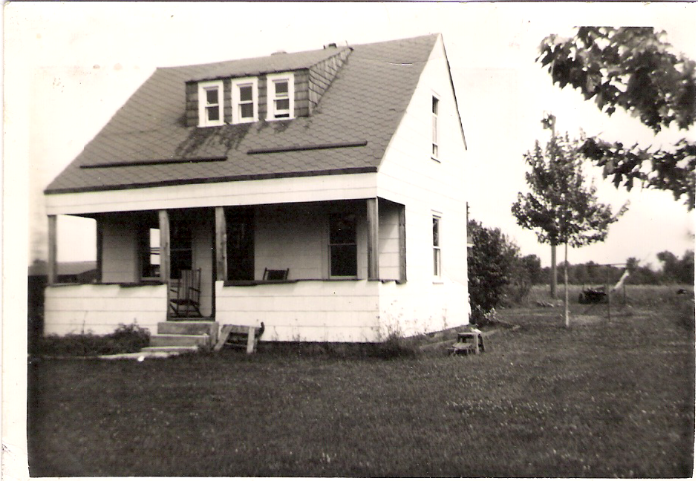

Romulus house in process of construction
Circa late 1930’s

