Naturally, it was evening when it happened, not daytime when repair shops were open. And Sunday to boot, when businesses close early.
Lisa and I were in Virginia on our first long-distance ride and needed gas. After filling up, Lisa noticed her back tire was low. Not the front tire, but the inaccessible back.
We filled the tire at the air pump. It went back down. Lisa rolled the bike forward. I knelt behind and looked for leaks, but couldn’t find any. We placed a call to Roadside Assistance.
The sympathetic operator said “Sorry you are experiencing trouble,” and called a tow truck.
When the truck arrived, the equally sympathetic driver said “The Harley shop ain’t open till morning. I’ll park your bike in my garage and meet you at the dealer about 8 AM tomorrow.”
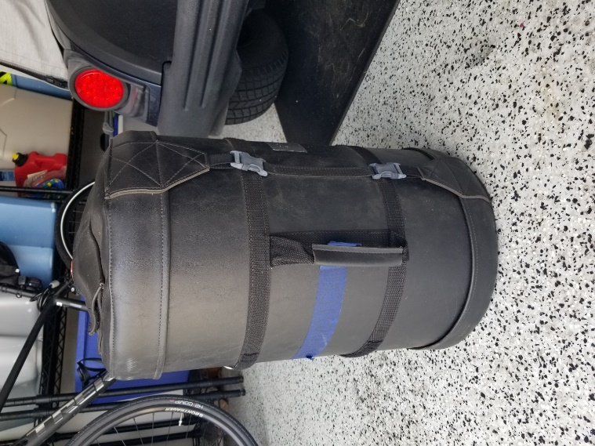
He left us at the gas station with one bike, and two large hard-sided luggage bags. After figuring out the logistics we rode off with Lisa seated behind me holding the heavy bags like outriggers. We weren’t going far lugging all that gear.
One of the two luggage bags
A mile later we saw a sign outside a nondescript hotel, shining in the night like the star of Bethlehem.
$35
Why pay more?

Why pay more? When we entered the room, I flipped on the switch. The small wall-mounted 40-watt fixture almost illuminated the room. The bedspreads on the twin queen-sized beds did not match the room or each other. The bathroom door wouldn’t close because the top hinge had pulled out. Exhausted, we plugged our electronics into the receptacle and went to bed. In the morning, nothing was charged. The light switch controlled all the power in the room.
We made it to the Harley dealer by 8 am. We now pay more.

