My Spiritual Journey
Norma Beasley
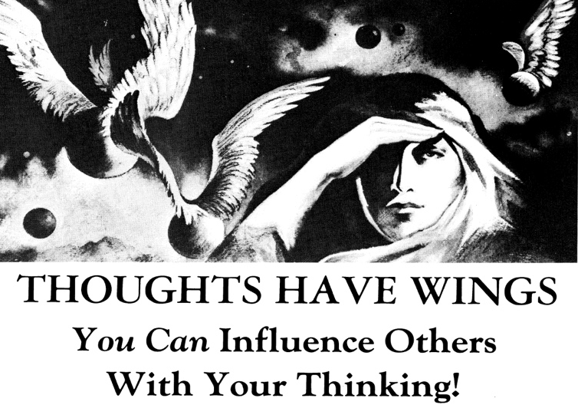

I was introduced to Sunday school and church as a youngster by my grandparents who were deeply committed Christians. Heart, soul, and mind. I attended services every Sunday. A hiatus ensued after graduating from high school.
The thought-provoking Rosicrucian ad above caught my attention one day as I browsed through a Psychology Today magazine. The illustration, arcane to me at the time. What esoteric message is this conveying? The verbiage piqued my curiosity and ignited my desire to learn more about the powers of mind and the Rosicrucian Order, AMORC.
I couldn't afford Rosicrucian membership dues, but I had access to the Rosicrucian Digest. This periodical became my Bible. The concept of the “master within” was embraced even though I didn’t understand what it meant. I joined the Order and became a lodge member. In time I was asked to become lodge secretary, accepted the invitation, and found it to be a stimulating yet tremendous challenge. Gratefully, I learned about the nuts and bolts of a well-known and respected organization while seizing the opportunity to evolve personally and spiritually.
Rosicrucians are known for their illuminating thoughts, good works, and dignified manner in conducting daily affairs. A principal edict espoused by the Order is to give service. Through the years, I have been an officer in many administrative and realistic positions. I am currently serving my second four-year term as district manager.
As a Rosicrucian, I have learned to honor the divinity in each person I meet to the best of my ability, including children. I have tried to never cast disparaging remarks toward someone. I have learned to take the high road or remedy the situation if possible. I have enjoyed the opportunity to participate in world, national, and local conventions, workshops, initiations, teleconferences, book salon discussions, convocations, and mystical weekends. I enjoy fraternizing and learning about mystical subjects with my fratres and sorores the world over.
The monographs, a study syllabus, have been invaluable in learning about principles, techniques, and experiments in mysticism. Reading materials such as the Digest, and Forum have added to my enlightenment. Access to other resources include the Council of Solace, the archives, essays, Rosicrucian TV, free download books, and more. All have added to my enjoyment and intellect as a member of the Order.
Being a Rosicrucian has indeed become a way of life. A living philosophy of pragmatic mysticism.

