09.06.24
Etya Krichmar
Words 284 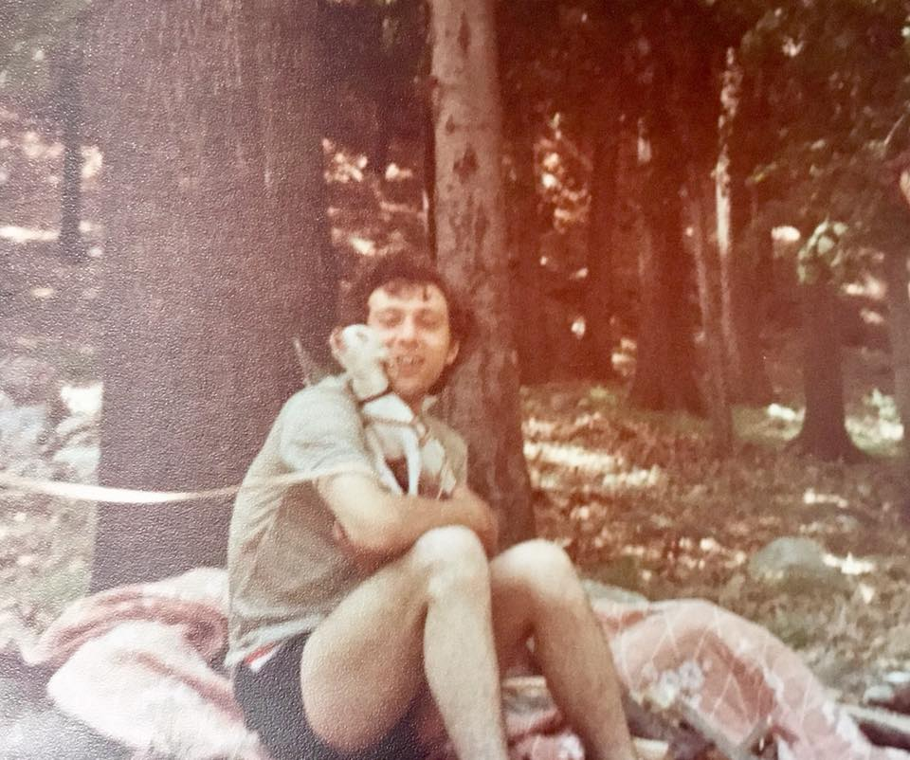

Bambi
Bambi strutted through the house like a king, his tiny frame belying the confidence of a much larger breed. He looked just like the cartoon character from Red Deer, his wide eyes and delicate legs making everyone fall in love with him on sight. But Bambi, our rescue Chihuahuacha had a naughty side—he humped everything in sight, utterly unfazed.
We knew our pup was not perfect from the beginning, but we put up with his quirks. We even mated him with a beautiful copper-colored female of the same breed, and he became a dad to four little pups.
But things took a wild turn after our son was born. In his usual cheeky manner, Bambi would sneak into the nursery and steal pacifiers as if they were his prized possessions. It didn’t stop there. One winter morning, just as I was about to take my son out for a walk, I discovered that Bambi had peed on the baby’s blanket. He sat by the door with that innocent face, tail wagging as if to say, “What are you going to do? I dare you.”
Eventually, with the chaos and a new baby in the house, we had to part with Bambi. But the story didn’t end there. We found him a home with a breeder, where he quickly became the leader of the pack. His tiny stature did nothing to diminish his rule. He earned the title by screwing every female and male.
And, as if his antics weren’t enough, Bambi had one more hidden talent—he was a singing dog. Whenever the right tune played, he threw his head back and serenaded the room, making us miss him a little more.

