It’s odd how cataclysmic events affect our lives. Some people suffer and lose irreplaceable valuables, homes, and in the worst case, lives Others may discover new connections or rekindle old ones. These events bring people together in unexpected ways.
Hurricane Helene decimated a corridor of land well beyond the shores of Florida, wreaking havoc inland and touching the state of Tennessee. In Germany, Helmut Müller, retired after years of working at Ramstein AB, Germany, saw a newspaper article about the disaster and wondered if his friend, Pete Bohannon, also retired and now living in Johnson City, Tennessee, had been affected.
Helmut emailed Pete and asked if he had any information about other American servicemen, he served with at Ramstein. I was one of the people on the list. Pete had my email address because he had been the best man at my wedding and we had kept in touch via Christmas cards and occasional catchup emails.
Helmut befriended a lot of Americans. In addition to his day job at the air base, he also was a member of the German Army Reserves. He invited many young airmen on weekend Bivouacs. One weekend it was my turn.
We camped out in small “pup” tents, one of which was devoted entirely to beer. After a night of revelry around a blazing campfire, the tent was empty and we were full. I walked to the campfire and vaguely remember crawling back.
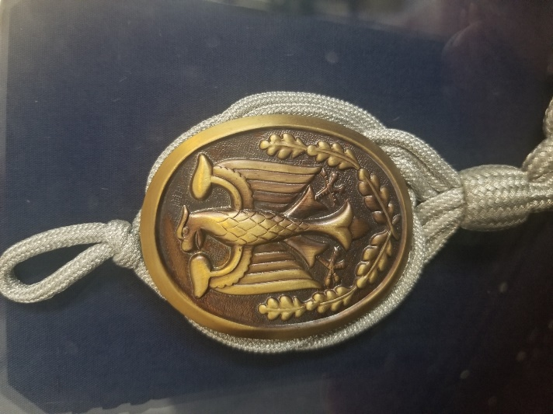
The next morning, we orienteered, or navigated by compass, through a swamp. It was an effective hangover cure. But the highlight of the weekend was a trip to the shooting range. I fired a pistol, a rifle, and a machine gun, and was surprised to find I’d won a Schützenschnur, the German marksmanship medal.
The Schutzenschnur, now in my display case.
I emailed Helmut and he responded.

