GOOD TIPS

My son, Jamie, lives by certain rules, some good, some not so much. One good rule is to always generously tip your waiter or bartender.
Joe and I were visiting Jamie in Annapolis, Maryland one summer and we decided to go into Baltimore’s Inner Harbor for the day. Baltimore Inner Harbor is a huge open area right on the water which historically was a former shipbuilding and steel mill site in the 1800’s. Today it is a popular destination with restaurants, shopping, entertainment and the beautiful Baltimore National Aquarium which we toured prior to lunch.
The three of us were enjoying a beautiful day eating at a table outside Planet Hollywood and Jamie began talking with Kevin, the young man waiting on us. Jamie has a unique talent of engaging people into comfortable conversations no matter where he is.
As we were getting ready to leave, Jamie placed a generous tip on the table. Kevin came over and thanked us, then asked if we would like to have free tickets to an Orioles Baseball game. He said he had to stay and work another shift and couldn’t attend.
We accepted the tickets and went to Camden Yards Baseball Stadium. It was an impressive stadium but even better, we were three rows up from third base. Thanks to my generous and cordial son, we got to enjoy a beautiful day rooting for the home team.
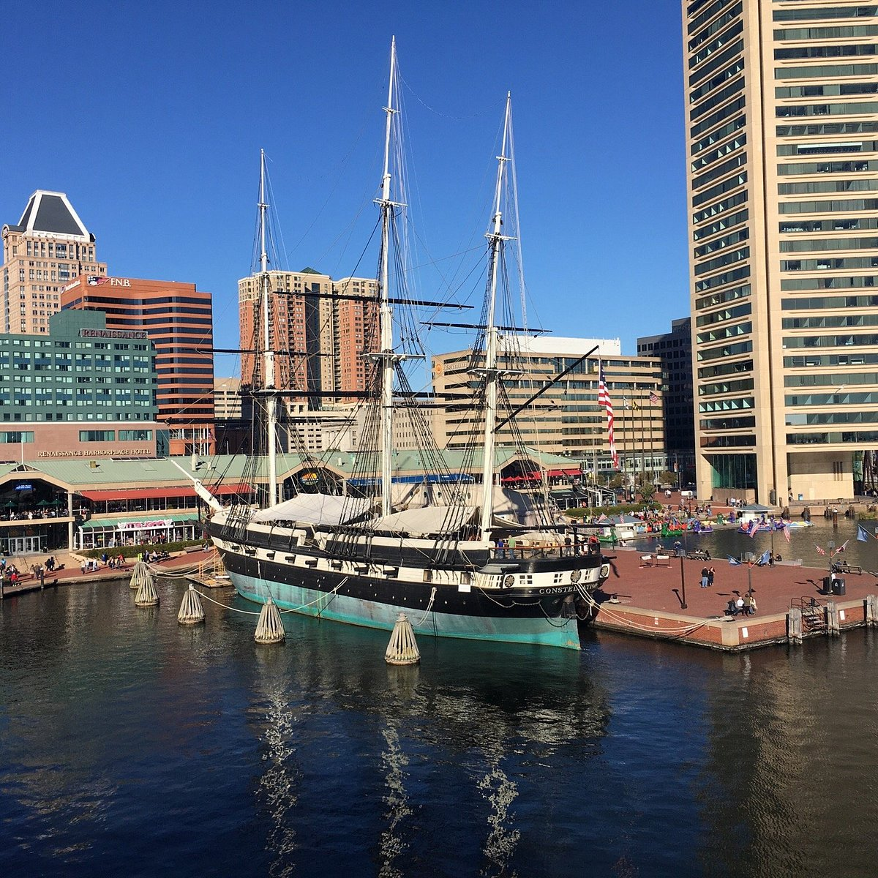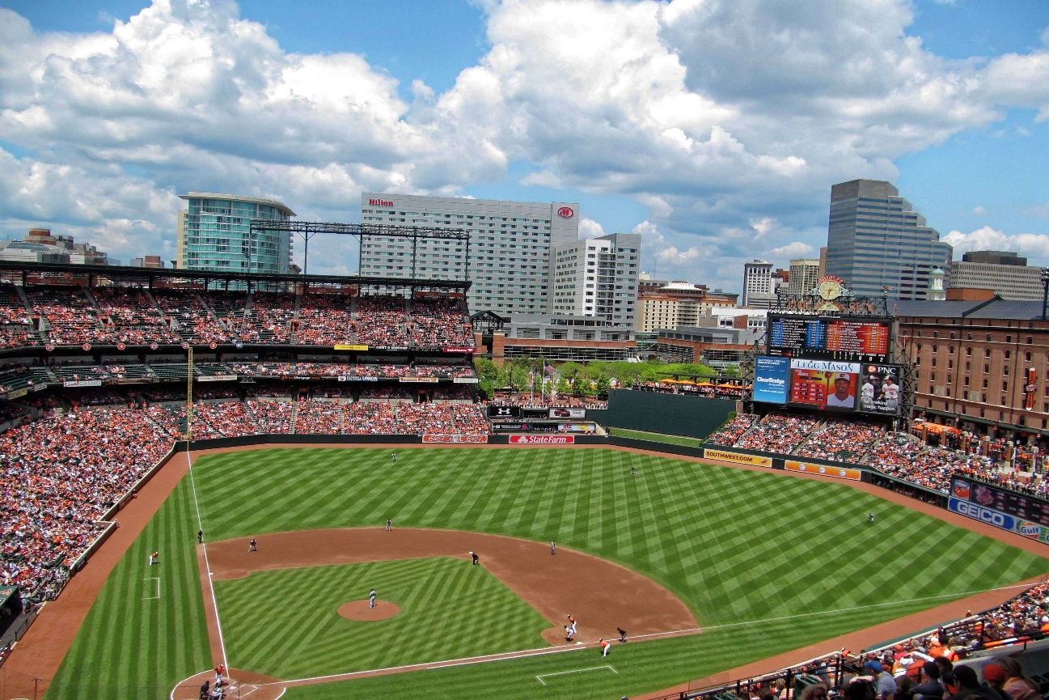

BALTIMORE’S INNER HARBOR
CAMDEN YARDS STADIUM

