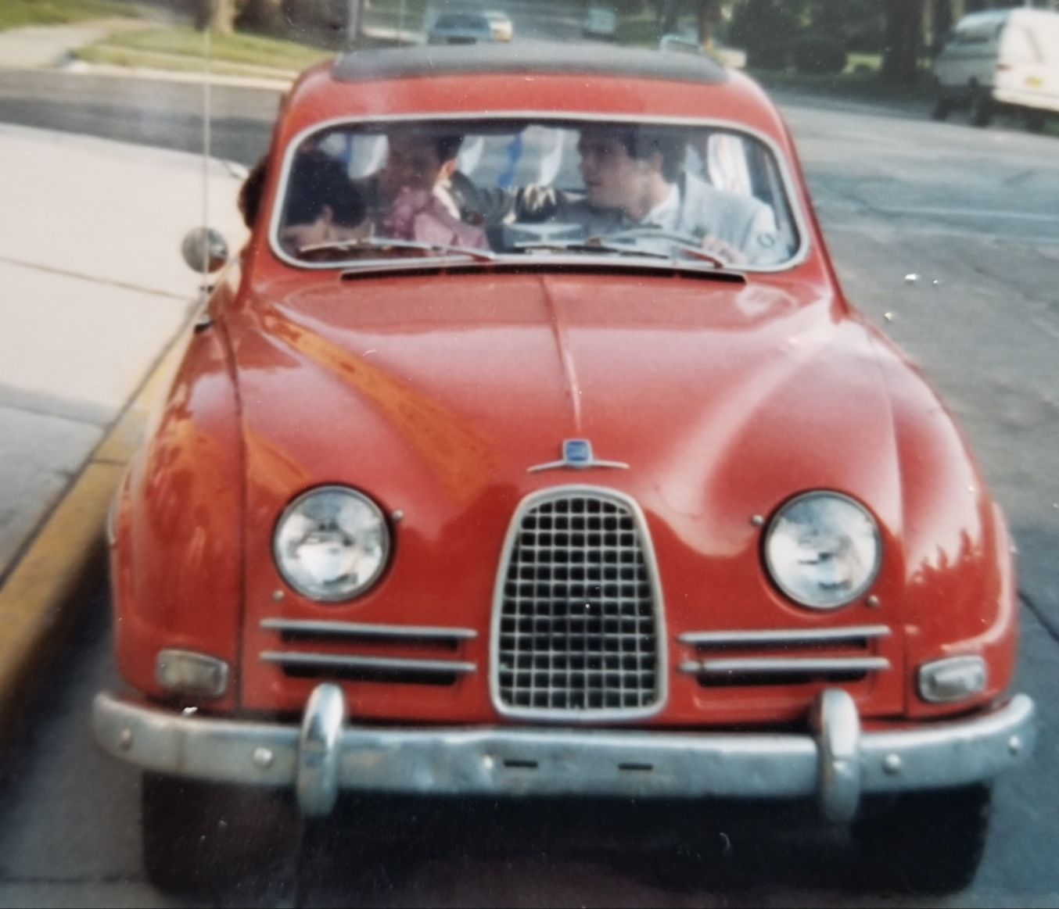
Dave Anderson is driving with my sister Mary in the passenger seat and Lisa and I in the back on our church Wedding Day, 5 Jul 86.
Danny wanted $300 for the 1962 Saab Type 96, his ice racing car, which was already 13 years old in 1975. The Saab was unique, and by unique, I mean quirky. I never saw another one on the road. The car spoke for me, my introverted self, saying all I would not say out loud.
The bright red exterior resembled a VW beetle that some benign giant had grabbed by the front and rear bumpers and stretched. It had a hand-operated fabric sunroof, a longish hood, and a smallish trunk.
The almost white metal dashboard held a speedometer, ignition switch, AM radio, glovebox, and a little odd knob. When you pulled the knob out, a curtain inside the front grille blocked the air, keeping the little engine warm in winter. The car had a “four-on-the-tree” manual transmission.
The little two-cycle, three-cylinder engine boasted fifty-seven horsepower, about half that of a large motorcycle. Curiously, the radiator was placed behind the motor, sandwiched between the engine and firewall.
When I filled up at the pump, I added oil to the gas tank and shook the car to mix it, which raised a few eyebrows. With a good tailwind, it made nearly seventy-five miles per hour.
The car loved snow. In deep snow, the front tires spun until they caught hold, and the little Saab took off like an underpowered rocket. It loved to ram snowbanks, sledding over them. With just a sharp turn of the wheel and a touch of the hand brake, it slid around snowy corners like a stunt car. I taught my sister the technique and let her use the Saab on the promise that she’d slide around a corner with Mom in the car.
Mom wasn’t happy about that. But I was.

