EIGHT MILLION STORIES PART TWO
JOHN ROCHE
Labor Day weekend 2024. While my cemetery adventures on Saturday opened my eyes, there was still some exploring to take place in the old neighborhood. On Sunday morning, I jumped in Boomer—have I told you that my daughter still owns my 2013 Honda CRV, that I call Boomer after a 2014 incident with a deer on Route 8 north of Pittsburgh? Digressing again. As if the cemeteries on Saturday weren’t enough excitement, I wanted to go back to the community that shaped my life.
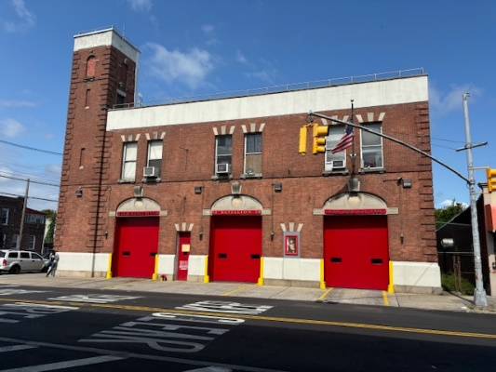
Traffic crawled on the Belt Parkway as I passed JFK International Airport. Not unusual—but worth noting. While driving to Flatlands in Brooklyn, or as my dad used to call it, “BROOKLYN, USA,” a thought shot into the seventeen-year-old brain. Let’s get off at Rockaway Parkway and stop at Hook and Ladder Company 170. I can introduce myself as the son of a former FDNY retiree. Knowing the firefighter spirit, they might give me a decent reception.
However, I heard sirens as I exited the parkway. While I was stopped at the traffic light, a fire engine with huge numbers 257 raced past the intersection. Engine Company 257 shared the building with Hook and Ladder 170. When I turned right on Rockaway Parkway, Hook and Ladder 170 screamed past me, hot on the trail of Engine 257. I thought of my dad, Georgie would have been so proud to see his successors responding to an emergency, but my visit to the empty firehouse was off.
Disappointed, I drove on to Flatlands.
It’s been many, many years since I traveled down Flatlands Avenue. I shouldn’t have been surprised at the hustle & bustle along the three-mile route. But the sight of the endless number of businesses lining both sides of the street took me by surprise. In my younger years, I often rode my bike along Flatlands. The neighborhood had an almost rural feel to it, with single family homes spread out among the canals that fed off Jamaica Bay. From the looks of it, I’d say many of those waterways had been filled in at some point.
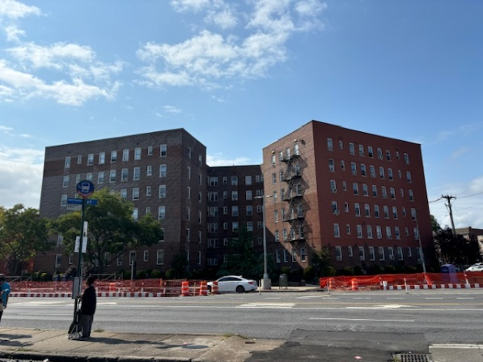
I decided to take the back-door method to my old haunts. I turned off Flatlands at Avenue L and turned right on Troy Avenue. The intersection at Avenue K was a right turn only. I looked to my left—shocked to see the apartment across Kings Highway. The building was the scene about one of my earlier vignettes titled Bulbs A Poppin, which I wrote in December 2023. I found a parking spot and took some photos of 4149/4155 Kings Highway.
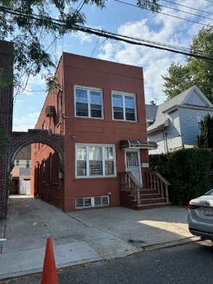
After the brief stop, I cruised the old hood. Passing my elementary school-- PS 119—I meandered down E. 38th Street, until I stopped in front of 1154, the house where I lived my wonder years. There was no traffic. I sat there for a few minutes, admiring how well the building had been kept up. No longer a stop sign at the corner of Avenue J, I waited about thirty seconds for the traffic light to turn green.
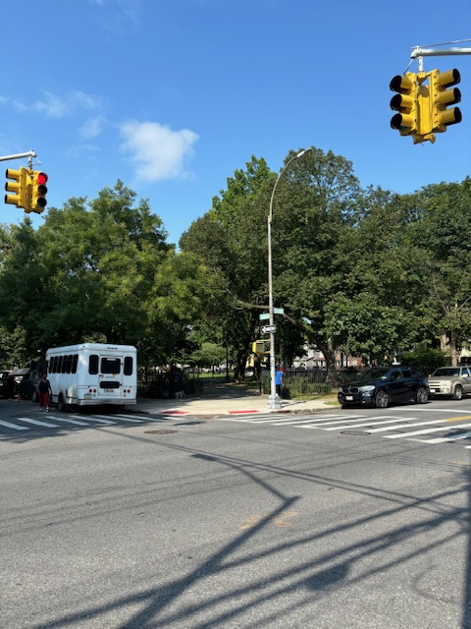

I coasted down E. 38th. The full city block Amersfort Park—my cronies and I knew it as “J” Park—materialized on the right. I found a parking place near the middle entrance.
I wanted to walk through my Field of Dreams. Once bordered by huge sycamore, maple and oak trees, the central mall was a large flat, well-trimmed grassland. I played first base—maybe an omen, since I never got past first base for a long, long time-- in the spring and summer. In autumn and winter, John Roche was an NFL quarterback, throwing perfect spirals to my receivers. Now, his field is gone. Replaced by three-to-four-foot mounds among the dozens of new trees, No more home runs…no more touchdowns.
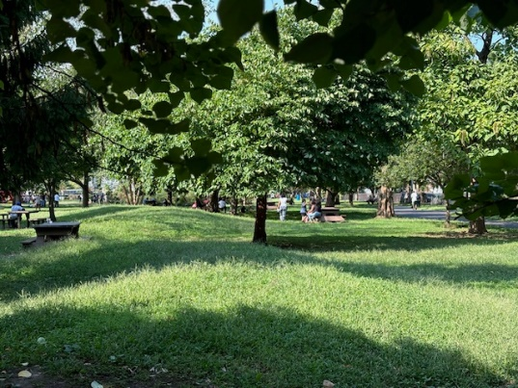

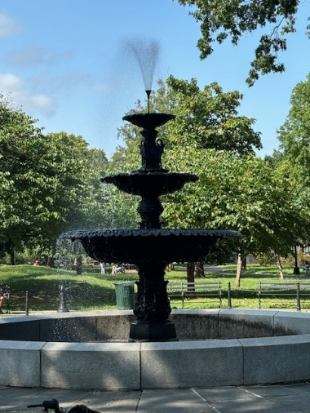
I strolled toward Avenue J. The “Umbrella” was gone. Rain or shine, the umbrella was our meeting place. Once a haven for the lily-white kids of Flatlands, older West Indian gentlemen now sat on park benches around a beautiful fountain.
I approached the group and sarcastically asked, “What have they done to my park?” To a man, they all just looked up at the crazy white guy who was screaming in their park. The Seniors from the West Indies did not speak or understand English. I quickly took some pictures before leaving.
Back in the car, I cruised up and down the streets of my youth like a Zamboni cleaning the ice at a hockey game. Halfway down East 39th Street between Avenues I & J, a shiver ran up my spine as I passed Faye Mazetta’s house. Faye and I had a crush on each other. She was a year older than me, attractive, and an honor student. That trifecta scared the hell out of me—didn’t know about cougars back then. Things just never worked out. One of those “what ifs” in life.
I departed the haunts by turning right off Avenue J on Brooklyn Avenue. I passed the NYPD 63rd Precinct building, then moseyed around the junction area of Flatbush and Nostrand. After the afternoon finished, I returned to my daughter’s apartment in Queens.
Just another day of fresh squeezed lemonade.

