EIGHT MILLION STORIES PART ONE
JOHN ROCHE
Labor Day weekend 2024. Peg and I flew up to the Big Apple for her annual appearance at the U.S. Open tennis championships with our daughter Morgan. Peg and Mo have a glorious tradition at the old world’s fair site in Queens. John—as in me—gets left to his own devices. I lost my flavor for tennis a while back. So, I don’t usually get invited.
At one point, I thought about joining them. Peg told me, “I’ll buy you a general admission ticket and you can come along.”
“How much is the ticket?”
“$300,” she answered.
“I’ll go to Plan B.”
Two years ago, I used the same opportunity to look up an old friend. The day became the catalyst for a story named PAT, my submission to the LifeWriter’s Anthology Turning Points. Déjà vu all over again. I called Pat and we were going to spend the day driving around Staten Island, bringing back old memories of my college days while the girls were having fun at Billie Jean King land.
Unfortunately, Pat had some family issues and cancelled, leaving me with eight million options to salvage the day. When life gives you lemons, you make lemonade.
My mom, aka Booby, passed away on Groundhog Day 2023. She was 102 and led an interesting life. I had not been to the gravesite since her funeral. So, I thought I’d pay her a visit.
At this point, I feel the need to insert a little family history. In 1970, my uncle Rich passed after an accident onboard ship off the coast of the Belgian Congo. He had married a Jew and later divorced. The Catholic Church did not consider his remains worthy to be interred in at the Roche family plot on the consecrated grounds of Holy Cross Cemetery in Brooklyn. My father, who married a heathen—as in non-Catholic-- my mother, also was not welcome to spend perpetuity with the wild and wonderful Roche clan at Holy Cross.
Enter Nassau Knolls. The resting place is a small, comfortable location for the deceased. I don’t have a clue how they picked out. the location. But they’re there. When we buried Booby last year, only two names were on the stone, Dad and Uncle Rich. We had not heard from my uncle’s last wife, Betty, for at least twenty years. We presumed that her children had better ideas for her remains than spending eternity with the Roches.
The trip to the cemetery in Port Washington on Long Island included the usual bumper-to-bumper traffic on the Long Island Expressway—known to all as the L.I.E. Doesn’t much matter what time of day…you’re gonna experience twenty mph in a fifty-five zone on the L.I.E. I made a quick stop at a deli to get a sandwich and a bottle of water. A family tradition, the Roches take something to eat at the gravesite, calling it a picnic.
I pulled the car up to the Section One marker and noticed the lack of grass growing in front of the grave. Odd, I thought. Two things stood out.

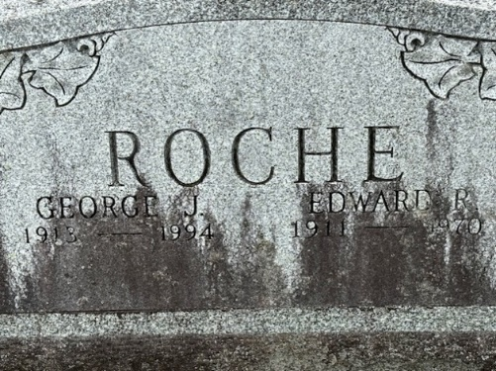

My mom’s name wasn’t engraved on the stone. Wait a minute. She was buried a year and a half ago. What gives? I’ll check it out at the office.

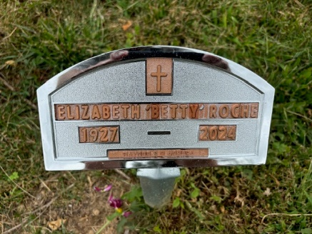
A small marker stood next to the stone with Betty’s name on it. No exact date. Just read 2024. One may think it odd—maybe even a little bit morbid-- but I was overjoyed to see Aunt Betty’s name on the marker. It meant that the foursome was once again together. Ahhhh! Spiritual relief.

I drove down to the office. It was Saturday before Labor Day. The bathroom was open—thankfully—the office was closed.
My picnic in Port Washington finished, I drove for an hour to the consecrated Roche resting place at Holy Cross Cemetery in Brooklyn.
Travelling along Brooklyn Avenue, memory after memory popped into my head. Between Avenue I and Avenue H stood “The Cut,” where my peers once gathered to observe the freight trains rumbling through the neighborhood. At Farragut Road, I passed the home of Theresa Anne Mylot, a very aggressive girl who I could not handle. While stopped at the Church Avenue red light, an MTA B35 bus lumbered eastbound. I rode that bus to my friend Dana’s house. A twinge of excitement ran through my body, when I recalled his mother, Maria--one hot redhead. The light turned green, and the car rolled toward my Tilden Avenue destination.
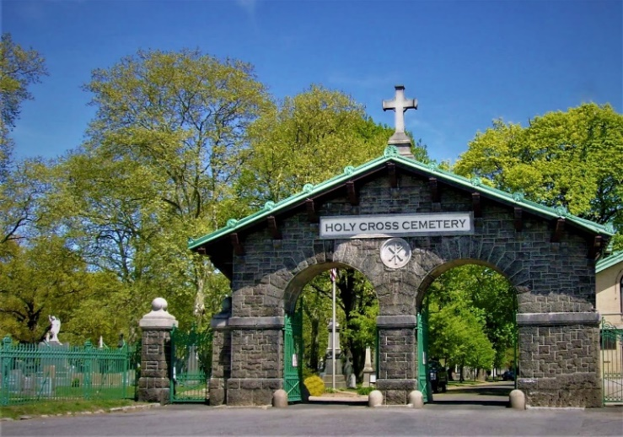
Relatively small at 100 acres, the Diocese of Brooklyn maintains the consecrated grounds. I was greeted by a friendly caretaker, who fielded my requests and directed me to the Roche family plot. I meandered to the Saint Ambrose section, where childhood memories of bus rides to the resting place with my parents came to life. It may have been a lucky guess, but I parked the car at the right row. Three stones down stood the grave marked ROCHE.
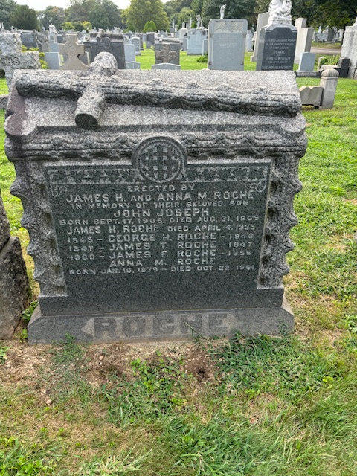
Six souls occupied the resting place, three of whom were infants. George, who only survived three months, would have been my big brother. Then again, would they have conceived me, had he lived? Sweet mysteries of life. I said a prayer and departed.

It was getting late in the day. After stopping at the office to thank the caretaker, it was to return to my daughter’s apartment in Queens. Approaching Linden Boulevard, a 17/76 moment occurred.
Seventeen-year-old John announced, “I want to go to Greenwood.”
Seventy-six-year-old John responded, “But I’m tired and running out of gas.”
“Shut up 76. You only go around once. We’re going to Greenwood. Suck it up.”
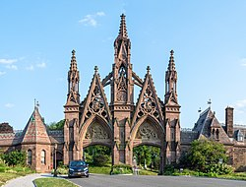
Greenwood Cemetery is where my mother’s relatives--the Pitts and the Rigoulots--reside now. I think of Greenwood as the Forest Lawn of the east, because of the number of celebrities buried there. Among them, Leonard Bernstein, “Boss” Tweed, Charles Ebbets, DeWitt Clinton, Horace Greeley, and Louis Tiffany.

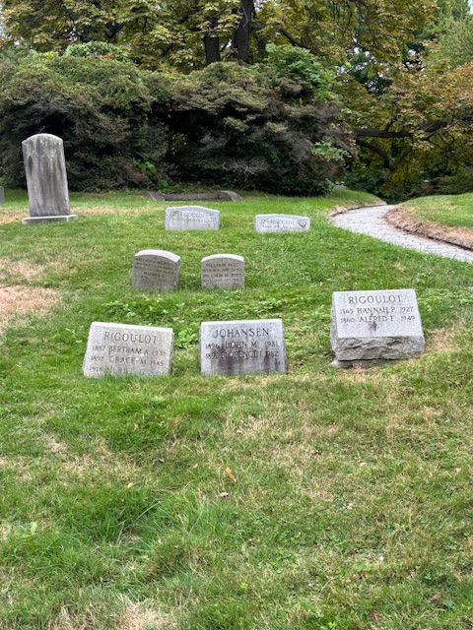
The property is a massive 478 acres. Adorning the rolling hills and dales, over 7000 trees and several ponds make this location an oasis within the bustling borough of Brooklyn. The cemetery offers daily group tours via bus or walking. One can just walk through the grounds looking for celebrity gravestones--celebrity maps are available at the main gate. Several spots in the park boast spectacular views of the New York City skyline.

My next stop was Calvary Cemetary in Queens, where I thought two of my aunts are now residing rent free. The stop was going to have to wait until Sunday morning, as the day was getting late. The traffic crawled on the Brooklyn-Queens Expressway—the B.Q.E. On Sunday morning, I wished to look in on my favorite aunt—Clara—and her sister—Estelle. Both passed in 1974.
I navigated to Calvary on Sunday. I wasn’t quite sure where I was going to find my relatives. The cemetary was closed. Returning to my daughter’s apartment, I jumped on the internet, realizing that I was looking in the wrong boneyard for my aunts. They currently occupy a plot in the high rent district of Evergreen Cemetary in Queens. I didn’t get to visit them—I’ll take care of that on my next trip to the Big Apple. I was able to get a picture of their shared crypt.
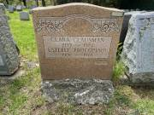
Honestly, Saturday was a tad different. But it may have been one of the best glasses of lemonade ever.

