THE First Lady
John Roche
In 1979, I received a Christmas present from Colonel William McQuade, 911th Airlift Wing Commander. On December 29th, I assumed the command of the 17 member 911th Weapons Systems Security Flight--a group that expanded to 84 personnel over the years and become the 911th Security Forces Squadron during my command. The squadron was extremely active for a reserve unit. We trained for a world-wide mission. We normally activated on very short notice.
Among my favorite events were the Pittsburgh visits by VIPs. I worked with the Secret Service, other armed forces units, local law enforcement entities, and municipal authorities for almost fifty arrivals at the Pittsburgh International Airport (PIT). Always an exciting time, the conclusion of the trip ended with a reception line at the aircraft for the support personnel. I shook the hands of Presidents Carter, Reagan, George Bush, Clinton, and George W. Bush. How many non-political folks can make that kind of statement?
That said:
I only met the lady for a minute or so in 1980. She made a memory that is as clear as crystal some 44 years later. My first VIP detail was for the First Lady in 1980. As a rookie second lieutenant, I was excited to be called in for the security detail. The normal pre-visit briefings took place before the arrival. Trust me, the security arrangements are very detailed from touchdown until wheels-up.
Rosalynn Carter arrived, deplaned, and left the base in the six-car motorcade. Where she went, I do not know. But I found the down time in between arrival and departure to be very boring. I sat in my office for several hours until the phone call came in telling me that DANCER was on her way back to the base.
I rallied the troops and we returned to the flight line. The event went smoothly, and the support personnel were asked to line up for the reception by Mrs. Carter. I was last in line. The White House photographer asked me if I would like to take a picture with the First lady. Who would refuse such an offer?
I still melt, when I think of the wife of the President of the United States walking up to me, offering her hand and saying in the most Plains, Georgia charming southern drawl,
“You mean you want to take a picture with little ole me?”
I had to do all I could from losing it.

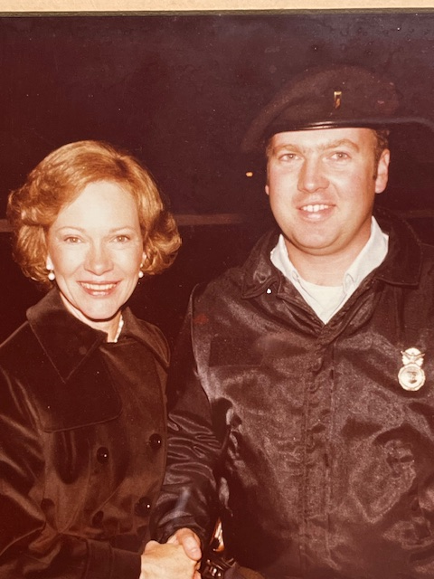

Rosalynn Carter passed away last week. Upon hearing the news, I smiled as I thought of that night in 1980. Her words still make me melt…and smile.

