EIGHT MILLION STORIES PART TWO
JOHN ROCHE
Labor Day weekend 2024. After my cemetery adventures on Saturday, the old neighborhood still awaited me. On Sunday morning, I jumped in Boomer—my daughter still owns my 2013 Honda CRV, that I call Boomer after a 2014 incident with a deer on Route 8 north of Pittsburgh. Digressing again. As if the cemeteries on Saturday weren’t enough excitement, I went back to the community that shaped my life.
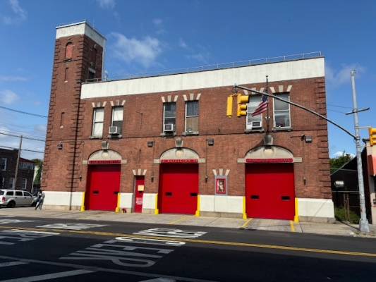
Traffic crawled on the Belt Parkway as I passed JFK International Airport. Not unusual, but worth noting. As I drove toward Flatlands in Brooklyn, or as my dad used to call it, “BROOKLYN, USA,” a thought shot into the seventeen-year-old brain. Let’s get off at Rockaway Parkway and stop at Hook and Ladder Company 170. I can introduce myself as the son of a former FDNY retiree. Knowing the firefighter spirit, they might give me a decent reception.
I heard sirens as I exited the parkway. While I was stopped at the traffic light, a fire engine with huge numbers 257 raced past the intersection. Engine Company 257 shared the building with Hook and Ladder 170. When I turned right on Rockaway Parkway, Hook and Ladder 170 screamed past me, hot on the tail of Engine 257. My thoughts flew to my dad. Georgie would have been so proud to see his successors responding to an emergency, but my visit to the empty firehouse was off.
A tad disappointed, I drove to Flatlands.
Many, many years since I traveled down Flatlands Avenue, I shouldn’t have been surprised at the hustle & bustle along the three-mile route. The sight of the endless number of businesses lining both sides of the street still took me by surprise. In my youth, I often rode my bike along Flatlands. The neighborhood had an almost rural feel to it, with single family homes spread out among the canals that fed off Jamaica Bay. It appeared many of those waterways have been filled in over the last sixty years.
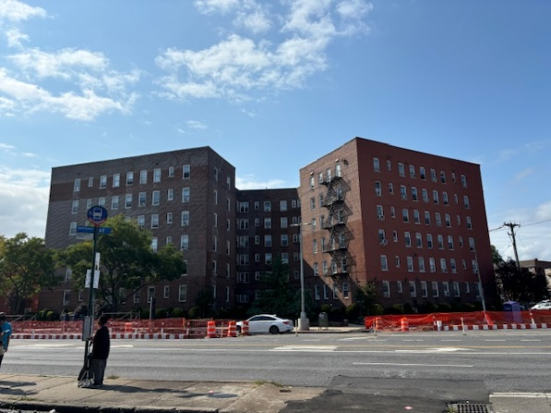
I turned off Flatlands to Troy Avenue. Approaching Avenue K, I had only one choice, a right turn. To my left a déjà vu moment occurred as I looked at the apartment building across Kings Highway. The building was the scene about one of my earlier vignettes titled Bulbs A Poppin, written in December 2023. I found a parking spot and took some photos of 4149 Kings Highway,

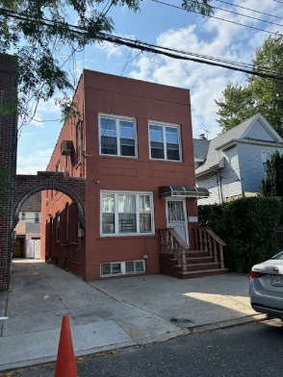
After the brief stop, I cruised the old hood. Passing my elementary school-- PS 119—I meandered down E. 38th Street, until I stopped in front of 1154, the house of my wonder years. There was no traffic. I sat there for a few minutes, admiring how well the building had been kept up. After a few minutes, I drove on. In my youth, a stop sign would have greeted me at the corner of Avenue J. Now a traffic light greeted me. I waited about thirty seconds for the traffic light to turn green.
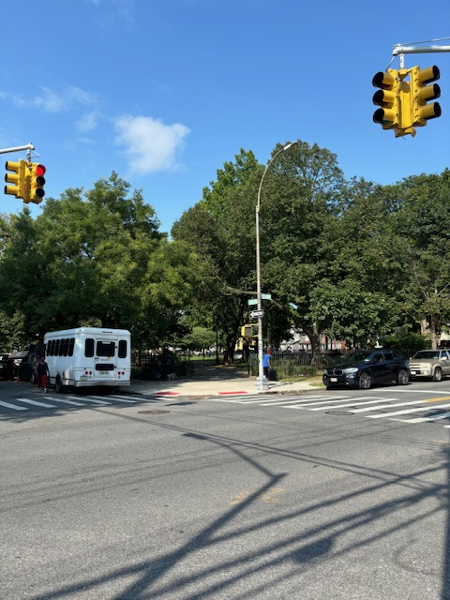
The light changed and I coasted down the street. Amersfoort Park—my cronies and I knew it as “J” Park—filled the entire city block to my right. A parking space appeared near the central entrance.
I walked through my Field of Dreams. Once bordered by huge sycamore, maple and oak trees, the central mall was a large flat, well-trimmed grassland. I played first base—maybe an omen, since I never got past first base for a long, long time-- in the spring and summer. In autumn and winter, John Roche was an NFL quarterback, throwing perfect spirals to my receivers. Now, his field is gone, replaced by three-to-four-foot grass covered mounds among the dozens of new trees, No more home runs…no more touchdowns.
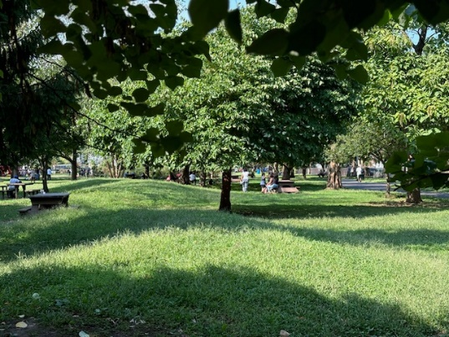

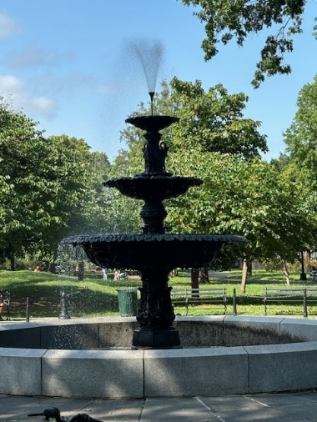
Strolling toward Avenue J, the “Umbrella” was gone. The umbrella was a ten-foot tree stump covered by a large circular metal canopy. Rain or shine, the umbrella was our meeting place. Once a haven for the lily-white kids of Flatlands, older West Indian gentlemen now sat on park benches around a beautiful fountain.
I approached the group and sarcastically asked, “What have they done to my park?” To a man, they all just looked up at the crazy white guy who was screaming in their park. The Seniors from the West Indies did not speak or understand English. I quickly took some pictures before leaving.
Back in the car, I cruised up and down the streets of my youth like a Zamboni cleaning the ice at a hockey game. Halfway down East 39th Street between Avenues I & J, a shiver ran up my spine as I passed Faye Mazetta’s house. Faye and I had a crush on each other. She was a year older than me, attractive, and an honor student. The trifecta scared the hell out of me—didn’t know about cougars back then. Things just never worked out. One of those “what ifs” in life.
I turned off Avenue J to Brooklyn Avenue, driving past the NYPD 63rd Precinct building. Nostalgically, I entered the junction at Flatbush and Nostrand, the hub of the Flatlands/Flatbush district. The afternoon finished, I returned to my daughter’s apartment in Queens, savoring another drink of lemonade.

