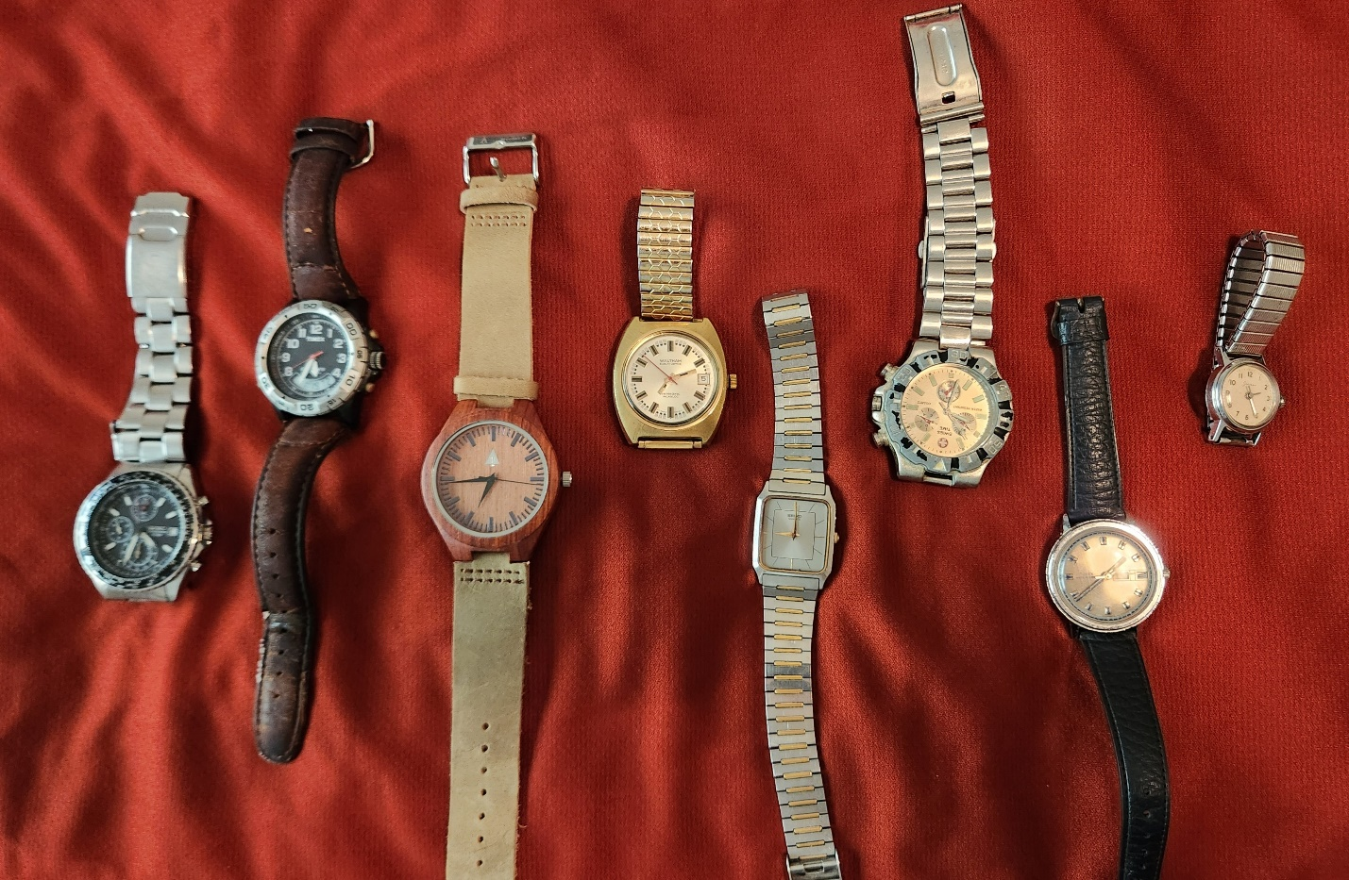
Watch This…
1
8
7
6
5
4
3
2
Obviously, I like electronic and mechanical watches, although I prefer mechanical, or I wouldn’t have so many of them. It fascinates me that a craftsman can create a windup mechanical device with springs and gears small enough to fit on a wrist and keep accurate time.
I used to tease Mom that if she didn’t spend her money, I’d waste it on something foolish like a motorcycle. When that threat wore thin, I told her I’d buy a Rolex. One day, she called my bluff. She said, “Did you know a Rolex costs eighteen thousand dollars?”
I considered buying a Rolex when Mom died as a remembrance, but I found that Rolexes do indeed cost eighteen thousand dollars. I inherited a bit of cheapness from Mom, so I didn’t buy one. Maybe I will if the price comes down. I occasionally look at cheaper mechanical watches like a Bulova, but I don’t use a watch enough to justify the cost.
When I wear a watch, which is no longer a daily thing, I pick watches #1 and #2, but mostly #1. The #1 watch, a Seiko, is an aviation chronograph and performs most of the functions of an E6B flight computer. A multipurpose dial around the face is part of a slide rule function comprised of the fixed dial under the bezel and the moveable dial outside.
For example, to multiply six times six, place the six or sixty on the outside dial in line with the ten(one) on the inside dial. Then look for six on the inside dial. Opposite of the six, on the outside dial, you’ll see thirty-six. A reverse process is used for division. For example, to divide thirty-six by six, find thirty-six on the outside dial and align it with six on the inside, in a ring at the edge of the watch face. Then look for the Ten(one) on the inside dial. The answer, six, will be aligned with it on the outside dial. The user must keep track of the decimal point as the slide rule doesn’t accommodate it. I doubt anyone under sixty has ever used a slide rule for computation.
Watch #2 is technically the last military watch I used and my third Timex Explorer. It is light and has the handy Indiglo nightlight feature. Like watch #1, it also has a movable dial, called a bezel, around the face, a handy feature for using the watch as a compass for land navigation.
Watch #3. Joseph gave me this watch at his wedding. It has a unique wooden body, and his wedding date is engraved on the back. I wonder how waterproof it is, but I won’t test it.
My sister Mary gave me Watch #4 as a high school graduation gift, paid for with babysitting money. I kept it because she gave it to me. I know what time and effort it cost her. She earned money by spending countless hours watching other people’s kids instead of having fun, and because a thirteen-year-old kid doesn’t have a lot of money, the purchase represents a significant sacrifice on her part. The Waltham watch is an early battery-operated model. Unfortunately, the batteries in these early watches lasted not years but months. The watch still runs, but not for long.
Watch #5 is a “Tank” model Seiko, so called because of its squarish design. I bought it at the BX at Ramstein in the 1980s using Christmas money from Dot and John DiFava. I like the watch's thin, almost weightless design because it doesn’t flop around on my wrist, but I wish it had a secondhand. I haven’t worn the watch in years because I have become enamored with the larger chronographs.
Watch #6 doesn’t work. It just quit one day without warning, like a disgruntled employee. I bought the watch at a bazaar in Balad, Iraq. It bears the scars of constant exposure to the heat and sun of a semi-desert climate and the corrosive limestone in concrete. I suppose I keep it for sentimental reasons since it is the last watch I wore when I did real work. When we returned from the deployment, I became a First Sergeant, a position I held for five years, and then a Superintendent.
Watch #7 is a mechanical wind-up watch. It still works. I wore it as a teenager and failed to throw it away. It’s funny; I have the watch but have no idea where my high school class ring, which mom insisted I had to have, is.
I received Watch #8, a wind-up Sears brand and my first watch, on my First Holy Communion. The watch looked right-sized on my eight-year-old wrist, but now I realize it is smaller than the traditional woman’s watch, and I have to squint to read the numbers. It still runs.
My First Sergeant watch is not shown. I bought it at the First Sergeant Academy and wore it until I gave up the diamond. The watch isn’t part of my collection of artifacts, as it is in my retirement medal display case on what, in military terms, is called an “I love me” wall.
And now, for the lesson in land navigation you didn’t know you needed or wanted. Analog watches with hands can be used as a navigational compass. Lay the watch flat and point the hour hand at the sun. Halfway between the hour hand and the twelve o’clock marker is South. If the watch has a movable bezel, rotate the bezel to indicate south. This method works for approximate directions and is an excellent backup navigation method. I am all about being able to navigate after I spent the night stranded in the woods as a teenager. I wrote about it under The Silva Compass heading.

