THEN AND NOW PROMPT DECEMBER 2024
CHRISTMAS
When the white flowers of a wild shrub, “bitter bush,” appeared, the leaves of Euphorbia, or Snow in the Mountain, began to turn white, and the green leaves of the Poinsettia, with which it was often planted, changed to red, then my heart filled with joy and excitement. Christmas was
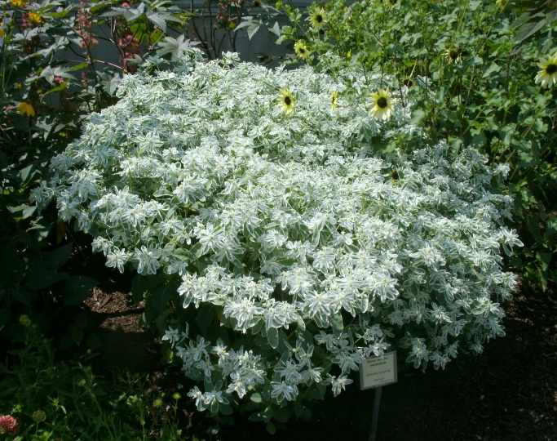
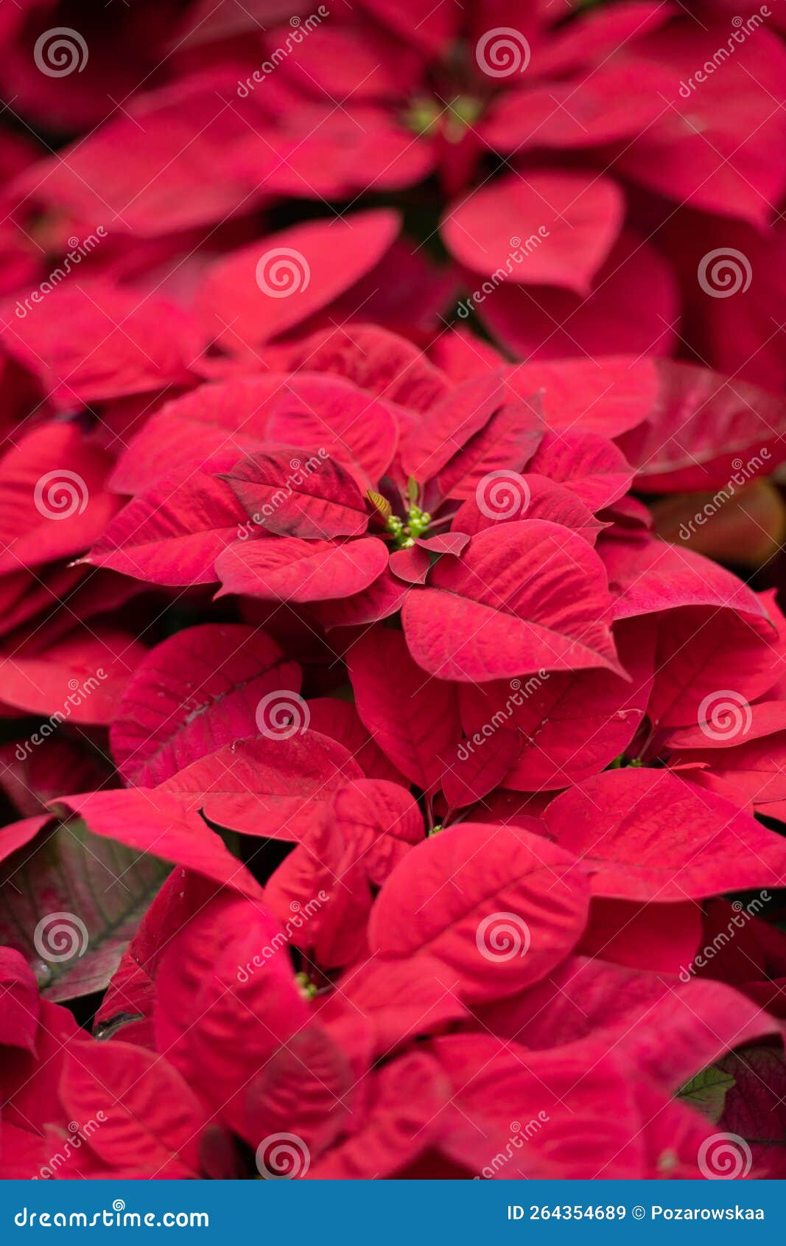
fast approaching. Shortly, the surroundings would be ablaze with this spectacular show of colours.
Christmas traditions would soon begin in our home. One of these was my dad arranging to paint the house. The lower two feet of trees around the yard, curb walls and garden stones were painted with “whitewash”, a solution of water and lime from the lime-kiln my father had burned over a period of maybe three days, some months earlier.
Then Mum, with the help of my older sisters, hung new drapes and curtains, they had either purchased or sewn.
Other activities included baking of Christmas cakes, for home consumption and also to give as presents, or serve to guests who visited us during the holiday season.
One highlight for me was going to Grand Market in Mandeville, with my older siblings and some of their friends, on Christmas Eve night. There, we strolled through the bright, twinkling lights of the capital, greeting friends whom we encountered. The street vendors were still out, and some stores remained open. This proved convenient for those who had not yet completed their shopping.
My treats included ice cream cones, crunchy American apples, unlike our local soft-textured red Otaheite apples, sweets, and chocolates. A cold bottled pineapple soda was my favourite drink. Even today, I occasionally indulge in that soda, just to feel the nostalgia of those earlier years. The siblings closer to my age and I, purchased starlight sticks that emitted sparkles like stars when lit, and also a mechanized toy with a handle that I wound up until the handle became taut. Releasing the handle set tiny wheels in rapid motion with a whirring sound. Friction produced flashes and sparkles of colourful lights. The results also produced the smell of a chemical reaction, and burning metal.
Attending church on Christmas Sunday with my parents, and other members of my family, was non-negotiable
On Christmas day, or the designated day, the celebrations began. My family’s traditional Christmas dinner consisted of stuffed roast turkey, roast beef, fish, rice and peas, steamed vegetables and a fresh, garden salad. The showpiece was the leg of ham, baked, cored, and glazed, and decorated with cloves, pineapple slices and cherries. The rich aroma of food cooked with spices and herbs, lingered in the air, activated my nostrils and whetted my appetite.
Prior to this, Dad brought the ham home. It was a large object, wrapped in a black casing, and covered in transparent plastic. The casing was a black rubber/tarlike substance, and I watched as dad carefully cut and peeled it away, bit by bit. This revealed the ham, tucked snugly in a greasy netting. Then the process of preparing the ham began. This required a fire outside in the coal pot and placing on it a large container with water. Dad then immersed the ham to boil for about two hours to precook it, and get rid of excess salt. On completion of this step, the ham was then ready to be baked and dressed. We enjoyed the ham over a few days until only a large bone remained. This was destined to create the grand finale, a steaming pot of ham bone flavoured red or gungo peas soup. This meal marked the end of Christmas celebrations.
Having eaten our Christmas dinner, my family and I distributed presents from under our Christmas tree. Recipients opened and displayed them on respective beds, decorating the arrangements with flowers and foliage from the garden. I enjoyed going from room to room throughout the house, visiting the displays, admiring the presents everyone else got, and hearing who gave them.
After Christmas, we visited our relatives and friends, primarily on my paternal side. Some of them lived many miles away, where it was even cooler than in our area. They visited us, in return. My sisters and I looked forward to being served Christmas cake and sorrel, a popular red Christmas drink, at all the homes we visited.
There was a hiatus in Christmas celebrations for me, between the years 1967 to 1970, when my sister, Winsome and I, pursued tertiary education in Canada. We attempted to follow one of the annual rituals in our first year, and tried to bake a traditional fruit cake. Then I suggested,
“Let’s go all the way, and put some icing on the cake.”
“Are you sure? Do you know how to?”, Winsome replied, tentatively.
Enthused, I said, “Yes, I remember how it’s done. In addition, why don’t we use blue colouring in the icing?”
Something went wrong along the way, The blue icing tasted bitter, and ruined the cakes. But the icing was not the sole reason for the disappointing results. That was our first and last attempt to make our Christmas cake.
During those four years, a couple from our church, Ewald and Morna Kiel, hosted us to Christmas dinner. There we had a Christmas tree, turkey and the trimmings, with cake, mince pies, butter tarts, and ice cream for dessert.
I returned to Jamaica in September, 1971 with my husband. Much had changed since I left in 1967. My Dad sold the farm and moved closer to the town of Mandeville. Most of my siblings left home, set up homes elsewhere in Jamaica, and started families of their own. Keith remained at home with his family. My sister, Winsome remained in Canada and continued to reside there with her family. Some years after my return, another sister, Marcia and her family left to reside in the USA.
Our family numbers increased greatly with the addition of spouses, children and grandchildren, a total of twenty-six persons. My siblings and their respective families living in Jamaica, all returned to our parents’ home for dinner at Christmas. Marcia and Winsome, and their family, joined us occasionally.
The practices for the Christmas celebrations remained the same, except that the menu expanded to include curried, goat, and macaroni pie, and after distribution of presents, respective families visited with each other, young children and teens gravitated to those of around the same age. The youngest children drifted outdoors to stroll on the lawn, admire and even pick flowers in the garden, and play games in the open air.
The sound of harmonious chatter resounded throughout the property.
Dad held court with the men in the family, in the sitting room. Conversations got animated. and together they enjoyed a few beverages. This included his famous pimento liqueur, which he made each year, and gave one bottle to each of his sons and sons-in-law. Somehow, that served as a reminder to the latter, that they each met with his conditional approval, and that he expected them to be good to his much-loved daughters.
Mom sat on the porch, her presence welcoming, her smile, warm. Members of the entire family, including children stopped by and visited with her. Here, they updated her on developments within their family, enquired of her well-being, and of any plans for the future.
My parents were delighted and fulfilled to have their grandchildren around them, and firmly believed having young children around, kept them young. I saw unconditional love in words and actions as my father affirmed,
“Let all the grandchildren come, and break up my things.”
Staunchly by his side, it was evident that Mum shared the same feelings.
I have never permitted myself to forget those words.
Over the years, 1978- 2002 even though I lived in Trinidad and Tobago, I returned home each year to share Christmas celebrations with my family. Our dad died in 1983, but our family continued to celebrate Christmas dinner at home with Mum, until her death in the year 2000.
As long as her health permitted, Mum continued to make the house ready for Christmas even getting done tasks that Dad had undertaken.
I relocated to Canada in the year 2002, yet embarked on my pilgrimage to Jamaica each year, to celebrate Christmas with our extended family.
My mother’s death, in the year 2000, led to more changes. The time and place for our Christmas dinner began to rotate among the homes of family members. Contributions from each home, consisted of drinks, various dishes and desserts.
All my siblings prepared their homes for Christmas in the way we had grown accustomed to. Christmas dinner day began very early to give us sufficient time to complete all the cooking, and leave home in time to arrive at the venue promptly.
Families continued to exchange gifts.
Subsequent events led to further changes in our celebrations. Rupert, the eldest child, died in 2013, Pauline the second oldest died in 2020 and Jasmine the fifth child, in 2022, leaving Mary, and me in Kingston, and Keith in Mandeville, sixty miles away.
Our individual homes have now become the hub for our families’ Christmas dinner. We are now the elders in our families. Traditions die hard, and each year finds me observing the rituals and trying to create the atmosphere I became accustomed to. There are five members in my family, plus one who resides in Canada. Some of the dynamics of shared bonds among siblings, and the buzz of large family celebrations, are absent.
The words of the following song, “Where are you Christmas” capture how the Christmas celebrations transitioned, for my family and me, and my sentiments.
……. My world is changing
I'm rearranging
Does that mean Christmas changes too?
……The joy of Christmas
Stays here inside us
Fills each and every heart
With love

A kiln or furnace for reducing limestone or shells to lime by burning
A metal, rod of about seven inches, coated almost fully with a substance that sets off gashes of twinkling lights once lit, until it burns out
It did not matter if, in their activities, they broke all of his prized possessions.
2 Songwriters: Mariah Carey, Will Jennings, James Horner For non-commercial use only.

