Title: Willing subjugation
Author: © Terry Deer
Date: April 2, 2025
Word count: 890

From prompt: stillness and encounter with an animal

Nothing is more relaxed than a sleeping cat. For them, sleep is an art form, as assiduously studied as yoga or tai chi, and with similar results. Whether curled into a comfortable round bundle or stretched and twisted like a contortionist, every cat knows how to find the essence of sleep: a willing absence from reality.
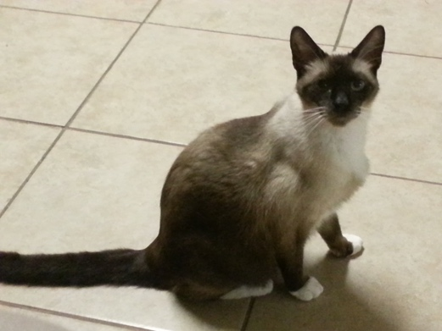
Steffie and I share our home with two cats, though in the past we've had as many as five at a time. Twelve toms and queens have come into our lives and left their imprints behind when they departed, each as unique as a thumbprint. I've known cuddlers, clowns, hunters, and divas: long and short-hairs, tabbies and calicos, a black panther, a marmalade pudding, and one snowshoe Siamese who was too sexy for his tail, ears, and whiskers. I've loved them all, and never more than when they're asleep. No matter what mayhem they commit; regardless of what is broken or shredded−or, God forbid, peed on−I can forgive them murder in the first degree when they wrap themselves into tidy packages and abandon consciousness.
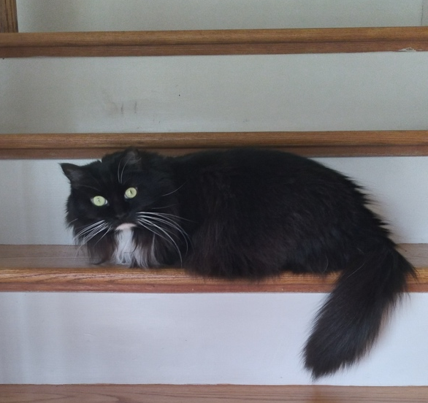
Lady Jane Chesterfield is our senior cat, so called because she strongly resembles a well-padded armchair. She is a long-haired, rotund tuxedo cat with a perpetually surprised expression and the longest whiskers I've ever seen on a cat. They stand out against her fur like tapering strokes of white ink on black paper. The splash of white chin between her dark cheeks makes her look as though she has muttonchops.
Awake, Lady Jane is a model of decorum and maintains her dignity even in the face of sneak attacks by her stepbrother, Joey the Magnificent. Glaring down at him from the bed or the top stair, her plume of a tail sweeping majestically from side to side, she rarely gives up the moral high ground. When she is asleep, it's another story. She falls asleep in stages, first collapsing onto her side and then rolling onto her back. Next comes a series of full-body wriggles, as she curls herself to one side and the other until she is comfortably arranged. Finally, relaxed, she spreads all her white-socked feet abroad and bares her furry white belly, the image of a debauched sheepskin rug. It's absurd behavior for such a genteel lady, all her modesty cast to the four winds. I treasure these moments of abandon, wishing I were as ready to show my vulnerability. I'm humbled by her trust in her surroundings and the people watching over her.
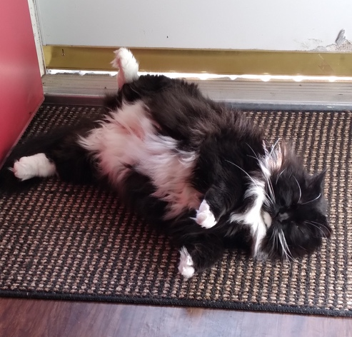
Sadly, such moments of quiet repose are fleeting; Joey is almost always lurking nearby.
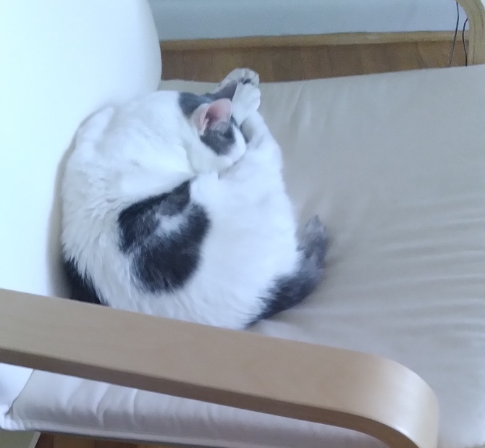
Joey the Magnificent is a troublemaker and a trial to our sedate Lady Jane. Stillness is not in his nature. He's barely out of kittenhood and wants a playmate; it's a shame he lives with three elderly females. Awake, he's in perpetual motion: up and down the stairs and the cat tree, sometimes tearing around the house in a fit of temporary madness. Whenever I find the entrance rug at the foot of the stairs askew, I know who has been there.
Like many of our rescues, Joey was a feral kitten, but there is some pureblood in him: his long legs and abbreviated tail betray Manx ancestry. It never takes him long to get to the highest point in the room. Few shelves are above his reach, which makes decorating with breakables a risky business. Fortunately, he is careful and not given to gravity experiments.
When I'm working on the computer I often feel Joey's compact body brush up against my calf, a brief greeting before he hops into the IKEA rocker that is his chair. He seems to like to keep me company. To watch him sleep, all I need to do is lean a few inches to the side. It's healing to take a moment away from the keyboard and observe someone who knows he has all the time in the world and nothing pressing to do.
Sometimes, when he's deliberately keeping one eye open, Joey sits on his haunches and tucks his front paws together, head up and eyes slowly drifting closed, ready to wake up and get moving should anything interesting happen. This is how he sleeps when he's on the top platform of the cat tree; it's what we call meatloaf mode. However, when he's completely relaxed, he turns into a cinnamon bun, curled like a lady's chignon, back paw planted between his ears, his nose buried under his thigh, the dark splotches on his pale side rising and falling with his gentle breath. Sometimes, he snores.
Jane never snores.
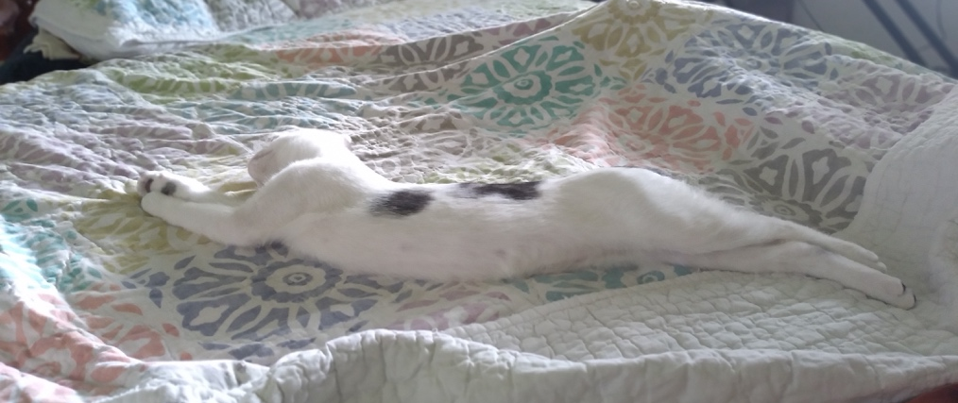
I watch my boy cat and remember when he was small enough to sleep spread out on a sofa pillow, before he grew into his length of leg and became a jumper and a climber. I have a photo of him sprawled on his side, back legs, body, and front legs all one extended, curved line, like Stretch Armstrong after a tug o' war. He's never been much of a lap cat. The only exception is when I'm sitting up in bed with a book: that's his cue to pin me down. What does it matter that my legs are cramping, or my bladder is aching? Joey the Magnificent is on my lap, and he's purring.

