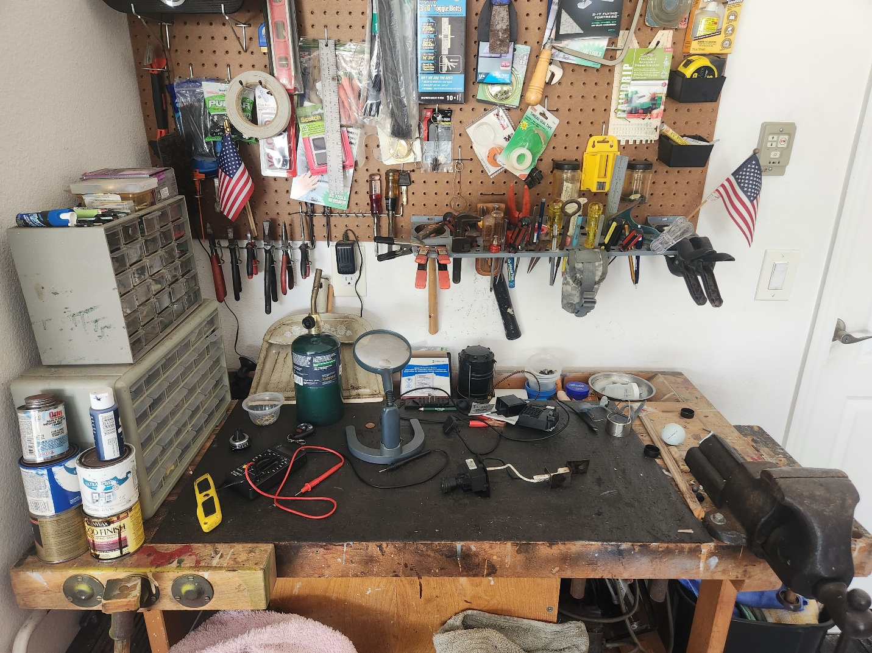

My workbench is a survivor. I bought it at a *Globus Baumarkt* (hardware store) in Germany when Lisa and I were first married, and I started making wooden toys for our oldest son, Derreck. It was just the right height so I could work comfortably. I like all of the features, but especially the storage door and shelf, the wooden top, and the two built-in wood vices. I kept it in the attic of our apartment house in Lambsborn, and made toy trucks and a working crane under the glow of a single light bulb, using a small set of hand tools: a saw, a hammer, and a rasp. The workbench made a helpful companion to the poor man’s saw table I picked up at the BX. A fledgling woodworker could clamp a handheld circular saw to the underside of the table and raise the blade through a slot to make a cheap and dangerous table saw.

The workbench traveled with us to Utah, where it occupied a spot in the garage. My tool collection grew, and I acquired some handheld power tools. But I dreamed of having a real workshop, filled with woodworking tools and a large bench.

That dream came true when we bought a house in Pennsylvania. I built a three-car garage and transformed one bay into my workshop. I built a wraparound workbench along two walls, added a real table saw, drill press, planer, jointer, band saw, and lathe. And a dust collection system. My German workbench held the place of honor, standing free in the center of the workshop. I built many things there—more toys, cabinets, dressers, and even a bay window.

When we moved to Florida, I sold all of my tools except for what I could fit into my bag and a toolbox. But I took my beloved workbench with me. The workbench is now stationed in the garage, near the door into the house. It is my domain, and it reflects who I am.

On the left side, I placed two of those little compartmented storage boxes. One day, I swear, I’ll label the compartments. But I only think about it while searching through all twenty-four compartments when I want a small screw. My memory fades soon after, only to be revived when I make another search.

A little plastic box on top of the storage containers holds a mechanical pocket watch in several pieces. I gave my son, then sixteen, the watch after he begged repeatedly. He promptly left it in a pocket, and Lisa washed it. Lisa heard it clunking around the dryer and rescued it. I kept it to fix, one day, and I have worked on it. Joseph is now thirty-seven years old, but one day I’ll complete it.

The workbench features a full-length trough at the back for tools. Mine contains empty single-serve fruit containers, which I figure will work well for small parts storage. One of them is filled with parts for a metal model of the lunar lander. I made a lot of models during the pandemic, while recovering from cancer surgery, filling our curio cabinet with little bombers, fighters, a pirate ship, and an Imperial cruiser. My wife would love to see them all fly away and leave her ceramics alone. I am resolved to finish my lunar lander before my eyesight fails me completely.

I also have bits and pieces of metal wire and plastic parts too good to throw away, because I may use them one day. Two dustpans are propped in the back, along with a lantern-style LED light, which comes in handy, and an empty magnetic metal parts bin, which serves no function except to attract any metal objects around it. It is currently stuck to a metal Buc-ees mint container, which is also empty. I see there are two sets of earplugs. I never wear earplugs, but you never know, I may need them one day.

The surface of the bench is covered by a black shelf liner, which helps when assembling small parts. On the left side of this area, I have the cheap multimeter that I’ll have to put back in my toolbox one day, along with a propane torch from an aborted attempt to fix my wife’s gold necklace. The necklace sits in another fruit cup. I swear I’ll fix it before Christmas, but I’ll likely abandon my attempt and take it to a jeweler.

I have a magnifier stand in the middle. I use it occasionally, but I have recently come to rely more on the Zoom function on my phone. However, it will likely remain on the bench for good. The right side of the bench contains parts I’m trying to fix. I have a working solar light, just missing the globe, the door switch from my washing machine that I’m sure I can repair, and the ignition switch from my grill, which might still function with a little work. I’ve already replaced both the door switch and ignition switch, but you never know when the old parts might come in handy.

At the far right, I’ve bolted the ancient machinist's vice I got from my grandfather. The vice is a pass-down item, and I expect one of the boys will take it.

Overall, the workbench sports the evidence of years of use and benign neglect. There are various paint stains, and I can identify every project that produced the paint marks. Here and there, I see gouges from misapplied screwdrivers and chisels, hammer marks, and drill holes from many projects. The bench will be with me until I am no more. Maybe I’ll have it cremated with me so that I can take it to the afterlife.